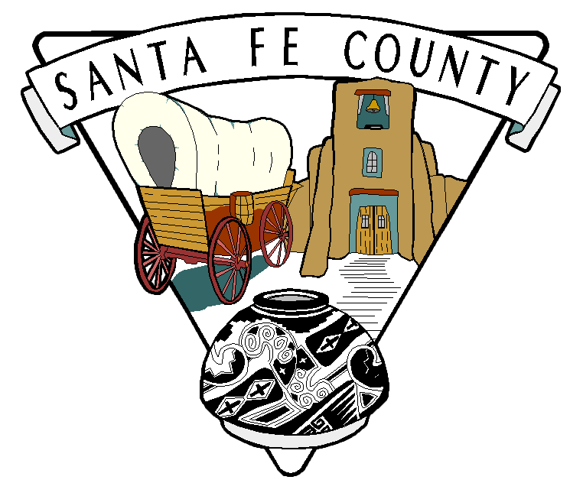

Community Services Department
Santa Fe County Teen Court Program

Notice of Funding Availability
-YOUTH EDUCATIONAL AND RECREATION PROGRAM-

This Notice of Funding Availability (NOFA) is provided by Santa Fe County – Community Services Department for the Santa Fe County Youth Educational and Recreation Program.

Funding under this solicitation may be used to develop and administer age appropriate educational and recreation programs to serve the youth in Santa Fe County between kindergarten and 12th grade.

Successful applicants shall clearly delineate programs that are evidence based or a demonstrated promising practice to increase the health and overall social wellbeing and shall affect specific health indicators which include but are not limited to: building protective factors to increase mental and/or physical health and reduce substance abuse and/or obesity, and address enhanced learning opportunities.

Document Type: Funding Notice
Funding Opportunity Number: CSD-YERP-FY16/17
Opportunity Category: Discretionary
Posting Date: March 4, 2016
Closing Date: April 1, 2016 – 2:00 PM MDT
Funding Instrument: Grant Agreement
Category of Funding: Youth Education Programs
Expected Number of Awards: 10 +/-
Total Program Funding: $225,000
Maximum Amount of Funding per Program: $30,000
Cost Sharing or Matching Requirement: 20% (Soft or Hard)
Maximum Amount of Program Administration: 5% of Total Grant Award
Term of Funding: May 1, 2016 – June 30, 2017

Description: The Santa Fe County Community Services Department – Teen Court’s Youth Educational and Recreation Program is intended to provide funding for the development and administration of educational recreational programs that are age appropriate and designed to provide programming to children from kindergarten through the 12th grade throughout Santa Fe County.

Successful programs shall integrate evidence based or promising practices that increase the health and overall social wellbeing of Santa Fe County youth. Additionally programs shall affect specific health indicators for Santa Fe County which may include but are not limited to, providing a safe community and supporting a healthy community, building protective factors to increase mental and/or physical health and reduce substance abuse and/or obesity and enhanced learning opportunities. Programs shall use methods intended to recruit and market youth including high risk youth into the program.

Eligible Applicants: Non-profit organization and units of government.

Additional Information on Eligibility: A youth and education program is not an eligible applicant. As defined, an eligible applicant is a non-profit or unit of government that will serve as the Fiscal Agency/Fiduciary for the program.
Authorized Program Area: For the purposes of this funding notice, the authorized program areas are limited to Youth Education and Recreation programs.

Eligible Activities: For purposes of this funding notice applications shall be limited to non-profits and units of government for use in the administration and implementation of youth education and recreation programs.

Supplanting: Grant funds are intended to add to, augment, or supplement, not replace, resources already committed to the program activities.

Application Procedure: Applicants may request application information by contacting Jennifer N. Romero at 505-955-9555 or jnromero@santafecountynm.gov. All applications are due no later than 2:00 PM MDT – April 1, 2016, and shall be submitted in accordance with the procedures outlined within the application packet.

Award Selection Procedure: Upon receipt and review of each application for completeness, applications will be rated and ranked by the Community Services Department – Teen Court Sub-committee utilizing the rating criteria included within the application packet. All applications recommended for award will be forwarded to the Santa Fe County Manager’s Office for review and consideration.

Notification: All applicants will be notified in writing of their rating and funding decision no later than thirty (30) days after the date of application.

Reporting Requirements: All selected applicants (grantees) shall be required to submit quarterly financial and programmatic reports as required.

TERMINATION: Santa Fe County shall have the right to terminate this Notice of Funding Availability at any time. The terms of this NOFA are contingent upon sufficient appropriations and authorizations being made by Santa Fe County, or the Legislature of the State of New Mexico if State funds are involved. If sufficient appropriations and authorizations are not made, this NOFA shall terminate upon notice being given by Santa Fe County. Santa Fe County is expressly not committed to the expenditure of any funds until such time they are programmed, budgeted, encumbered and approved for expenditure. Santa Fe County’s decision as to whether funds are sufficient for fulfillment of this Notice shall be final.

