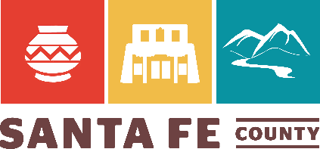

SANTA FE COUNTY
SINGLE-USE PLASTICS AND POLYSTYRENE
WORKING GROUP
NOTICE OF AND AGENDA FOR
REGULAR MEETING
Tuesday, July 18, 2023, 5:30 p.m.
The Santa Fe County Single Use Plastics and Polystyrene Working Group their regular monthly meeting on Tuesday, July 18th, 2023, at 5:30 p.m. in the County Administrative Complex, Johnson Conference Room, 100 Catron St., Santa Fe, NM 87501.
AGENDA
- Call to Order
- Roll Call
- Approval of Agenda (Action Item)
- Approval of June 27, 2023, Meeting Minutes (Action Item)
- Matters from the Working Group
  - Assignments and Research Planning
- Discussion and Next Steps (Action Item)
- Matters from the Public
- Other Business
- Adjournment (Action Item)
IN-PERSON ATTENDANCE
Members of the public have the choice of listening and participating in this meeting in person or virtually. Members of the public listening and participating in person will be required to comply with Santa Fe County policies concerning visitor screening and the wearing of cloth face coverings in effect on the day of the meeting. Please contact (505) 986-6200 for copies of Santa Fe County’s current policies, which are subject to change.
Santa Fe County makes every practical effort to assure that auxiliary aids or services are available for meetings and programs. Individuals who would like to request auxiliary aids or services should contact Santa Fe County Manager’s Office at (505) 986-6200 in advance to discuss specific needs (e.g., interpreters for the hearing impaired or readers for the sight impaired).
ALTERNATES TO IN-PERSON ATTENDANCE
Alternatively, members of the public can listen and participate in the meeting via WebEx, using meeting link https://sfco.webex.com/sfco/j.php?MTID=m7145f2200d0bd082f14b0757cadcd98c (access code) 2488 772 1614 and password g6RfV35Yhdu. To participate by phone, call 1-408-418-9388. To participate via the internet, go to https://sfco.webex.com/sfco/.

