Natural Resources
In the San Marcos District, we will:
- conserve our natural resources
- ensure enough water for residents
- provide safe and healthy watershed
- set an example for education, sustainability, and resource management
- respect the quiet and private nature of the District
- promote public health, safety and general welfare (Envision a safe community)
- promote clean air
- cultivate dark skies
- enhance scenic views, movie sets and scenic byways
- protect the natural views
- enable rural lifestyle
- balance a healthy wildfire ecosystem
- encourage use of renewable energy
- conserve our natural resources
- respect the quiet and private nature of the District
- inspire rural character and lifestyle
- enhance scenic views, movie sets, scenic byway
- maintain the character of region within and surrounding San Marcos District
- maintain the archaeological assets of the area
- set an example for education, sustainability and resource management
- create trails that coexist well with the landscape and archaeological assets (promote non-motorized recreational trails)

Water

San Marcos area does not have any perennially flowing surface streams. Residents and business owners rely on wells and hauling water for their daily needs. The Santa Fe County Utilities Division operates a 24-hour Self Service Water Dispensing Facility, “Ojo de Agua,” Convenience Center, located at 13-B Camino Justica in the Santa Fe County Public Safety Complex. Santa Fe County residents and commercial customers can set up an account to use the facility by visiting the Santa Fe County Utilities Office. A commercial customer is defined as anyone purchasing 10,000 gallons or more at one time. Residents are charged $0.01 per gallon and commercial customers are charged $0.02 per gallon. Customers are required to prepay to their accounts before using the dispensing facility. Roughly 500 customers are registered to use the dispensing facility as of spring 2018. Water at the facility is sourced from the Rio Grande via the Buckman Treatment Plant.

Although the County does not keep data on the number of businesses and households currently engaged in rainwater collection, the Sustainable Land Development Code (SLDC) does require that new residential developments and new or remodeled non-residential developments in the County collect rainwater using cisterns. For residential structures, the County’s rainwater harvesting requirement states that rainwater must be captured from a minimum of 85 percent of the roofed area and be placed into a rain barrel, cistern or other catchment system including passive water harvesting and infiltration techniques. For non-residential structures, systems shall be designed to capture rainwater from all of the roofed area to be connected to a drip irrigation system to serve landscaped areas.

Santa Fe County has incomplete data about the number or status of working wells in the area. The United States Geological Survey (USGS) operates several ground water site inventory wells in the District that monitor aquifer depth. Recent hydrologic studies of the area are unavailable. Unlike northern parts of the County, there are no acequia systems in San Marcos. There are also no community water systems in the District. While old planning documents relied on development based on water availability, current zoning does not differentiate development areas based on water.

View sheds

The Turquoise Trail National Scenic Byway starts just outside of the City of Santa Fe and heads down HWY 14 through San Marcos District. This Byway showcases the area’s mining history and takes visitors through the villages of Cerrillos and Madrid, giving them a taste of the Old West. This landscape, with views of the basin and scenic hills, has attracted residents and inspired filmmakers who have made the area a backdrop for many films. The natural beauty and open vistas in the area are one of the region’s biggest natural resources that distinguish the character of the District.

Air Quality

San Marcos area, like much of the region, is known for its clean air. The American Lung Association gave Santa Fe County’s air quality a B grade in 2016, down from an A following a day between 2012 and 2014 in which ozone levels barely exceeded Environmental Protection Agency (EPA) standards. EPA standards have increased in 2015, setting the bar at 70 parts per billion down from 75. From 2007 to 2013, Santa Fe County scored all A’s for low levels of ozone and B’s and A’s for its levels of particle pollution. Santa Fe County has often been known for having the cleanest air in America, in 2011, the World Health Organization said the air here was among the cleanest in the world.

Minerals

Areas of San Marcos District near the Cerrillos Hills Park were historically a source of copper, lead, zinc, gold, silver and turquoise extracted both small-scale and larger commercial mines.

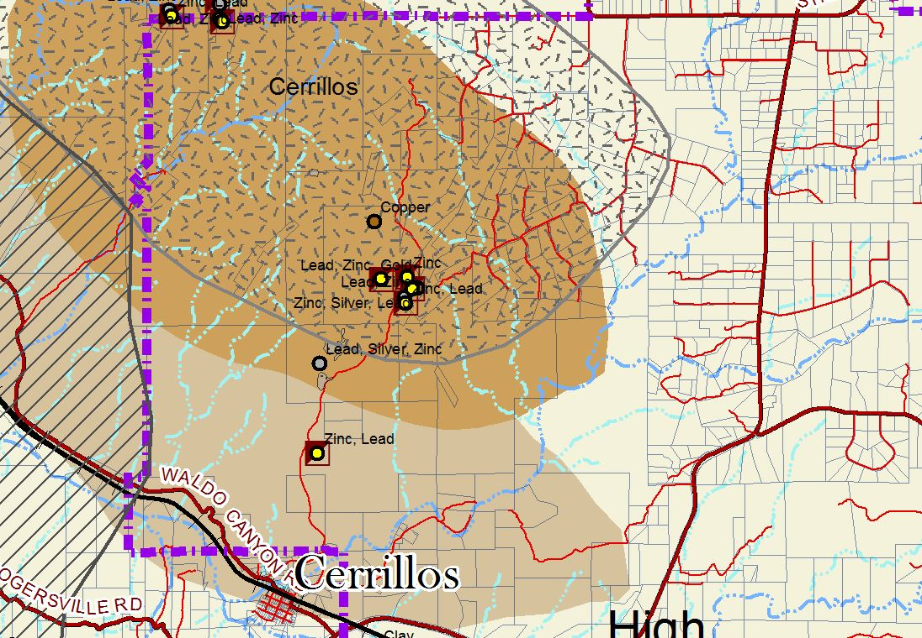

Sun/Wind

San Marcos area, with large open spaces, allows residents to have easy access to solar power. Many private residents have solar panels to power their off-grid houses. There is also the potential for wind power in this area, though fewer residents currently have wind turbines. These alternative and renewable sources support the rural and independent lifestyle that attracts many people in the District.

Animals

San Marcos area is home to the Gray Vireo, a state-listed threatened species. These birds typically prefer open pinon-juniper woodland with a shrub component. Threats to this species include loss or alteration of suitable nesting habitat and wintering habitat. This area is also home to a few Species of Concern. The Pinyon Jay, which is essential for the health and propagation of pinon trees, is a medium-sized jay that looks like a miniature crow. The Pale Townsend’s Big Eared Bat finds its home here, along with the Bendire’s Thrasher.


© Noah Strycker, Macaulay Library- Pinyon Jay

Soil

San Marcos soils include Zozobra-Jaconita complex, Khapo sandy loam, and Arent-Urban land-Orthents complex in the northern part of the District. By the San Marcos Arroyo, the soil composition includes Zozobra-Jaconita, Chupe Riverwash, Zia fine sandy loam, Agua Fria-Paraje, and Vitrina-Haozous. Garden of the Gods area of the District, with the definitive rock formations has Rock ourcrop-Skyvillage complex, Penistaja family sandy loam, Kech-Cerropelon-Rock outcrop complex, and Penistaja family loam. Next to the Cerrillos Hills, the sand composition is primarily Kech-Cerropelon Rock outcrop, with some Truehill extremely gravelly loam and Sandoval-Badland complex.

Open Space

Multiple agencies own property in San Marcos District. Santa Fe County Open Space owns 437 acres, Bureau of Land Management (BLM) manages 3,876 acres, the State Land Office (SLO) has 1,826 acres, and New Mexico State Parks (State Parks) owns 1,059 acres in the Cerrillos Hills Park. Each agency has a different mission for public access and use. Santa Fe County aims to make its own Open Spaces available for recreation, while balancing conservation. The BLM leases property for grazing and agriculture, as does the SLO, with little emphasis on recreation. State Parks uses Cerrillos Hills for cultural and historical interpretation. There are also several private conservation easements, with 39.6 acres under protection.

Trails

On Cerrillos Hills State Park’s six miles of trails people can experience scenic views of northern New Mexico through hiking, mountain biking and horseback riding. Besides these formal trails, there are informal trails throughout the District that are used for walking and horseback riding. BLM lands also provide trails for a range of recreational activities.

Key Issues

- Diminishing water resources for current and future residents
- Private well use and monitoring
- Diminishing water resources for future development
- Watershed becoming polluted
- Fossil fuel spills
- Noise pollution in the area concerns residents
- Night lighting/light pollution
- Development immediately adjacent to NM 14 threatens integrity of Turquoise Trail rural character
- Littering
- Fire hazards increasing
- Enforcing penalties on littering

Vision statements that inform Goal A:
- conserve our natural resources
- ensure enough water for residents
- provide safe and healthy watershed

Goal A Conserve and protect water and natural resources to ensure enough water for residents, while providing a safe and healthy watershed

Connecting Actions
- Well monitoring/where there is/isn’t water
- Non-build areas
- Managing ecosystems
- Landscaping
- Water collection/water harvesting
- Water treatment/recycling water
- Teach sustainability
- Code enforcement
- Identify water sources in District
- County water filling station- additional site within the District
- Design guidelines

Vision statements that inform Goal B:
- inspire rural character and lifestyle
- enhance scenic views, movie sets, scenic byway
- maintain the character of region within and surrounding San Marcos District
- maintain the archaeological assets of the area
- set an example for education, sustainability and resource management
- create trails that coexist well with the landscape and archaeological assets (promote non-motorized recreational trails)
- balance a healthy wildfire ecosystem

Goal B Inspire the rural character and lifestyle of the region by enhancing scenic views (including the Scenic Byway), maintaining the archaeological assets of the area, creating trails that coexist well with the landscape and archaeological assets, setting an example for education, sustainability and resource management, including a balanced wildfire ecosystem.

Connecting Actions
- Create manageable setbacks for businesses and residents
- Establish traffic parameters for small businesses that match character of area
- Setback recommendations
- Non-build areas
- Managing ecosystems
- Landscaping
- Design guidelines
- Identify rules and regulations protecting byways
- Establish rules for number of lights, types of lights and hours of use

Connecting Actions
- Teach sustainability
- Code enforcement
- Business sponsored trash dump
- Having a community trash pickup day
- Public education and public service announcements
- Establish traffic parameters for small businesses that match character of area
- Managing ecosystem
- Early adopter/pilot case for robotic trash pickup
- Signs that are fun for community communication
- Community education group
- Establish rules for number of lights, types of lights and hours of use
- Promote renewable energy generation
- Non-build areas
- Encourage fire awareness when building homes and necessity of controlled burns

https://www.newmexico.org/things-to-do/scenic-byways/turquoise-trail-national/
http://www.santafenewmexican.com/news/local_news/santa-fe-slips-to-b-grade-in-national-air-quality/article_0eda2313-e8b8-581d-91a9-818a7411e968.html
http://avianconservationpartners-nm.org/wp-content/uploads/2017/01/Gray-Vireo.pdf
https://www.allaboutbirds.org/guide/Pinyon_Jay/id
https://www.allaboutbirds.org/guide/Pinyon_Jay/id
https://websoilsurvey.sc.egov.usda.gov/App/HomePage.htm
https://santafecountynm.maps.arcgis.com/apps/MapSeries/index.html?appid=494e97891d524635936a5b9b759d7c63

