Santa Fe County & Tesuque Valley Planning Committee

Tesuque Community Plan 2021

Draft Oct 2021

Acknowledgements
Community Members

Special thanks to the numerous community members who contributed valuable time, information and insight into the planning effort. This Plan is the product of everyone who participated.

Planning Committee Members

The Tesuque Planning Committee and the Santa Fe County Growth Management Department & Planning Division are forwarding this Plan for approval. The Committee represents those individuals who were committed to completing the directive of Resolution 2019-47 which authorized a community planning process to amend the 2013 Tesuque Community Plan. The following individuals have worked consistently and tirelessly to finish the task.

Annie-Laurie Coogan
Adelmo Del Archuleta
Barry and Myssie Acomb
Benjamin Shield
Brenda Atencio
Bruce and Debbie MacAllister
Bruce Stuart
Cam Duncan
Chris Ortega
Colin Keegan
Dale Osmun
David Dougherty
David Perez
Deborah and Bill Parker
Deborah Cox
Denise Hurtado
Donna Strahan
Eddy Jon
Eric Sirotkin
Heather Katz
Helen Larsen
Ip Denise
Jack Johnson
Jacob Clemens
James Goodwin
Jamie Gagan
Jane Morrison
Jeanne C Boyles
Jennifer Jenkins
Jennifer Romero
Jennifer Wilson
Jarry Barron
Joanne Dephillips
Judy Chiba Smith
Karen Buxbaum
Kerry Heinemann
Larson Brecken
Larson Lenny
Lynn Pickard
Malkah Schmider
Margo Cutler
Marshall Hunt
Megan Seret
Melanie Corcoran
Michael Tobias
Micheline Devaurs
Patrick Hanson
Peggy Catron
Peter Wurzburger
Quinn Simons
Randolph Buckley
Rebecca Bradshaw
Richard Renaldo
Shirley Crow
Steve Ross
Sue Barnum
Ted and Dawn Williamson
Tom Easterson-Bond
Ton Heinemann
Tor Vann
Valerie
Vanessa
William Parker

County Officials

Henry Roybal, Commission District 1  Anna Hansen, Commission District 2 | Anna Hamilton, Commission District 4  Hank Hughes, Commission District 5
Rudy Garcia, Commission District 3

County Manager
Katherine Miller

Growth Management Department & Planning Division

Penny Ellis-Green, Growth Management Director  Robert Griego, Planning Manager  Lucy Foma, Senior Planner | Tim Cannon, Senior Planner  Gary Brett Clavio, Transportation Planner  Paul Olafson, Planning Projects Manager

SECTION I: INTRODUCTION
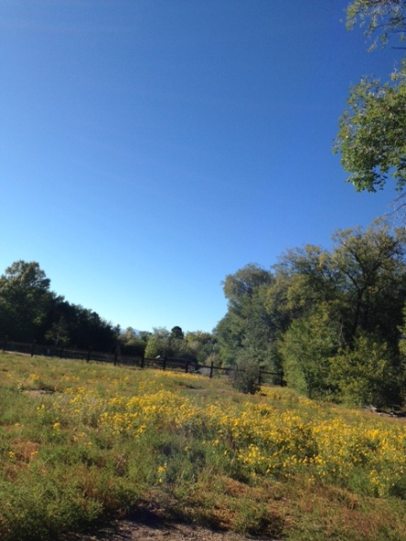

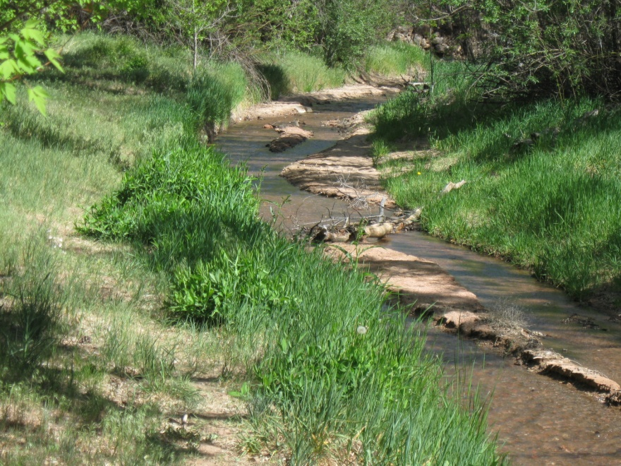
Executive Summary

Introduction

One of the main goals of this community plan is to ensure that Tesuque maintains its rural and agricultural character as a distinct, viable village. Tesuque residents do not want Tesuque to become a bedroom community for Santa Fe.

Tesuque has struggled to maintain its rural quality, as Santa Fe, a city of over 85,000 continues to grow around it. Through this community plan and past community efforts and partnerships, Tesuque continues to reinforce its historic development patterns and maintain a healthy ecosystem, enabling a sustainable future as a small distinctive rural community.

Purpose
The purpose of the 2021 Tesuque Valley Community Plan is to provide consistency between the Tesuque Community Plan and the Sustainable Growth Management Plan (SGMP), as well as to provide a basis for amendments to the Tesuque Community District Overlay in the Sustainable Land Development Code (SLDC). The Rio Tesuque Community Land Use Plan was originally adopted in the year 2000 and the Tesuque Community Plan was updated in 2013 as an amendment to the SGMP.
The 2021 Tesuque Valley Community Plan was authorized by the Board of County Commissioners (BCC) via Resolution 2019-47. After adoption by the BCC, the 2021 Tesuque Community Plan Update will amend the 2013 Tesuque Community Plan within the SGMP.

Plan Area Description

The Tesuque Valley Community Plan covers the Traditional Historic Community of Tesuque which is identified as the Tesuque Community District and is located just north of the City of Santa Fe in the unincorporated area of central Santa Fe County. The Tesuque Community District is an area lies between the City of Santa Fe to the south, the Santa Fe National Forest to the east, the Pueblo of Tesuque to the north and US Highway 285 to the west. The area includes approximately 2,950 acres encompassing the Rio Tesuque and surrounding foothills. This river valley, at the base of the foothills of the Sangre de Cristo Mountains, is home to 1,094 residents.

Document Organization

The document is divided into three sections:
Section I: Introduction & Executive Summary provides a general overview of the plan and planning process. It also provides the community context including a brief history of the area; demographic, housing, and economic trends; existing land use and development patterns; and existing zoning.

Section II: Plan Elements addresses issues of particular concerns organized under the following plan elements:
- Bishop Lodge Corridor and Roads
- Land Use, Densities and Development Patterns
- Acequias, Agriculture and Riparian Areas
- Social Trails
- Public Access to Santa Fe National Forest and Trails
- Fire Safety & Prevention
- Community Facilities
- Water Supply and Waste Water

For each element, there are goals, an overview of issues and opportunities, key information and implementation strategies. Implementation strategies are action tasks such as proposed policies, regulations, partnerships, or "next steps" needed to achieve the desired goal. Land Use Plan policies may be implemented through the Tesuque Community Overlay District in the Sustainable Land Development Code.

Section III: Implementation provides a concise guide to plan implementation. This section describes strategies intended to achieve community goals, provides a timeline for implementing those strategies and identifies appropriate funding sources (when applicable), responsible parties, and potential partners to assist with plan implementation.

Purpose & Intent

The purpose of the 2021 Tesuque Valley Community Plan is to update and replace the 2013 Tesuque Valley Community Plan. Community plans articulate the community’s vision and goals for the future, identify and document past and recent history, describe current conditions and major trends and provide recommendations and strategies for achieving the community’s vision and goals. The purpose of the 2021 Tesuque Valley Community Plan is to replace the plan for consistency with the Santa Fe County Sustainable Growth Management Plan (SGMP). The plan update will also provide a foundation for consistency between the Tesuque Community Plan and the Tesuque Community District Overlay in the Sustainable Land Development Code (SLDC). The 2021 Tesuque Community Plan is intended to provide a framework for justification of changes within the Tesuque Community District Overlay in the Sustainable Land Development Code (SLDC). The plan articulates the vision for the community and provides guidance for design standards and uses, locations and intensity of development in order to enhance rural development patterns, protect scenic features and environmentally sensitive areas and accommodate the anticipated natural growth of the community. When adopted, it will amend the Santa Fe County Sustainable Growth Management Plan as a Community Plan.

The County and community members identified several areas of inconsistency between the 2013 Tesuque Community Plan, the SGMP, and the Tesuque Community District Overlay in the Sustainable Land Development Code (SLDC). Through a review of the documents, staff identified the following areas that needed to be addressed:

- Change the land use categories in the Plan to be consistent with the land use categories in the SGMP
- Remove any regulatory language and references to regulations within the Plan document
- Remove and replace references to ordinances which are no longer in effect
- Modify the fence and wall section of the Tesuque Plan to address residents’ privacy and road user safety
- Introduce cannabis ordinance into the Tesuque Community Plan
- Address consistency between Tesuque Plan Language and regulations within the Tesuque Community District Overlay regarding height and other standards
- Review uses intended only for the Tesuque Rural Commercial Overlays that are currently allowed in other parts of Tesuque
- Review Community District Overly uses regarding schools

CHALLENGES AND OPPORTUNITIES

The plan addresses new and changing conditions within the Tesuque community. Among the conditions addressed are responding to drought, flooding, fire risks, water rights and conservation concerns, implementation of the applicable terms of the Aamodt settlement agreement, changing land use patterns such as increasing proportion of second homes in the plan area and population changes, and concerns regarding enforcement of applicable land-use and fire safety codes.
Flooding
Flloding has become an issue in Tesuque when heavy rains occur. Addressing road drainage and bridges may become an issue in the future.

Wildfire Issues
Each of these contextual factors has significant potential impact on Tesuque. The extended drought has raised concerns about Tesuque’s heightened vulnerability to wildfire and highlighted the need for Tesuque residents to take steps to prevent wildfire and enhance the Fire District’s capacity to respond to a major wildfire event. Wildfire is addressed in this plan update in the “Fire Safety and Prevention” plan element.

Aamodt Settlement
The implementation of the Aamodt settlement has the potential to significantly alter the community. Implementation of the settlement will involve extending water infrastructure to serve Pueblo and County residents, including Tesuque residents. Tesuque residents have expressed concern that implementation of the settlement in the plan area may impact the community’s roads and detract from their scenic attributes.

Enforecement

Current issues needing enforcement include traffic, abandoned homes and fencing regulations.

Road Safety Study

Tesuque’s proximity to Santa Fe and the Santa Fe National Forest has opened it to significant volumes of traffic from motorists, bikers, bicyclists and hikers seeking to access public lands and other amenities. There is a need to improve the roads for pedestrian and bicyclist safety. Safe transit stops and potential trailheads are some options that have been suggested by the Tesuque community. Santa Fe County is currently in the process of undertaking a Road Safety Study along Bishop’s Lodge Road, Tesuque Village Road and Arroyo Griego to identify existing safety issues for road users.

Tesuque Open Space Management Plan and Tesuque Trail Study
Santa Fe County is moving forward with a Tesuque Open Space Management Plan and Trail Study.

Planning History & Community Outreach

Background: Residents of Tesuque have been involved in planning efforts for many years starting with the Las Tres Villas planning effort of 1974-1978. Their dedication has resulted in both the designation of the area as a Traditional Historic Community in 1998, (via Ordinance 1998-6), and in 2000, the adoption of the Rio Tesuque Community Land Use Plan, (via Resolution 2000-165), and the associated Tesuque Valley Community Zoning District, (via Ordinance 2000-13). In 2010 residents recognized the need to revisit and update their community plan in light of new challenges brought on by extended drought, the Aamodt settlement, the recession, and by the County’s adoption in 2010 of the SGMP and the pending adoption of the SLDC.
1974-78 Las Tres Villas
1998 Traditional Historic Community
2000 Rio Tesuque Community Land Use Plan

2013 Tesuque Community Plan : Santa Fe County’s Board of County Commissioners authorized a planning process to update and amend Tesuque’s community plan throughResolution 2011-134.After working together on a draft plan, the County Staff and the Tesuque Planning Committee presented the draft plan to the community in May 2013. The community workshops were advertised in the paper, on the county website and invitations were mailed to all property owners in the plan area. Over 50 people attended, providing valuable information and insight. The committee reviewed input from the workshops and incorporated it into a “Community Review Draft” which was distributed for community review on July 12th. On July 29th, 2013, the committee and county staff presented the draft plan at a community open house and met with individual community members to seek further input, answer questions and address concerns. To encourage community review and attendance, county staff sent out informational brochures providing background information and a summary of the draft plan to all property owners in the plan area. The community presentation was also advertised in the paper and on the county website. Over 40 community members attended and provide positive feedback on the draft. On July 31st, county staff and the committee set up an informational table at the annual Tesuque Fire Station Barbeque where they provided copies of the draft plan, answered questions and recorded further input. On December 10, 2013, the Board of County Commissioners adopted the plan as amendment to the SGMP via Resolution 2013-139.
2013

.

2021 Plan Process

TO BE WRITTEN AT CONCLUSION OF PLANNING PROCSES

Next Steps:

The Tesuque Valley Community Plan will be implemented on an on-going basis through a variety of mechanisms including zoning amendments to the SLDC, capital improvement projects, community projects and programs. Implementation will be initiated and monitored by the community through the existing Tesuque Valley Community Association Community Organization (CO) as authorized by the Santa Fe County Board of County Commissioners. Santa Fe County and other governmental agencies will have an important role as collaborators in implementation as well as supporting plan goals and objectives.

Related Plans, Policies and Programs

As part of the Tesuque Community Plan planning process, the following plans, policies, codes and programs were reviewed in order to understand the current policy and regulatory framework that guides development in the area and determine appropriate amendments to the framework:

- Tesuque Traditional Historic Community, Santa Fe County Ordinance 1998-6: Established Tesuque as a Traditional Historic Community under state law, a designation which prevents Tesuque from being annexed without consent of a majority of qualifited voters (see NM Stat § 3-7-1 2013)
Santa Fe County Plans and Ordinances directly related to the planning area:

- 2015 Santa Fe County Sustainable Growth Management Plan (SGMP) The Santa Fe County Sustainable Growth Management Plan provides policy direction for managing future growth across the County, including direction on creating, adopting, and implementing community plans.

- Tesuque Community Plan 2013
- Sustainable Land Development Code (SLDC)
- Santa Fe County’s Cannabis Ordinance 2021-03
- The Aamodt Settlement and its relationship to community water sources

Other relevant Santa Fe County Plans, Programs and Ordinances:

- 2016 Santa Fe County Sustainable Land Development Code (SLDC) Provides zoning regulations and standards for new development. The SLDC implements the County’s and includes the Tesuque Community District Overlay.

- Santa Fe County Open Space Program: The Santa Fe County Open Space Program currently manages about 6,600 acres, including161 acres of open space southeast of the planning boundary along Little Tesuque Creek. The area includes the La Piedra trail which provides a connection to the Dale Bale trail system.

- Santa Fe County Capital Improvement Plan (CIP): Guides public investment in projects to serve existing and future development.
- Santa Fe County Infrastrucure Capital Improvement Plan (ICIP): Comprised of projects generated by the County and project requests from the community that are submitted to state legislature for capital outlay funding.

- Santa Fe County Community Wildfire Protection Plan: Identifies areas at high-risk of wildfire including Tesuque; identifies fire mitigation programs and policies.

Regional Authorities:

- Metropolitan Planning Organization (MPO)- A federally funded transportation policy-making organization responsible for programing federal transportation dollars and for transportation planning. The MPO planning area includes the community planning area

Recognized Tesuque Valley Acequia Associations:
- Acequia Madre de Tesuque
- Acequia del Cajon Grande
- Acequia Chiquita
- Cy Moore Ditch
- Acequia Del Medio
- McCune Ditch (historic)
- Beaty Ditch (historic)
- Carsuelo Ditch (historic)
- Tesuque Pueblo Ditch

State and Federal Agencies:
- Office of the State Engineer and Interstate Stream Commission- Responsible for administering the state's water resources. The agency has had a major role in contributing to the following:
  - Jemez y Sangre Regional Water Plan- The Jemez y Sangre Regional Water Plan projects future water usage and identifies strategies to provide adequate water supply across Los Alamos County and portions of Santa Fe, Sandoval, and Rio Arriba County.

  - Santa Fe County, the Pueblos of Nambe, Pojoaque, San Ildefonso and Tesuque, the State of New Mexico, the United States, and the City of Santa Fe (“Settling Parties”) entered into a Settlement Agreement, which was approved and adopted by the Federal Court in 2016. The final judgment and decree was filed on July 14, 2017. The Agreement primarily concerns the water rights of the four Pueblos in the Aamodt adjudication within the Nambé-Pojoaque-Tesuque basin, but it also makes certain beneficial concessions regarding non-Pueblo water rights. The goal of the Settlement Agreement is to resolve the Pueblos’ water rights claims while preserving existing non-Pueblo water uses. This goal is achieved, in part, by bringing more water into the Pojoaque Basin through the construction of a regional water system for both Pueblo and non-Pueblo water users.
- NM Environment Department- Administers programs and regulations to promote a healthy, high functioning environment. The agency’s responsibilities include the administration of the Liquid Waste Program and Drinking Water Program.
- NM Department of Transportation- Responsible for planning a safe, integrated, and multi-modal transportation system. The agency’s responsibilities include managing construction activities on state roads and highways.
- US Forest Service: Manages the Santa Fe National Forest.
- Bureau of Reclamation: Lead federal agency for managing and implementing the Aamodt Settlement.
- Office of the State Engineer: Approves well permits

Tesuque Pueblo:
- Tesuque Pueblo is located north of the planning boundary. Tesuque Pueblo’s casino, commercial, and residential development have been significant sources of economic development in the region.

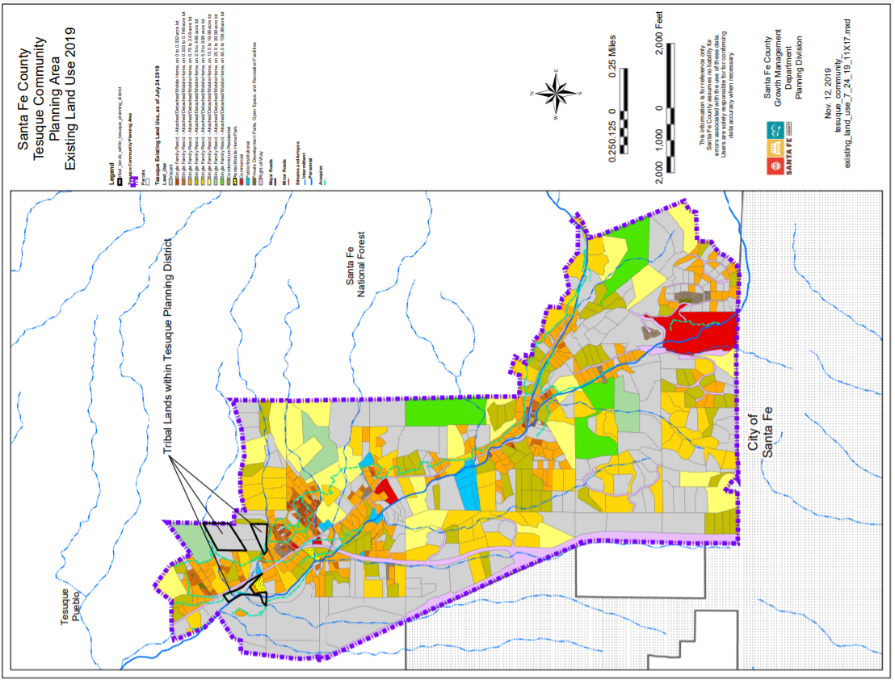

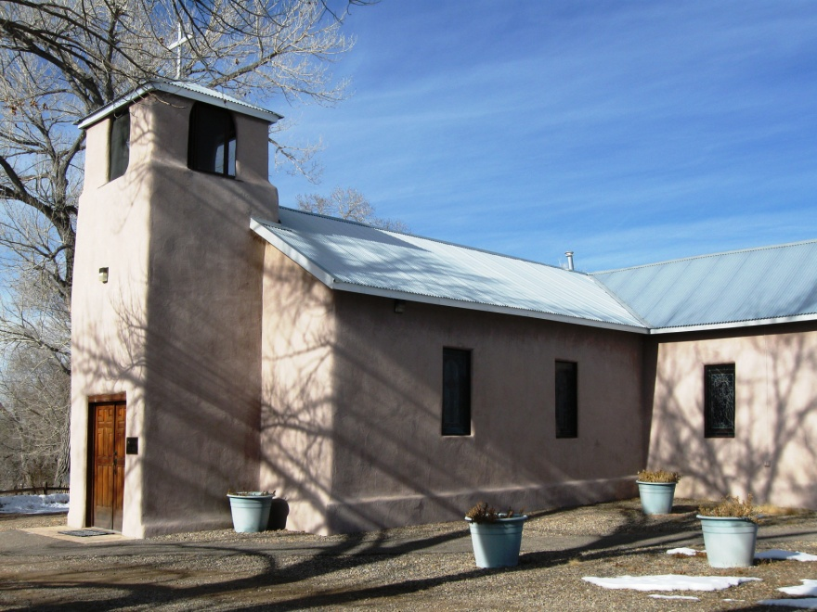
Community Context
This section assembles economic, demographic, land use, regulations, and historic information to provide an understanding of the community context today and how it evolved.

A Brief History of Tesuque
The name ''Tesuque'' is a Spanish version of the Tewa Indian '~at' unge' onwi" which means, "cottonwood place. Tesuque Village was historically part of Tesuque Pueblo which dates back at least to 900 AD. Historically, Tesuque Pueblo is noted for its exceptional pottery and for launching the initial offensive against the Spanish Colonists in 1680, which temporarily expelled the conquerors from the region.

The first of Hispanic settlement in the Rio Tesuque area occurred in 1732 after the De Vargas 'Reconquest' of 1692. In 1732, Antonia Montoya sold Juan de Benavides a piece of land containing much of what is now Tesuque. EI Rancho Benavides extended from what is now the southem boundary of Tesuque Pueblo to the junction of the Big and Little Tesuque rivers between the mountain ridges on the East and West of the river. El Rancho Benavides became known as San Ysidro (the patron saint of farmers and the name still used for the local church) and later Tesuque Village. In 1752, Juan de Gabaldon obtained much of the Rio Tesuque region in a land grant from the Spanish Territorial Governor. In 1776, Fray Francisco Dominguez visited Rio de Tesuque village and documented that it contained 17 families with 94 people.

The acequias were, and are, much more than merely a means of fairly distributing crop irrigation water. In fact, the acequias are an important cultural heritage linking the whole community. In addition to providing irrigation water, acequias also supplied the community's drinking water, served as routes connecting individual habitations and through the "mayordomos" control of water rights, provided an effective political system that structured the entire village society. Land transaction and acequia records through the Spanish and Mexican periods show continued use of the valley and its water for agricultural purposes. A number of those same acequias irrigate the valley today, with over 150 registered water users belonging to the five acequia associations of the valley. The patterns and configurations of land division and land use in Tesuque today reflect this historic acequia network and the associated agricultural uses of the past.

The watershed that encompasses the plan area is traversed by the Rio Tesuque, which has long been used by both the Native American and Spanish settlers as a route into the nearby Sangre de Cristo Mountains, for purposes of moving herds of sheep and cattle, hunting and the gathering of firewood, piñones and other food sources and raw materials. Portions of the historic trail system remain intact today and are used by both residents and nonresidents, primarily for recreational uses.

Numerous houses and buildings used for business and residential purposes undoubtedly date back to the mid-1800s. Archdiocese records date the current San Ysidro de Tesuque sanctuary at 1886. The Tesuque Elementary School began serving this community and neighboring communities in 1930 and is one of the oldest schools in the Santa Fe Public School system. In 2005, a new school was built on the site incorporating most of the old building. Bishop's Lodge Resort and Spa, was initially purchased and developed as a personal retreat by Archbishop Lamy in the mid-1800s and many of the historic buildings, have been preserved; most notably the Archbishop Lamy Chapel which is recognized on the National Register of Historic Places.

In the 1950’s, 60’s and 70’s the community continued to flourish as a distinct rural community with a rich mix of agriculturally based uses which included:

- A tree nursery
- Apple orchards
- Custom butcher shop
- Iris farmers
- Williams Chicken Ranch
- Harvey family egg and dairy production for La Fonda
- Trout ponds for fish raised and delivered to Lamy to be served on the Santa Fe Super Chief
- Mushroom growers
- Vegetable gardens
- Irrigated pastures for livestock

Although there are fewer small farms and agricultural uses have downsized, the lives of the current area residents are still intermeshed through many of these environmental, economic, cultural and historical commonalties. Numerous rural endeavors are seen in the community today:
- beekeepers
- Apple and mixed fruit orchards
- Peacock and chicken owners
- Aspiring and exisiting vintners and distillers
- Vegetable gardens
- Irrigated pastures for horses and other livestock

The late 1970s through the present brought a wave of newcomers seeking a rural lifestyle close to amenities that the City of Santa Fe offered. Contemporary subdivision began to develop on the hills that encompass the valley and new home sites were developed on the valley floor.

Demographics, Housing and Employment

According to 2020 census data, total population growth for the Tesuque Census Designated Place, (CDP) which is congruent with the planning area, has been relatively low or negative as compared to the County. Between 2010 and 2020 the population increased from 925 to 1094 people representing a 18% increase over the decade.
However, growth in the number of housing units is extremely high for the County. According to the census data, the numbers of residential units increased by 33% from 2000 to 2010 while the number of vacant housing units increased by 131%. From 2010 to 2017, the number of residential units increased 6.8% (49 units), however the number of families decreased from 221 in 2010 to 193 in 2017 (13% decrease). This most likely represents a substantial increase in vacation and or second homes.

Residents of Tesuque have grown older in the last decade. In 2020, 37% of the population was 65 years or older, while in 2010 it was 23%. Continued increases in the elderly population may increase the need for services in the area.

According to American Community Survey 5-year estimates, Tesuque has lower unemployment rates and a larger percentage of its residents in the workforce than Santa Fe County as a whole, including the City of Santa Fe. Tesuque’s 2010 median annual household income of $105,538 was nearly double the City and County median annual household income of $53,698. The median household income in 2017 went down to $70,563. However, although Tesuque may be regarded as affluent, an estimated 8% of households in the community have incomes of less than $14,999. The community recognizes diversity as an indicator of a healthy, resilient community and is strongly committed to maintaining economic diversity.

The limited amount of commercial development and community services in the planning area limits employment opportunities available within the community. Most working residents travel outside the community for work. The average commute time of 25.35 minutes is higher than in Santa Fe County, with a mean commuting time of 22.46 minutes.(https://fred.stlouisfed.org/series/B080ACS035049).

Major employers in the planning area are listed below. In addition to these employers, a number of Tesuque homes employ a significant number of people.

- Tesuque Elementary School
- Santa Fe Mountain Center

- Tesuque Glass Works
- Tesuque Village Market
- Green Galleries

- Post Office
- El Nido
- San Ysidro Church
- Bishop’s Lodge Resort
- Shidoni Gallery
- Local Lodging

`DELETE ABOVE
Figure 1 Tesuque Census Data, 2010 & 2020
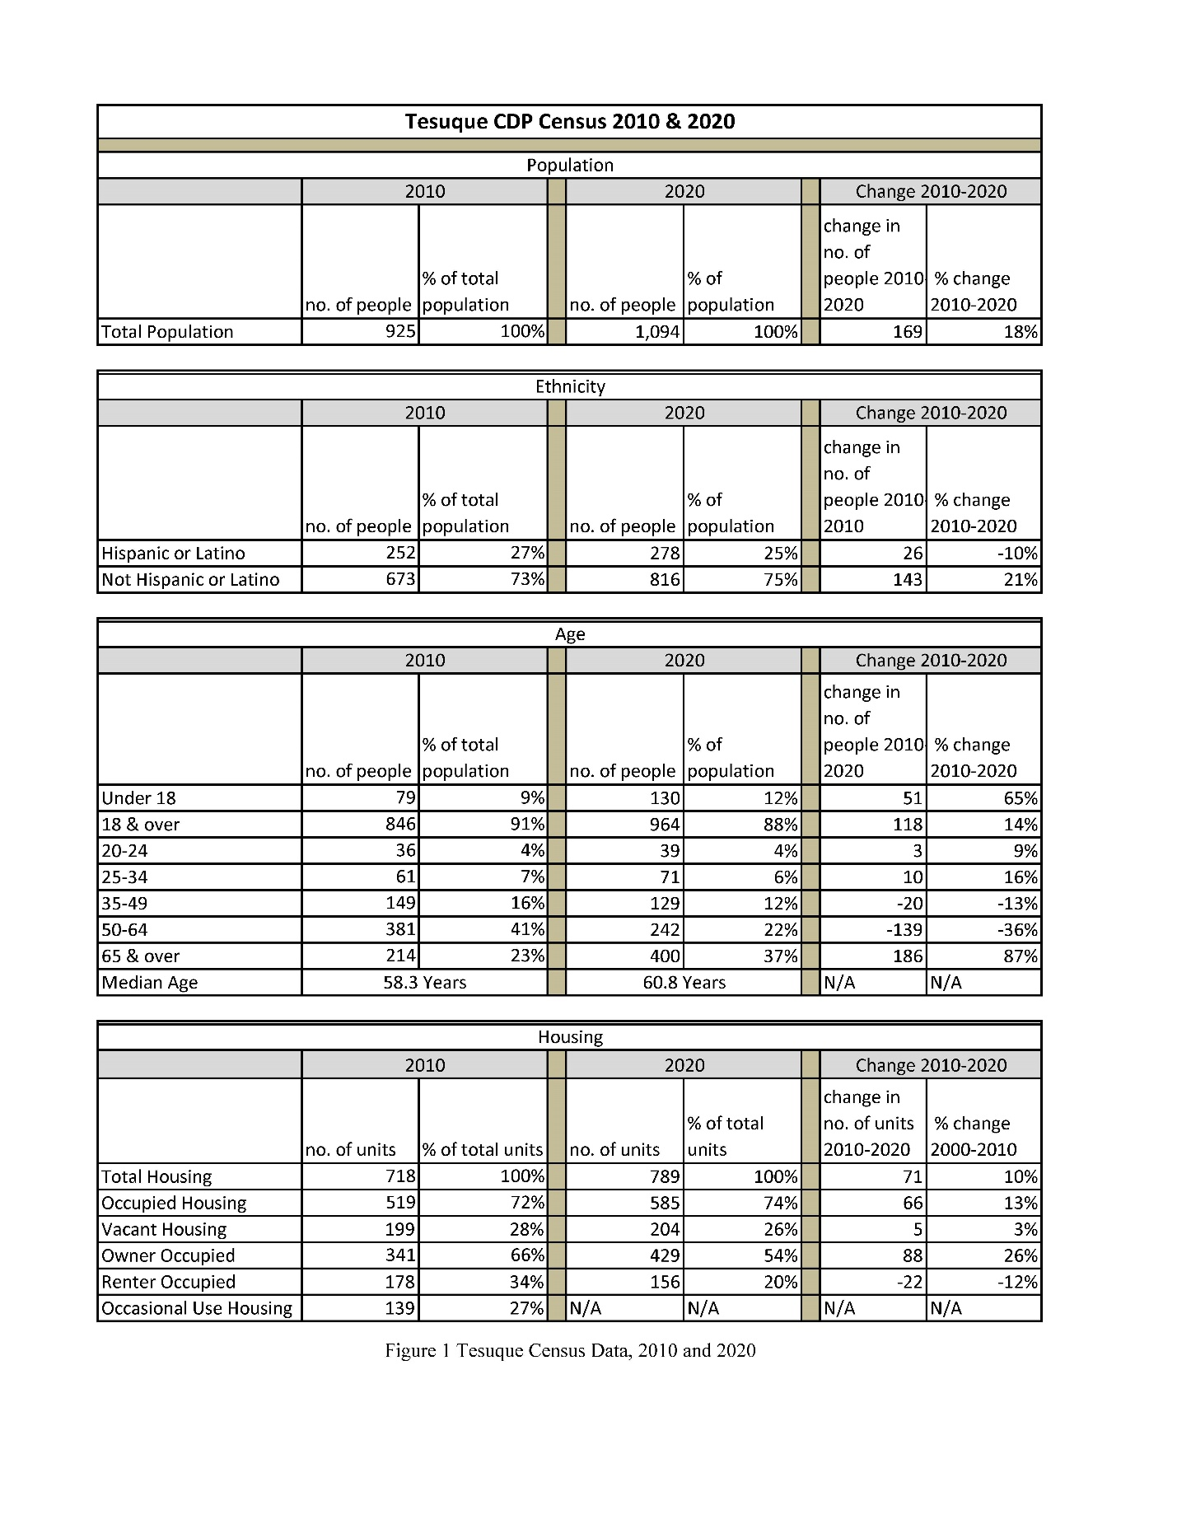

Map below deleted in Draft Plan

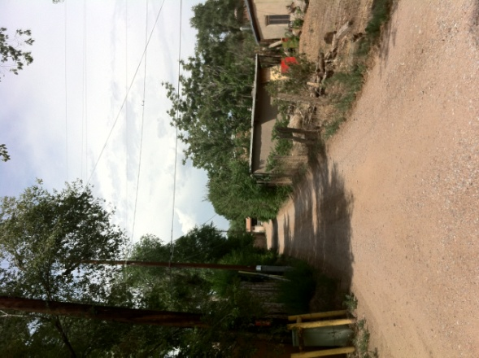
SECTION II: PLAN ELEMENTS

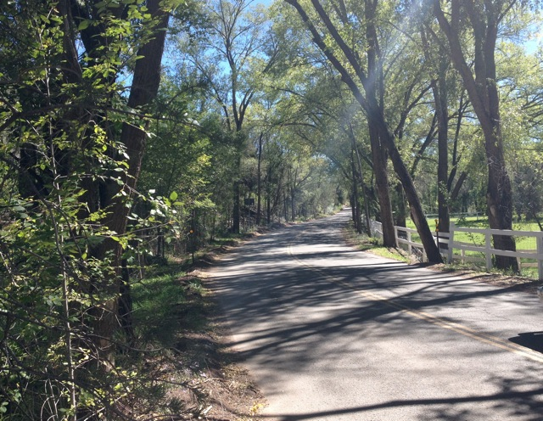

Bishop’s Lodge Corridor and Roads

Bishops Lodge Road and Tesuque Village Road

Centuries ago, Bishops Lodge Road was a segment of an old Native American trail network which connected the place now known as Santa Fe with Pueblos to the north. Once the Spanish began settling in New Mexico, this trail use expanded, connecting to a larger, nationally significant transportation corridor known as the Old Spanish Trail.
The Old Spanish trail was a trade route linking Santa Fe with Los Angeles. From 1829 to 1848, the Old Spanish Trail was the principal overland route in Northern Mexico between the provinces of New Mexico and Alta California.
In 2002, Congress and the President enacted legislation creating the Old Spanish National Historic Trail. Historically, there were two main trails leading north from Santa Fe through Tesuque Village: a seasonal high road (roughly aligning with the Old Taos Highway) and a seasonal low road (roughly aligning with the Bishops Lodge Road). Bishops Lodge Road was given Old Spanish National Historic Trail signage as the road closely parallels the historical alignment. From Bishops Lodge Road in Tesuque Village, the trail continued on to Tesuque Pueblo, Pojoaque Pueblo and then branched at Santa Cruz Plaza either northwest to Abiquiu or northeast to Taos. From there, the various overland routes of the trail continued and rejoined again in southwest Utah on the way to Mission San Gabriel and the Pueblo of Los Angeles.
Bishops Lodge Road and Tesuque Village Road, north from the Rural Commercial District along the valley of the Tesuque River, provide a unique corridor through the community that connects us to our history and to each other. Fencing in this area has historically been short, open fencing for farming and grazing management, which created the sense of a small rural agricultural community. Preserving this corridor, as well as our network of traditional narrow roads supports our rural lifestyle and the historic character of the valley.
As with many roads that weave through traditional communities in northern New Mexico, Bishops Lodge Road has all the characteristics of a winding, historic country road that could be found in many traditional communities and older villages here or even in Europe. Tesuque residents are committed to maintaining this aesthetic, complete with its over-arching tree canopy, narrow and curving road surface, and lack of paved shoulders.
Residents and visitors cherish the winding, historic entrance to the Village of Tesuque. Bishops Lodge Road and the northern section of Tesuque Village Road form the spine of Tesuque and connect the long narrow valley that follows the contours of the Tesuque River. Portions of these roads have been designated as sections of the historic Old Spanish Trail. Low speeds are appropriate and necessary given the number of curves in the road and limited sight distance in many areas.
Equestrians, pedestrians, vehicles, and cyclists use these roads to enjoy the view and connect with neighbors, the post office, the market, the elementary school, the forest and the City of Santa Fe. Wildlife travel along the waterway of the Rio Tesuque and cross the roads in many places. Rights-of-way for acequias and the natural channels of streams, creeks and arroyos that adjoin or cross the road must also be maintained and respected.
Road user safety due to high traffic volume and excessive speed is a major concern, particularly along Bishops Lodge Road and Tesuque Village Road. The road safety need for all users of these roads requires low impact intervention in specific places while preserving the rural character. Limited sight distance and safety concerns as well as the desire to maintain a visual connection to the area to include the pastures, orchards and natural features of the landscape justify establishing standards for fences and walls in these areas subject to identified boundaries and exclusions. The standards defined for fences and walls should recognize the distinct environments that are distinguished by land uses, topography, and historic development patterns and also recognize situations where very limited setback areas is available for walls and fences. The values that should be preserved in creating these design standards include road user safety, historic character, privacy and security concerns of property owners, and visual experience for visitors and residents coming into and traveling through Tesuque.
Fence and wall regulations outlined in the Tesuque Community District Overlay should be amended to include the following:
- Appropriate setbacks for fences and walls in the area along Tesuque Village Road north of the Rural Commercial Overlay A should be established.
- Opaque fences and walls fronting or running parallel to Tesuque Village Road north of the Rural Commercial and Griego Hill Districts should conform with maximum height limitations.
- Fences and walls along Bishops Lodge Road should be governed in a graduated manner, with fences and walls closer to the road maintaining a lower height and those set back further from the road permitted greater maximum height to maintain the visual openness that currently exists.
Fencing and walls adjacent to these roadways should be constructed of materials that will complement the surrounding scenic resources and, where feasible, be combined with landscaping.

Cars, Bicycles, People and Wildlife

Establish historic marker for Tesuque Historic Village

Other communities in Santa Fe County have built historic markers to designate their villages. The public and residents may appreciate small signs or construction built to mark the entry of an historic village.

Action- work with appropriate entities to secure funding for design, fabrication and installation of a set of historic markers for Tesuque.

Increase safety for all users while preserving the rural character of the Bishop’s Lodge Corridor with low impact focused intervention in specific locations.

Bishop’s Lodge Road and Tesuque Village Road are single purpose roads designed to serve motor vehicles. There has been an increase in pedestrians, equestrians, wildlife and particularly cyclists on the roads. They have become an expected part of the speed control and mood change for motorists. However, certain sections remain dangerous for all users. This is due to a combination of traffic exceeding the posted speeds, driveways with limited visibility, narrow road widths, unmarked and unmitigated wildlife corridors, poor road conditions and in some places steep and curvy road configuration.

Implementation Strategies

Transition Zones – Slowing Traffic Down
There is a need to slow down traffic entering Tesuque from the north and west on Tesuque Village Road and from the south on Bishop’s Lodge Road and make drivers aware that they are entering into a traditional village area with slower speeds, narrow rural roads and the occasional walker, cyclist and horseback rider. Additionally there is a need to slow traffic on approach from the north to the Tesuque Elementary School.
- Analyze and implement appropriate traffic calming measures, for example additional signage, striping, edge treatments, at-grade reflectors and sharrows for transition zones between the higher speed areas, 50 MPH - 35MPH, associated with traffic coming into the valley on Bishop’s Lodge Road and Tesuque Valley Road and the slower speed areas, 25 MPH, associated with the traditional historic community.
- Identify and implement appropriate traffic calming measures, such as a three-way stop or lowering the speed limit to increase safety for pedestrians and cyclists at the intersection of Bishop’s Lodge Road and Big Tesuque Canyon (CR 72A).

Bike Routes and On-Road Bike Lanes
Several options should be considered to alleviate the fear and potential danger resulting from car and cyclist sharing dangerous sections of the road.
- Connect cyclists to the City of Santa Fe and surrounding areas through a formalized bike route to follow Tesuque Village Road to US 285 west frontage to connect with Tano Road and Camino Encantado, both of which are designated bike routes.
- Develop plan for implementation in County CIP and Transporation Plan to be establish an on-road bike lane on Tesuque Village Road by “retrofit through widening” on the northern section. Keep speed limits low on Bishop’s Lodge Road to accommodate an in-traffic bicycle route from its intersection with Tesuque Village Road to the intersection with the south entrance of Bishop’s Lodge Resort.
- Support an on-road bike lane for a limited section of road on Bishop’s Lodge Road to provide the ability for southbound vehicles to pass cyclists biking up the steep climb from approximately the entrance of Bishop’s Lodge Resort to the top of the hill.
Develop plan for implementation in County CIP and Transporation Plan to “retrofit through striping” on the southern section.
Pedestrian Circulation in the Village Core
The village core is centered at the intersection of Bishop’s Lodge Road and Tesuque Village Road and includes small-scaled commercial and community development. The lack of safe pedestrian connections limits community members from walking to, from and in-between the post office, the school and the village market. Currently most people walk along the very narrow shoulders of the road way and find portions of the walk particularly difficult due to the guard rails. Within the village core area, the existing road right-of-way associated with Tesuque Village Road varies from approximately 130’ at its widest to approximately 65’ at its narrowest. The right-of-way associated with Bishop’s Lodge Road varies between approximately 25 feet and 40 feet. With appropriate design both rights-of -ways may accommodate safe pedestrian paths.

There is a need to improve signage and parking controls, particularly on the short section of Griego Road where it intersects with Tesuque Village Road that serves this area as a major thorough fare, yet also serves essentially as a parking lot of the Tesuque Village Market. Parking should be designed to control pedestrian circulation and vehicle intrusion into a road that is critical for fire access, school bus travel, and residential travel to and from Santa Fe. To this important safety end, fire lanes and cross walks should be identified in this important village core.

- Develop a pedestrian circulation plan that establishes safe pedestrian connections and crossings between the elementary school, the Village Market, the RTD Blue Route Transit stops and the post office and which includes appropriate traffic calming measures.
- Analyze and implement traffic calming measures to slow down traffic as it approaches the Tesuque Elementary school from the south on Bishop’s Lodge Road.

Equestrian Uses
Tesuque roads and shoulders are occasionally used by people on horseback primarily on their way to access local and Santa Fe National Forest trails. There is a need to identify specific routes that are aligned with roads and address safety concerns associated with the mix of roadway users and equestrians.

Wildlife Crossings and Corridors
There are several areas in the Bishop’s Lodge Corridor where wildlife crossings often result in conflict with auto traffic. Some of these locations are well-known by the community and are shown on the Bishop’s Lodge Corrdor map.

Minimize conflict between traffic and wildlife.
- Coordinate with wildlife conservation organizations, state and federal agencies to determine high frequency wildlife crossing areas within the plan area and adopt Best Management Practices plan for wildlife control and crossing.
- Road drainage design and improvements should consider conjunctive use by wildlife.

Dangerous Curves
Specific sections of Bishop’s Lodge Road are dangerous due to sharp curves and cars driving faster than the posted speed, including the area just north of the Bishop’s Lodge Property at the “S” curve and the curve at the intersection of Big Tesuque Canyon.
- Analyze a variety of approaches to increase safety.

Bishop’s Lodge Corridor and Implementation of the Aamodt Settlement

Protect the intrinsic qualities of the Bishop’s Lodge Corridor from impacts of the project.

There is concern that when the Aamodt Settlement is implemented in the planning area, the historic rural character of the Bishop’s Lodge Corridor (northern Tesuque Village Road and Bishops Lodge Road) will be degraded or completely lost, that the road will be widened and that the trees, acequias and natural features along the way will be destroyed.

Drainage and Erosion

Difficult terrain, road design and lack of preventative maintenance on both county and privately maintained roads has caused or contributed to soil erosion, impaired road surface and degradation of adjacent properties, stream beds and acequias.

Reduce drainage and erosion problems along Bishop’s Lodge Road, Griego Hill Road and resulting degradation of adjacent properties while maintaining the rural character of the existing road profile.

Implementation Strategies
- Recommend development of a comprehensive storm water management plan for the village core area
- Recommend Low Impact Development (LID) best practices and preventative maintenance practices on all future county road improvement and maintenance projects in the plan area.
      - Support bar ditches in lieu of curb and gutter.

Dangerous Driveways

Existing non-conforming and dangerous driveways continue to pose a danger to vehicles, cyclists, pedestrians and equestrians.

Implementation Strategies
      - Recommend all future county road improvement and maintenance projects to inventory all driveways within the project area and include improvements to mitigate existing non-conforming or dangerous driveways.

Dark Night Sky Lighting Standards In accordance with Nigh Sky Protection Act

Preserve the true natural night sky that our ancestors enjoyed.

As a rural road, road lighting in the corridor is minimal and should remain that way.
New road lighting should only be considered at key intersections and should be limited to lighting created for the purpose of enhancing pedestrian and traffic safety during evening hours.

Implementation Strategies
- All new road improvement or maintenance projects (private and public) in the plan area should be designed in accordance with the SLDC in order to protect the dark night skies.

- Rural roadway lighting standards shouldconserve energy and protect the night sky.
        - LEDs should be preferred or recommended over other lamp types.
        - All lighting should be shielded

Regional Transit Stop

Accommodate aging-in-place goals by supporting transit options for community members.

The North Central Regional Transit District (NCRTD) provides bus services to and from many small communities in the region. NCRTD established two transit stops within the plan area: One close to the Tesuque Village Market and another just south of the post office within county right-of –way. Both transit stops should be improved to provide for well-marked stops with shade and seating and be included as important destinations in the pedestrian circulation plan.

Overhead Utilities

Enhance the character of the Bishop’s Lodge Corridor and reduce the risk of accidents, fire and the danger of downed electric wires by converting overhead lines to underground.

Utility distribution lines mounted on utility poles following road alignments in the Bishop’s Lodge Corridor detract from the scenic quality and pose fire risks to the community. There may be opportunities to convert overhead utilities in the Bishopto underground utilities as part of the Aamodt Settlement implementation or future road and utility improvement and maintenance projects.

Updated map in new plan doc to replace one below

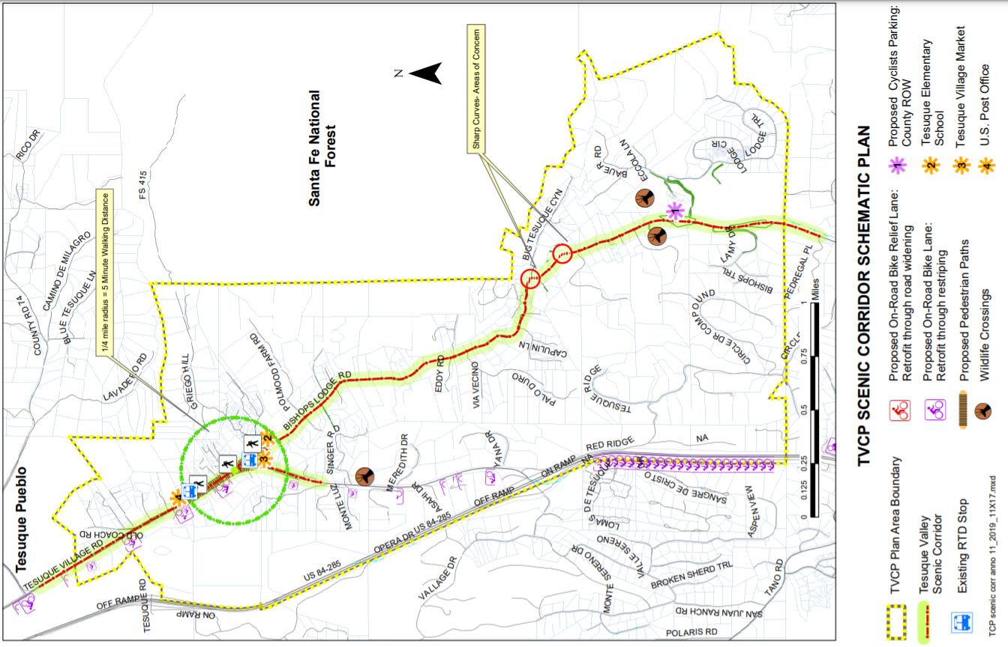
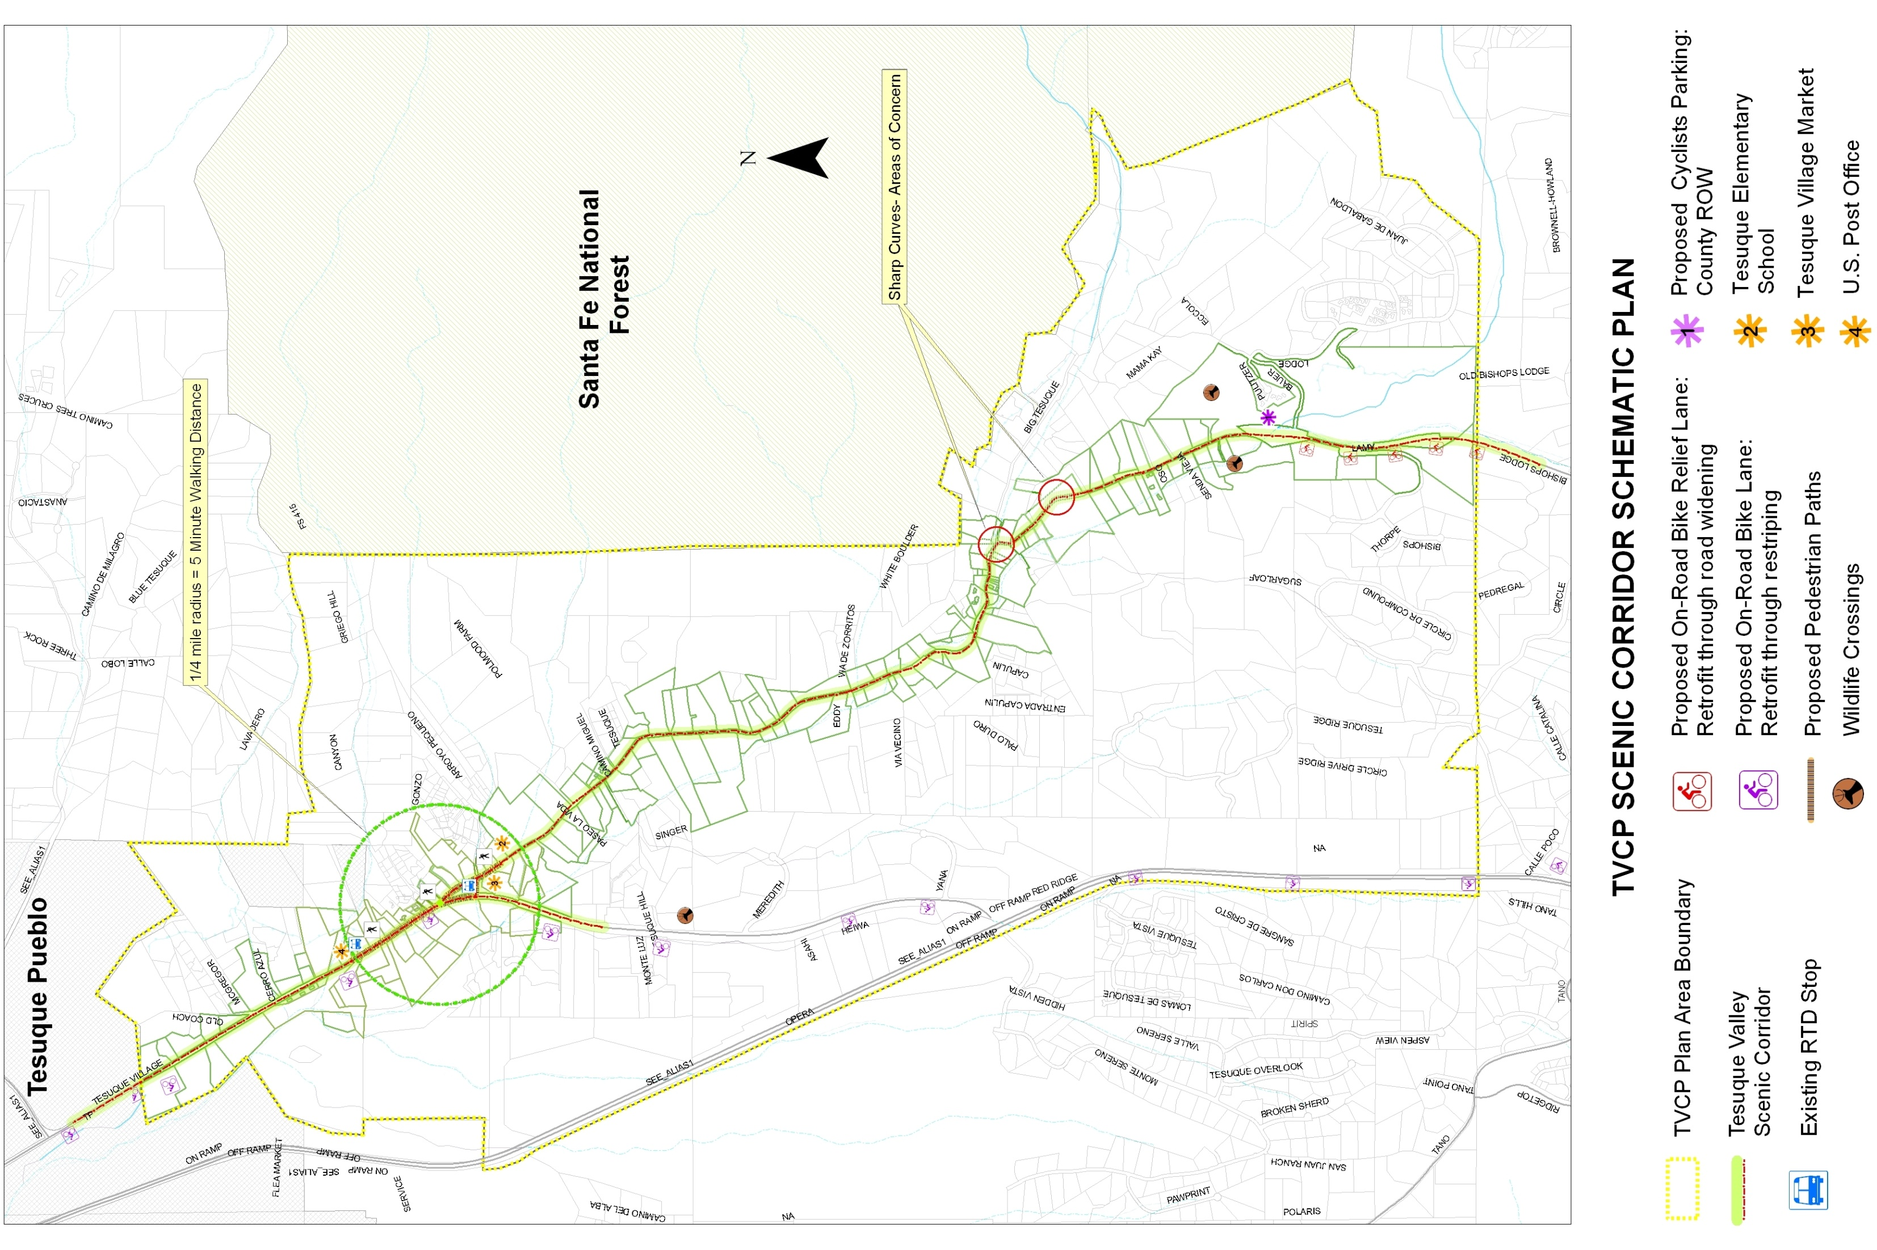
Figure 3 Scenic Corridor Schematic Plan

Map below replaced with most current map in updated plan Section 3
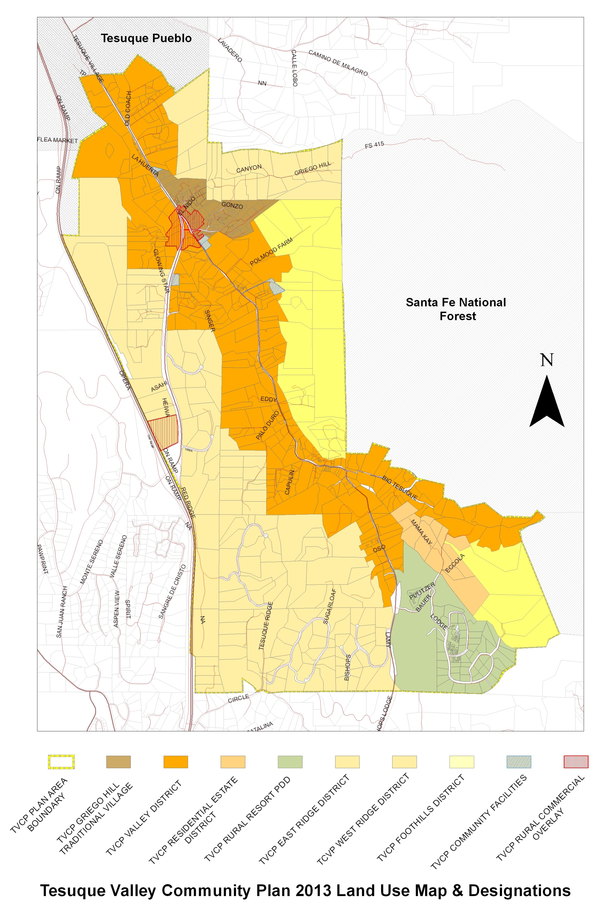
Figure 4 Future Land Use Map & Designations

zoning districts.
This plan supports home occupations that provide economic opportunities for residents that are appropriate for residential and agricultural areas.

To support aging in place, multi-generational family living arrangements and traditional development patterns, secondary dwelling units should be allowed at appropriate scale to maintain community character and to protect the environment.

Private Roads and Driveways

Due to the steep slopes and soil types in the plan area road design and construction must be carefully reviewed and monitored. In general new developments should design narrow roads and driveways that follow the natural terrain without creating large cut and fill areas; roads should be designed with more natural edges, using shoulders, ditches and grassy swales rather than curb and gutter.

Floodplain
The existence of complex floodplain conditions in the TCD planning area has led to community concerns regarding federal and local regulations. This plan envisions a cooperative approach to examining how floodplain regulations may be reviewed to ensure public safety as well as accurate depictions of developable areas.

Fire threats and santa fe fire code
In addition to the SGMP and the SLDC the community is subject to the provisions of the County’s Urban Wildland Interface code (as amended), and many regions are considered subject to ‘high-hazard” requirements governing the placement of structures, building materials, and fire hazard mitigation requirements. Thus, fire safety considerations must be factored into the Community Plan.

The Urban Wildland Interface (fire) Code ordinance was originally passed on 2001 and was recently updated. SF County Ordinance references are No. 2001-04, 2001-11, and, most recently 2018-08, which adopted the 2015 version of the International Wildland-Urban Interface Code.

Lot Coverage
Lot coverages for residential uses in the plan area vary quite a bit. In general the smaller the lots size the higher the lot coverage. To support the traditional development pattern, rural character and a healthy watershed, regulations for lot coverage should vary with lot size and pertain to permeable surfaces.

Natural Landscaping
This plan envisions the use of native and drought friendly vegetation and natural landscaping to the extent practicable. Native vegetation should be preserved on development sites and locally adapted (though not invasive) plants used for landscape buffers and screening, as appropriate.

Enforcement
This plan recommends a proactive approach to address code enforcement issues.

Strategy: Community members will continue to schedule meetings with Santa Fe County staff to proactively address code enforcement concerns and proactive engagement on these issues.

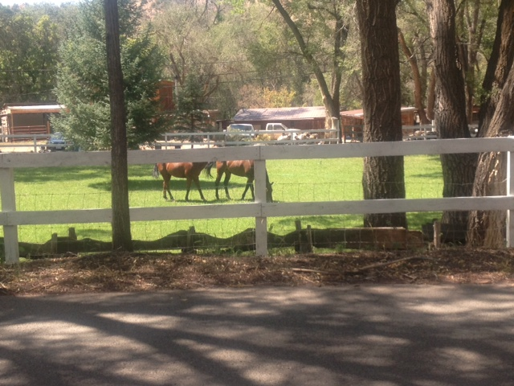

Agriculture, Acequias & Riparian Areas
The farms, orchards, gardens, lush river bosque, tree lined roads and functioning acequia systems provide connections to Tesuque’s rural roots. Preserving and enhancing this aspect of the plan area continues to be a priority.

Introduction
Tesuque’s history is deeply rooted in the traditions and practices surrounding acequias and agriculture lands as well as the riparian areas associated with the river bosque. They help identify Tesuque, support a variety of plants and animals and evoke the village’s history. Poorly sited development and the overgrowth of invasive species are threats to the health of acequia irrigated lands and riparian areas.

Programs and incentives are needed to preserve the acequias, restore the riparian areas and encourage the assembly of contiguous land for agriculture and open space.

Within the Tesuque District, there are a total of 848 parcels in the Tesuque Community Planning District, totaling 2,823 acres. Of these, there are 9 parcels totaling 78.68 acres with agricultural tax classifications.

Conservation Area Continuity:
Conservation areas and other easements are appropriate for the preservation of agricultural land, protection of river, arroyos or trail corridors and should interconnect to adjacent sites of a similar nature, as practicable.

The plan recommends a three-pronged approach to enhancing opportunities for agriculture production and riparian restoration:

An education-based approach:

Strategy: The Tesuque Valley Community Association will form a Stewardship Committee to educate and work with property owners on establishing conservation and/or agricultural easements on their property.

An interagency and community collaborative approach:

Strategy: Stewardship Committee will work with property owners to implement federal, state, local and tribal initiatives that are actively working to remove or control select invasive species such as elms and tamarisk and regenerate the vegetation native to the bosque and acequia irrigated lands.

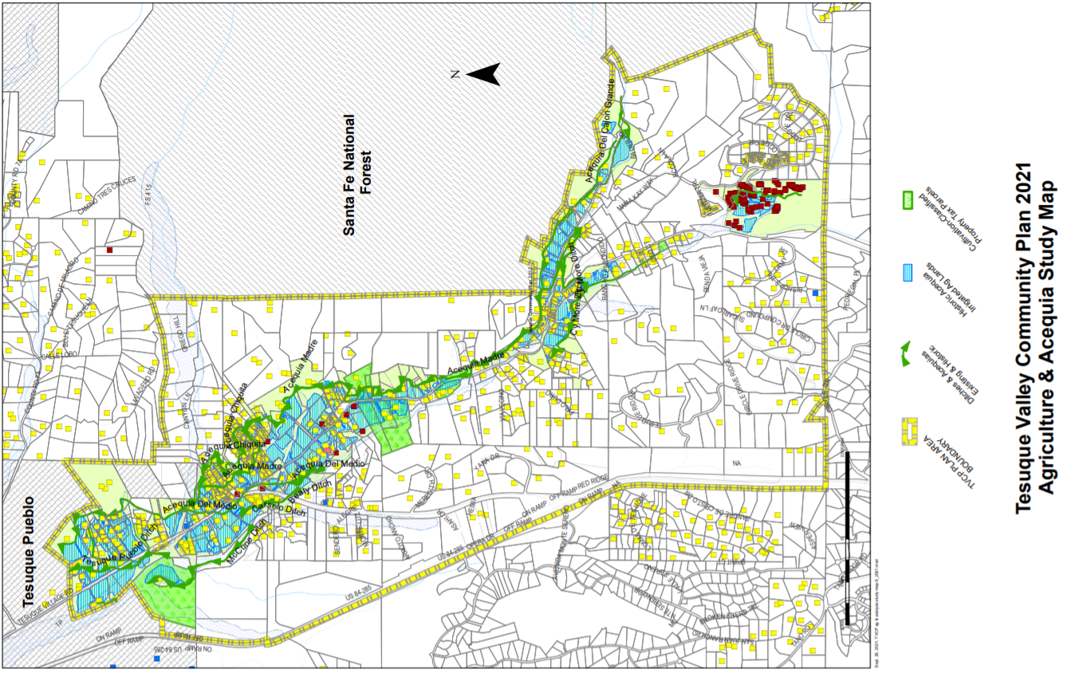
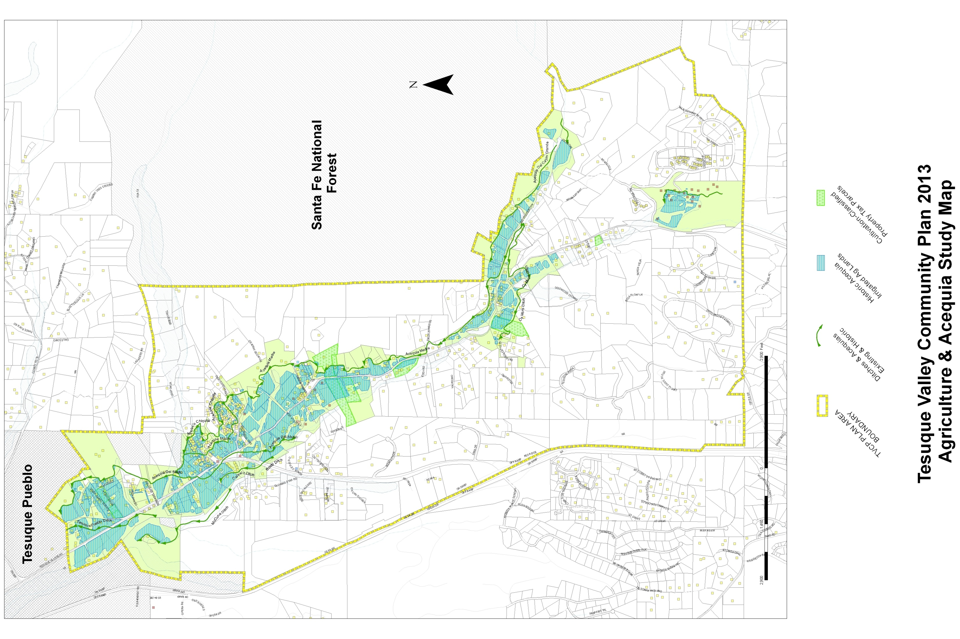
Figure 5 Agriculture & Acequia Study Map

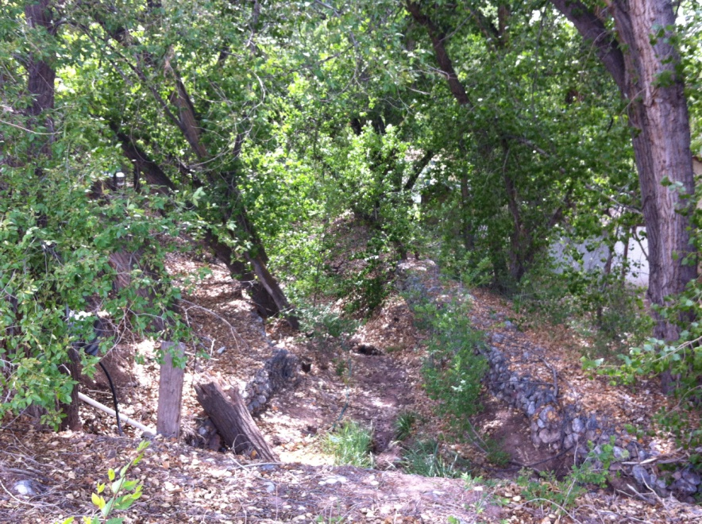

Social Trails

For generations, walking & horseback riding are ways we connect with our natural surroundings and neighbors. The historic network of community trails and paths is a part of our rural lifestyle that needs protection.

Introduction
In addition to roads and public trails, the village of Tesuque is connected by historic social trails. Such trails were established over time through historic use. They have significant community value. They facilitate land management, provide access to natural resources, support recreation, reflect village tradition, and connect neighbors to one another. Although Tesuque’s social trails have long since been established by historic use, these trails are generally not documented or officially recorded. There are concerns that as property ownership changes in Tesuque, access to social trails may be inadvertently and irretrievably lost.To preserve social trails and the values associated with them, the community plan outlines strategies that inform property owners and County development review staff of the location of these historic social as an initial step to protect those trails.

Goal: Preserve Tesuque’s historic social trails.

Strategy: The Tesuque Valley Community Association will work with property owners to record easements for the social trails with the County Clerk so that easements, points of access, and allowable uses are on record for title searches and are disclosed to new property owners.

Forest Road 415

Goal: Connect Tesuque to Santa Fe National Forest via Forest Road 415

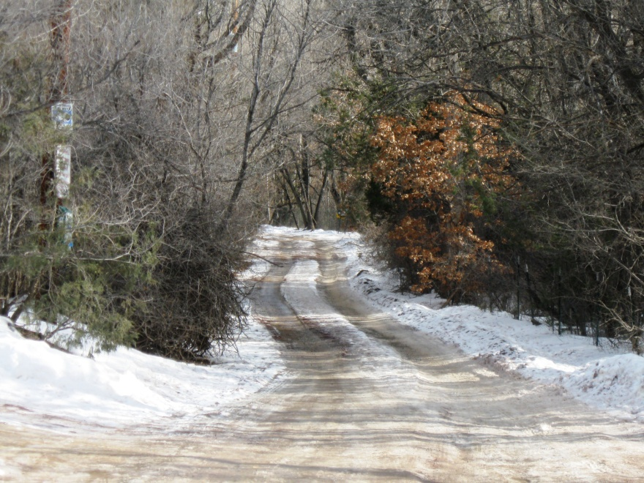

Public Access to Forest Land & Trails
Manage visitor use impacts associated with public trailheads.

Public lands and trails within and surrounding Tesuque Valley are valued by the community and broader region. These amenities also generate visitor use impacts that should be managed more appropriately than they are at present. The Santa Fe National Forest lands adjacent to the planning area include a vast system of trails through the Sangre de Cristo Mountains. These lands have high scenic, recreation, and habitat value. Tesuque Creek Trail, the Chamisa Trail, and Winsor Trails cross the Santa Fe National Forest and may all be accessed from trailheads in the plan area including trails associated with Bishop’s Lodge Resort and Spa.

As significant recreation amenities for the entire region, these trails attract more visitors than there are safe and convenient parking spaces to accommodate them. Parking on the sides of the road may impede traffic and emergency vehicle access. To enhance access to public land adjacent to the planning area, the community plan outlines strategies to develop additional parking facilities and to identify locations of “overflow parking”.

Strategy: The Tesuque Valley Community Association will work with Bishop’s Lodge and Santa Fe County Public Works to explore the possibility of creating parking spaces and trailhead signage on the public right of way north of the entrance to Bishop’s Lodge and/or within the Bishop’s Lodge facility, as appropriate, in order to provide additional parking for cyclists using the Windsor trail and alleviate parking congestion at existing trailheads, (see Forest Trails and Access Study Map page).

Strategy: The Tesuque Valley Community Association will work with Bishop's Lodge to explore the possibility of providing public access to the Windsor Trail using existing resort trails and road network.

Strategy: Currently County Road 72A provides a trailhead with limited parking for the Tesuque Creek Trail and Windsor Trail. The Tesuque Valley Community Association will work with Santa Fe County Public Works to develop signage at the trailhead that alerts hikers of trailheads off of Hyde Parke Road that provide access to the Windsor trail and Tesuque Creek Trail with more plentiful parking, (see Forest Trails and Access Study Map page 57).

Strategy: The Tesuque Valley Community Association will work with Santa Fe County Public Works and the Tesuque Valley Volunteer Fire District to provide signage at the County Road 72A trailhead.

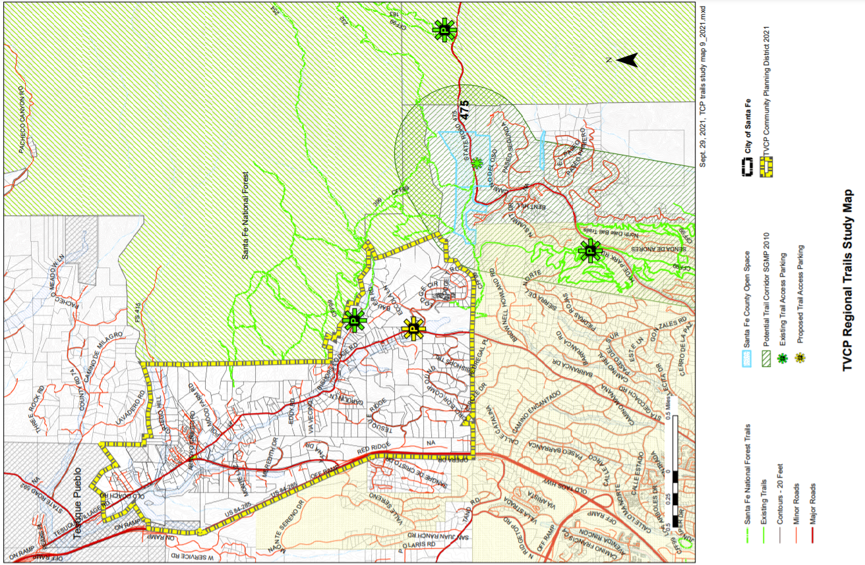
Figure 6 Forest Trails & Access Study Map

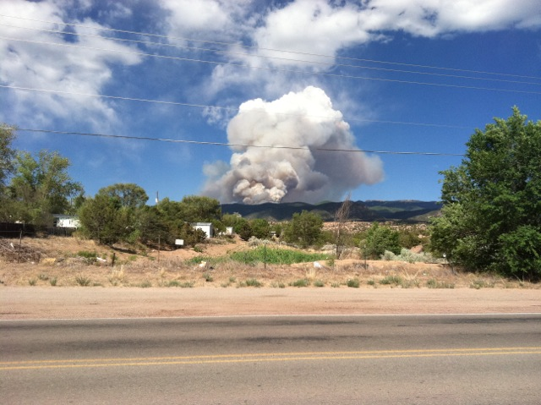

Fire Safety & Prevention

Fire will continue threaten the plan area. Having a proactive approach through prevention as well as being prepared for both are priorities of the community.

Tesuque is highly vulnerable to wildfire. Most of the Tesuque Planning area is located in the County’s Urban Wildlife Interface Area—a geography that encompasses areas of the County that are at the highest risk of experiencing wildfire.

Wildfire risk increases during drought conditions and may intensify as drought continues. The 2011 wildfire season was particularly horrendous. It included the human caused Las Conchas Fire in the Jemez Mountains which burned over 245 square miles and closer to home, the Pacheco Fire which came within 5 miles of the plan area and burned over 16 square miles. In 2013 wildfire season, the ongoing Joroso Fire, 12 miles northwest of the plan area, has burned over 11,000 acres of the Santa Fe National Forest. In 2020, the Rio en Medio Fire, just northeast of the Tesuque Community District, burned over 4,000 acres.

Increase Response Capacity

Fire protection in the village is provided by the Tesuque Volunteer Fire District which consists of three volunteer fire stations located in Tesuque Village, Tesuque Pueblo, and Chupadero. The Volunteer Fire District serves Tesuque Village, Tesuque Pueblo, Chupadero, Rio El Medio, Tano, Casa De San Juan, Sundance Estates, Vista Redondo, Los Camonitos, and Hyde Park Estates. Participants in the community planning process have expressed concern that water supply to support fire protection in Tesuque Village may not be sufficient. At present, the Tesuque Village fire station draws water from a 20,000 gallon tank associated with the Tesuque Mutual Domestic Water Consumer Association, a 90,000 gallon water tank at Bishop’s Lodge, and has access to a 97,000 gallon tank outside of the plan area at Rancho Encantado as well as the ability to draw water from two outdoor swimming pools in the community. In years past, the village fire station has had the ability to draw water from two ponds in Tesuque Pueblo, but this supplemental source is not considered reliable as they are periodicallydry. Of further concern is the possibility that a complete drawdown of the Tesuque mutual domestic well may collapse the system due to its age. The TVCA obtained Firewise certification in 2017 and continues to qualify each year by advancing programs of education and encouraging residents to midigate fire danger on their properties. The TVCA should continue to do this.

Strategy: Purchase and locate supplemental water tanks on suitable sites that support the volunteer fire district’s operational readiness and that minimizes visual/aesthetic impact. Locations that have been discussed with the community and the fire district include: elevated land just west of Tesuque Village Road across from the existing fire station, and a suitable site between Tesuque Elementary School and Bishop’s Lodge Resort.

Mitigate wildfire vulnerability.

Most of Tesuque carries an Urban Wildfire Interface Area classification of 1 indicating that wildfire risk is extreme or very high fire, or a classification of 2 indicating that wildfire risk is high. These classifications require that any new construction, or reconstruction, mitigate wildfire risk by requiring certain structure design standards; road, driveway, and gate standards; and terrain management.

Strategy: The community plan encourages residents to take advantage of the County’s free service to assess household wildfire vulnerability. This service provides information to fire districts regarding how to effectively fight fires that may affect households and educates households as to steps they can take to mitigate their wildfire vulnerability.

Establish provisions for fire access roads that don’t detract from the historic and rural character of the area.

Currently Santa Fe County and the Fire Marshall will allow14’ wide fire access roads to new residential structures. There is a need for adequate access to buildings for fire protection.. In addition, there is a need for fire lane and unrestricted fire access in vicinity of Tesuque Village Market.

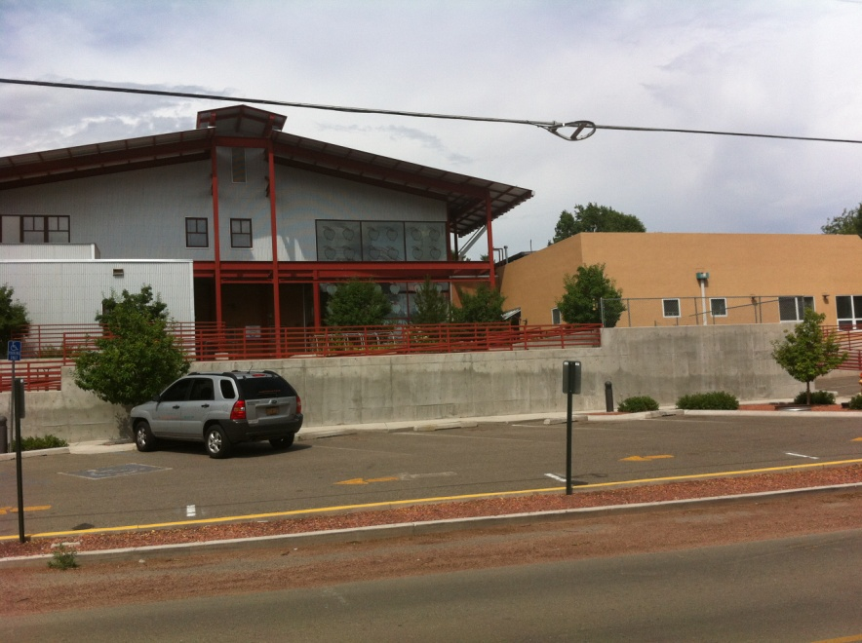

Community Facilities
Increase community cohesion and dedicated community space in Tesuque.

Key Observations:

Tesuque has a public elementary school located on Bishop’s Lodge Road. The school serves under100 students between kindergarten and sixth grade from Tesuque, Chupadero, Rio en Medio, Tesuque Pueblo, Espanola, and the City of Santa Fe.

The elementary school is highly valued and its continued function as a school is a priority in the community.

The Tesuque Fire Station located on Senda del Fuego road is one of three volunteer fire stations that services the communities of Tesuque Village, Chupadero, Rio El Medio, Tano, Casa De San Juan, Sundance Estates, Vista Redondo, Los Caminitos, Hyde Park Estates. While the space is occasionally used for community events, its main purpose is to support emergency response so opportunities for community events are limited.

The Tesuque Village Market, and San Ysidro Church, although not public establishments, function as important community gathering spaces for community members.

The San Ysidro Mission Cemetery and the Tesuque Elementary School playground are important open spaces that provide very different functions and specific community needs.

Tesuque does not have a community center or village park although its population is greater than several other communities with those amenities. The closest community center to Tesuque is the Santa Fe County Rio en Medio Senior and Community Center.

As a way of increasing cohesion in the community and facilitating implementation of this plan, the community has identified a need for a multi-purpose community facility, a small passive village park and a community website.

Policy: Create a community website that has an interactive community announcement page as well as an information kiosk at the post office.

Strategy: The TVCA will develop and maintain a community website.

Policy: Develop a multi-purpose community center.

Strategy: In collaboration with the county, the community will identify developed and undeveloped properties in the Village core area that should be considered as potential sites for conversion as a community center

Strategy: The community in collaboration with the County will conduct a needs assessment and develop a preliminary program to use as a basis for siting and design of a community center.

Strategy: Tesuque will work with State Representatives of House District 46 and Senate District 25 to secure a state appropriation or other means of funding to support the siting and development of a community center.

Policy: Increase community outdoor space in the heart of the village.

Strategy: Tesuque will work with the County to evaluate a variety of sites within the village core area and explore the possibility of establishing and maintaining a small passive village park in conjunction with proposed pedestrian paths.

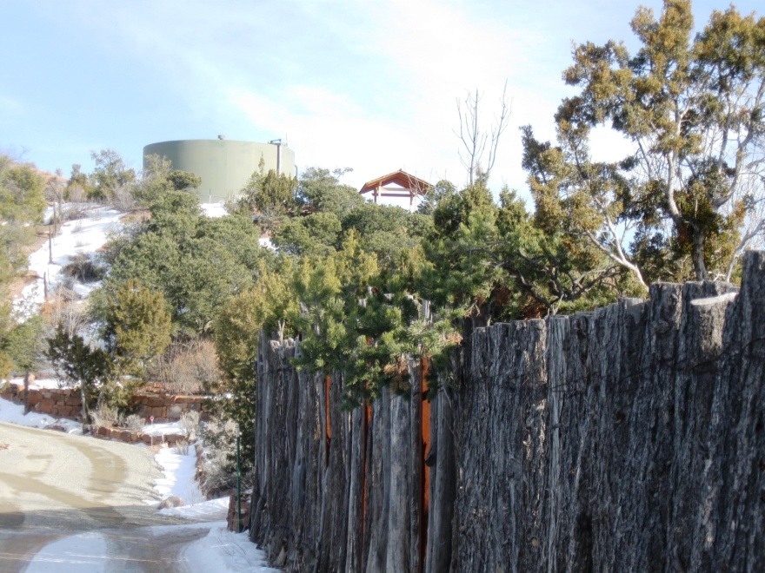

Water Supply and Wastewater Treatment
Tesuque’s quality of life depends on adequate water quality and water quantity.

All residents and businesses in the plan area currently use ground water either drawn from private wells or community wells for their domestic water supply and to certain extent fire suppression. Their direct experience with wells and irrigation flows have led to the general agreement that ground and surface water in the plan area “is not a constant, abundant, unchanging source”.

Aamodt Settlement and Implementation Through Tesuque

Water Supply and Wastewater Treatment-Tesuque’s quality of life depends on adequate water quality and water quantity. All residents and businesses in the plan area currently use ground water either drawn from private wells or community wells for their domestic water supply and to certain extent fire suppression. Their direct experience with wells and irrigation flows have led to the general agreement that ground and surface water in the plan area “is not a constant, abundant, unchanging source”.

The Aamodt Settlement will assist Tesuque residents and businesses in securing a more consistent water supply. As a result of the Aamodt Settlement, the Pojoaque Basin Regional Water System will be built to divert water water from the Rio Grande at San Ildefonso Pueblo and pipe treated drinking via a transmission line through the Pojoaque valley and down to Tesuque via Tesuque Village Road and Bishops Lodge Road. County residents and businesses in the Aamodt settlement area can opt into the system, ideally before the transmission and distribution lines are built, by formally making a well election through the U.S District Court.
Phase II of the Pojoaque Basin Regional Water System which goes through Tesuque is currently at 60% design. The Bureau of Reclamation is responsible for the design and construction of the system, but there will be another opportunity for Santa Fe County to give input at the 90% design phase,
The Bureau of Reclamation has identified 2026 as the goal to reaching 100% design. Substantial Completion will occur by 2028, at which point the transmission lines through Tesuque should be complete. The County will likely continue building the distribution lines out beyond 2028.

Well Election- A communication was sent out to all County properties within 200 ft of the planned water line in 2018, gauging interest in connecting and accessing a fund to cover connection costs. This was not a legally binding response. Property owners will need to formally file an acceptance of the settlement agreement and notice of domestic well election with the U.S District Court in order to retain their well and benefit from the protections of the Settlement or access the Connection Fund if connecting to the Regional Water System. Questions regarding the process may be directed to the Santa Fe County Utilities Aamodt Project Manager.

It is important to note that residents have expressed concern that the implementation of the Aamodt settlement has the potential to significantly alter the community. This plan addresses concerns that the proposed alignment of the pipes which are congruent with the Bishop’s Lodge Corridor may cause the roads to be widened and detract from the scenic quality and unique character. This plan does not address the terms of the settlement parties’ water entitlement and use which were established under state and Federal law through the Settlement Agreement.

Key Facts:
Domestic Wells- According to the 2021 well data from the Office of the State Engineer, and there are 566 wells in the Tesuque Planning Area – up from 517 in the year 2018.

Maintaining water quality in domestic wells should be a high priority. The CDC recommends separating wells from livestock locations by at least 100 feet. The County should increase its oversight to ensure that all standards governing separation of septic, livestock, and other sources of contamination are well-regulated and controlled

Community Water - The Tesuque Mutual Domestic Water Consumers Association provides water services to 107 service connections or a population of about 370. Bishop’s Lodge currently has their own water system but they will be required to connect with the Regional Water System when it becomes available.
Shidoni has their own water system.

Wastewater Infrastructure- Most households in Tesuque rely on individual septic tanks to manage their wastewater. Tesuque’s unique geographic characteristics, including soil depth to bedrock, percolation rate, depth to shallowest water table, slope, and flooding potential mean that many households in Tesuque are required to treat wastewater to higher standards than are achieved with a conventional septic systems and must purchase more expensive septic tank systems. Bishop’s Lodge, Sol y Sombra Trailer Park, Riverside Mobile Home Park, and Tesuque Elementary school each have small wastewater facilities to serve their populations.

Goal: Develop more centralized approaches to managing wastewater.

Strategy: Santa Fe County and the Tesuque Valley Community Association will explore the feasibility of developing central community waste water facility for the Village Core area and Griego Hill to include the Tesuque Elementary School, commercial uses, the mobile home parks and homes, (See Water & Wastewater Study Map).

Goal: Increase County oversight of liquid waste disposal systems, including septic tanks to reduce ground water and surface water pollution due to failing systems.

Policy: County should determine the efficacy of liquid waste disposal systems by requiring inspection and implementation of improvements as needed as part of development permit application for new development, change in use or increase in the intensity of activity.

Policy: County should determine the efficacy of liquid waste disposal systems by requiring inspection and implementation of improvements as needed as part of business license and/or home occupation permit application.

Goal: Increase awareness of Tesuque water quality and means of enhancing water quality.

Strategy: The Tesuque Valley Community Association will reach out to a technical assistance organization such as Amigos Bravos to explore ways for Tesuque residents to monitor the presence of contaminants that aren’t already regulated by the New Mexico Environment Department and if appropriate, develop a strategy to address water contaminants.

Strategy: The Tesuque Valley Community Association will form a subcommittee to develop educational materials documenting how individual households can minimize their impact on water resources.

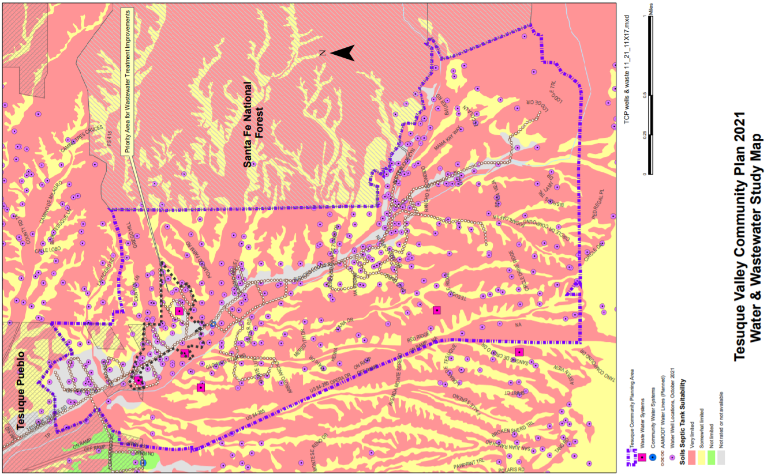
Update: Figure 7 Water & Wastewater Study Map

SECTION III: LAND USE PLAN
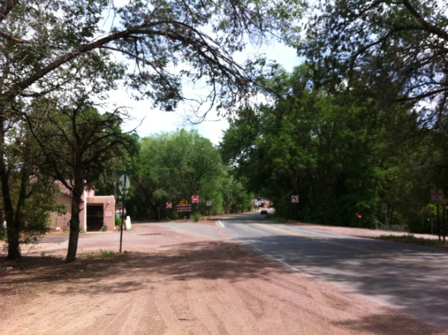

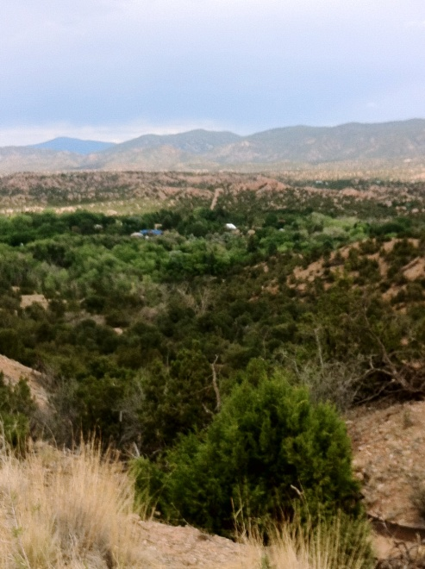
Land Uses, Densities & Development Patterns
Land Use in Tesuque is based on the acequia systems, small farms, rural roads, the natural terrain, small scale buildings and self-sufficiency. New development and land uses should reflect the existing unique character of Tesuque and support aging in place, rural lifestyles and the ability to enjoy the quiet tranquility of this place.

Introduction

This section identifies issues, objectives and strategies pertaining to land uses, densities, development patterns, home occupations and code enforcement.

It provides land use designations and map, and corresponding general provisions to address the following issues:

      - Community has identified concerns regarding enforcement of nuisance issues which are being addressed through regular coordination with County staff. There is an opportunity to support traditional family living arrangements, aging in place and mixed income objectives without additional land divisions by allowing “secondary dwelling units” that are appropriately located, sized and provided with high performing septic /wastewater treatment.
      - There is an opportunity to encourage and incentivize the preservation and assembly of agricultural and open space lands.

Land Use Plan and Map
The land use designations identified through the Sustainable Growth Management Plan and the 2021 Tesuque Community Plan are identified on the land use map and provide a general framework and guidance for future land use decisions.
The map delineates areas based on topography, compatible land uses, and appropriate locations for commercial and mixed-use development. General uses, densities, and development standards are described..

The planning area consists of primarily single family residential uses on rural lots ranging from less than a 1/2 acre to 40 acres. Most residences rely on septic systems and use domestic wells or community wells drawing on ground water. Residential development on the valley floor and on Griego Hill have remained consistent with the historic acequia development pattern that accommodates houses while preserving land for small scale farming and gardening sited for irrigation by the acequias. Lots associated with the western foothills reflect contemporary subdivisions patterns and range in size from 2.5 acres to 12.5 acres. The eastern foothills, adjacent to the Santa Fe National Forest, host several large lot estates and horse properties. There are also a limited number of condominiums scattered throughout the planning area and two trailer parks located off of Tesuque Village Road which house 20 - 24 units.

Commercial development is limited to Bishop’s Lodge Resort and Spa in the southern portion of the plan area and a few small establishments located at or near the intersection of Bishops Lodge Road and Tesuque Valley Road:
- Green Galleries- gallery which includes an outdoor sculpture collection and art consultant service.
- Tesuque Village Market- Includes a full-service restaurant and small grocery store.
- El Nido Restaurant

There are numerous businesses and home occupations throughout the plan area. The following commercial businesses are notable:
- Shidoni Gallery- Gallery which includes an outdoor sculpture collection.
- Tesuque Glassworks- Gallery and studio with an apprentice program for emerging glass artists and daily glass blowing demonstrations.
- Santa Fe Mountain Center- Administers a program to provide experiential learning opportunities for at risk and marginalized youth, a harm reduction, needle exchange program, STD and HIV prevention programs, and training and youth organizing for native communities.

Community facilities and services include the Tesuque Volunteer Fire Department, the U.S. Post Office, Tesuque Elementary School, San Ysidro Church and Cemetery, and the various acequia associations.

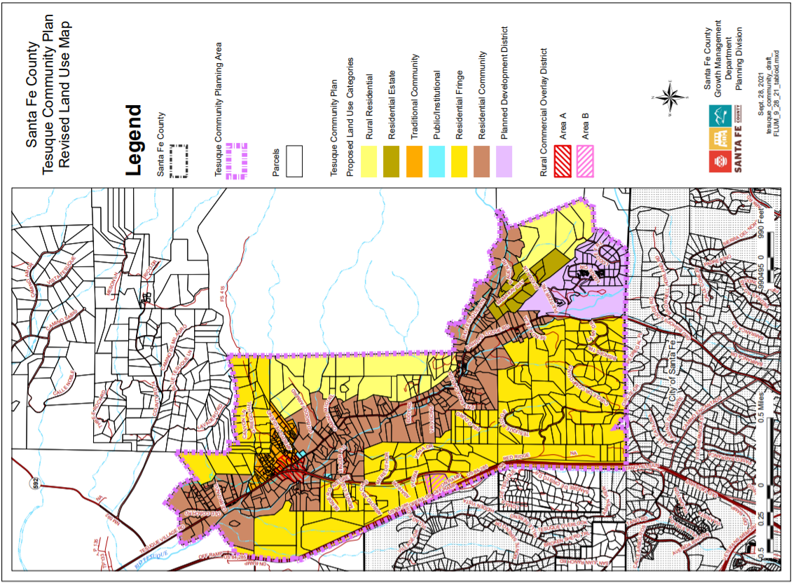

Land Use Categories
The Tesuque District Land Use Categories were developed through the 2015 SLDC process in accordance with the Sustainable Growth Management Plan (SGMP) Use Categories. The Tesuque District Land Use Plan includes six Land Use Categories: Rural Residential, Residential Fringe, Residential Estate, Residential Community Traditional Community, and Public/Institutional.

TVCP Griego Hill Traditional Village District
TCD Traditional Community District

Traditional Community. The purpose of the TCD TC district is to continue to reflect the unique historic development patterns of the old village with a mixed pattern of lot sizes and shapes and housing types. This district is primarily single-family residential district consistent with historic options for compact residential development including clustered housing, family compounds, and secondary dwelling units. Community facilities, institutional uses, agricultural uses, and home occupations that are residential in scale are appropriate in the district. The TCD Traditional Community district accommodates traditional community patterns, preserves historic and cultural landscapes, and protects agricultural uses, including agricultural found in traditional communities with acequia systems, from encroachment by development.

TCD Residential Community District

Residential Community. The purpose of this district is to recognize the area along both the Big and Little Tesuque Rivers as the green heart of the plan area and the feature that differentiates Tesuque from other areas. It encompasses more than 850 acres and represents much of Tesuque’s historic and agricultural past, as well as the community’s desire for continued agricultural use in the future. Preservation of this area as rural is tied to the need to keep the lands available and suitable for pastures, orchards and other agricultural uses; and for the preservation of the acequias. Uses are limited to single-family residential development, agricultural related uses, home occupations, and small scale commercial uses centrally located near the intersection of Bishop’s Lodge Road and Tesuque Village Road. (See Tesuque Rural Commercial Overlay).

TCD Residential Estate District

Residential Estate. The purpose of this district is to designate properties that are situated on a flat ridge above the valley floor adjacent to Bishop’s Lodge Hills Subdivision and accessed by either Mama Kay Way or Eccola Lane or Bauer Road. This area should continue to evolve as a primarily low-density single-family residential district with appropriate infrastructure and options for clustering in conjunction with contiguous common areas or conservation easements.

New development on slopes less than 15% should allow additional height for flexibility of floor plan design and architecture while maintaining integrity of scale and height for consideration of overall impact on viewshed and following County height regulations.
New development on slopes greater than 15% should be consistent with County Terrain Management standards.

TVCP East and West Ridge Districts
TCD Residential Fringe

Residential Fringe. The purpose of this district is to designate areas associated primarily with contemporary residential subdivisions that were established off the valley floor in the surrounding piñon/juniper covered hills. The East Ridge District encompasses approximately 185 acres in the northeast portion of the plan area and abutting the Santa Fe National Forest. The West Ridge District encompasses approximately 1025 acres along the western boundary of the plan area abutting highway US 285. Uses are limited to single-family residential development, agricultural related uses and home occupations that are residential in scale.

TVCP Foothills District
TCD Rural Residential

Rural Residential. The purpose of this district is to provide for the development of single family homes on large lots, either individually or as part of rural subdivisions; to preserve the scenic and rural character of the County; to provide consolidated open space and agricultural lands; and to recognize the desirability of carrying on compatible agricultural operations and home development in areas near the fringes of urban development while avoiding unreasonable restrictions on farming or ranching operations. This designation applies to two areas encompassing approximately 420 acres that cover large residential lots located in the foothills which border Santa Fe National Forest. This zoning district is characterized by less level, buildable area and more sloping terrain. Most of the area has good tree cover, with piñon and juniper trees predominant in the landscape. Many of the residential lots that are less than 10 acres are associated with land set aside as conservation easements or permanent open space. Uses limited to single-family residential development, agricultural related uses and home occupations that are residential in scale.

TCD Rural Commercial Overlay

The Rural Commercial Overlay is intended to support the needs of the community and to retain the predominantly residential character of the Village. Commercial uses that are small in scale are appropriate within this overlay zone in order to support the development of the village as a mix of residential and commercial. Commercial development should support local employment and provide local services which do not disrupt the quiet of the Village and promote self-sufficiency for the community.

This category is designated for two different areas:

Area A- Central Tesuque:
Area A is centrally located within the village core and covers lots or portions of lots with established historic commercial land uses. Area A Subdistrict has frontage on Bishop’s Lodge Road and/or Tesuque Village Road. The area is envisioned to continue as mixed-use village area supporting neighborhood scale retail and commercial uses, community facilities and open space

Area B- Tesuque Village Road Off-Ramp:
Approx. 9 acres

Area B is located along Tesuque Village Road just east of the interchange with US 285 on approximately 9 acres of vacant land that abuts public right-of-way on three sides; Tesuque Village Road on the south and east and Highway US 285 on the west. Area B Subdistrict functions as a gateway to Tesuque. The area is envisioned to be appropriate for neighborhood-scaled and neighborhood-oriented mixed uses, including commercial offices, live work units, studios, restaurants, retail of primarily locally produced goods, community services, recreation amenities. Area B Subdistrict is not appropriate for travel services, highway oriented development or retail where the majority of goods are not produced locally.

TVCP Community Facilities Overlay
TCD Public Institutional

Public Institutional. The purpose of the TCD PI district is to accommodate governmental, educational, and non-profit or institutional uses, including public or community parks and recreation facilities, and public, non-profit, and institutional residential uses, but excluding any such uses of an extensive heavy industrial character.

=

TVCP Rural Resort Planned Development District
Bishops Lodge Resort PD

Bishoh’s Lodge Resort is zoned as Planned Development (PD ) in accordance with Section 8.10 of the SLDC. This designation allows the property owner to develop the property in accordance with the approved Master Plan for the property. This designation applies to the master planned development district of Bishop’s Lodge Resort and Spa and associated residential development of Bishop’s Lodge Hills Subdivision and the Villas at Bishop’s Lodge Condominiums in the southern portion of the plan area abutting the City of Santa Fe boundary. Bishop’s Lodge Ranch, Resort, Hotel and Spa have served as a resort and lodge since 1918. This area has been planned, developed and operated in accordance with a master plan that was first approved by Santa Fe County in 1984 and amended in December of 2002. The master plan, as amended and recorded, provides for the development and operation of resort facilities on approximately 93 acres, including lodging facilities, a restaurant, a spa and pool, equestrian facilities and other recreational and resort amenities, as well as approximately 225 acres of open space owned by the resort and used for hiking, mountain biking, horseback riding and similar outdoor recreational activities.

Add language about current development approval

This property has a long and stable history of use as a resort, and it has the entitlements that reflect that history and its intended continuation. The entire area should continue to evolve as a planned development district as a resort and future subdivision should be limited and in accordance with the approved master plan. Approved but yet to be constructed development should continue in accordance with the approved master plan as amended and final development plans.

The community would like to see Bishop’s Lodge Resort & Spa first and foremost continue as a rural resort. However, over the course of the next 25 years external forces such as market preferences may require new uses be considered in order for establishment to remain viable. New uses, (that are not identified on the approved master plan) should be compatible with the rural character of Tesuque and be planned and approved holistically as a planned development district.

Historic, Cultural and Natural Resources

The site also hosts important historic, cultural and natural resources that should continue to be preserved and maintained:
- Archbishop Lamy Chapel which is recognized on the National Register of Historic Places.
- Portions of the site associated with the historic acequia irrigated lands and are currently used as gardens and orchards.
- Freshwater marshes along the Little Tesuque which are home to an abundance of vegetation, including highly valued historic cotton trees.

Water & Wastewater

The resort and the residential development are both served by central water and waste water facilities. The resort has an on-property water reclamation system filter and recycles all of their water.

Sustainable Management Practices

This plan supports and encourages the resort’s sustainable management practices particularly as they are related to water conservation.

Home Occupations
Home occupations in Tesuque contribute to making Tesuque a self-sufficient and lively community. Existing home occupations include but are not limited to:
- Bookkeeping services
- Counseling
- Construction company home office
- Consulting businesses
- Photographers studios
- Artists’ studios
- Craft production
- Architects offices
- Septic services home office
- Horse boarding services
- Distillers and vintners

Most home occupations in Tesuque are residential in scale and have little impact on their neighbors. Increased traffic from home occupations that have daily deliveries or patron visits is inappropriate due to the narrow roads and the primarily residential and/or agricultural character of the plan area.

Goal: Maintain compatibility between home occupations and neighboring residential uses.

No-impact and low-impact home occupations should be allowed throughout the planning area.

Cannabis production, manufacturing, sales and consumption section - placeholder



Implementation Strategy

Introduction

Implementation Matrix
The Implementation Matrix lists many of the strategies of the plan, and lays out the responsible entity, timing of implementation and potential funding sources, where relevant. The land use categories identified through the 2021 Tesuque Plan are consistent with the Zoning Map and Sustainable Land Devleopment Code. Capital Improvement Projects will follow the standard process for submittal, evaluation and adoption by the County. The remaining strategies are voluntary initiatives, and may involve collaboration of the community groups, Tesuque Valley Association with County departments, other public agencies or organizations. The Tesuque Valley Association should create an Implementation Task Force to organize committees to be responsible for coordinating the implementation of each of these strategies and activities.

Appendix

Rio Tesuque Community Land Use Plan 2000

