2025 LA CIENEGA/LA CIENEGUILLA COMMUNITIES PLAN

4.15.2025 Redline Draft

MAP OF LA CIENEGA and LA CIENEGUILLA PLANNING AREA

Note: MOVE BOTH 2001 AND 2015 ACKNOWLEDGEMENTS TO APPENDIX

2025 ACKNOWLEDGEMENTS:
La Cienega Valley Association Board Of Directors
Andrea La Cruz-Crawford, President  Pamela Romero, Vice President  Mary Dixon , Treasurer  Robert Romero, Representative Acequia de la Cienega | Jeff Montoya, Representative of Pueblo of Pojoaque  JJ Gonzales, Representative El Guicu Ditch  Julian Gonzales  Rachel de la Torre  La Cienega and La Cieneguilla Planning Committee
Pete Ayala  Marilyn Ballard  Jim and Karla Blaine  Carnilla Bustamante  Barbara C' de Baca  Charlie C' de Baca  Daniel C' de Baca  Andres Carrillo  Elaine Cimino  Tom Dixon  Carl Dickens | Alonzo Gallegos  JJ Gonzalez  Linda Grill  Grey Howell Tom Tom Kellie  Judy Kowalski  Mary and Leonard Montano  Joe Orr Isaac Isaac Pino  Carl Potter  Rey Romero  Santa Fe County | Robert Romero  Billy Schenk  Tom Simons  Michael Romero  Taylor  Warren Thompson  Vioma Trujillo  Richard Valerio  Charlie Velarde  Gilbert Vigil  Jose Villegas  José Varela Lopez  Dan Wallender

COUNTY OFFICIALS:
Justin Greene, Commission District 1, Lisa Cacari-Stone, Commission District 2, Camilla Bustamante, Commission District 3, Adam Fulton Johnson, Commission District 4, Hank Hughes, Commission District 5

COUNTY MANAGER’S OFFICE:
Greg Shaffer

COUNTY GROWTH MANAGEMENT
DEPARTMENT:
Alexandra Ladd, Growth Management Director
Lisaida Archuleta, Deputy Growth Director
Brett Clavio, Planning Manager
Nate Crail, Senior Community Planner
Joseph Scala, Community Planner
Andrew Harnden, Community Planner
Valerie Rangel, Senior GIS Planner
Herbert Foster, Planning Team Leader, TDR Program
Adeline Murthy, Planning Team Leader, Open Space & Trails
Maxx Hendren, Planning Team Leader, Capital Planning
Monica Harmon, Open Space Resource Mgt. Specialist
Rose Masters, Open Space Interpretative Ranger

1.1 INTENT AND PURPOSE OF THE PLAN

The intent of this plan is to reinforce the unique, historical, rural character of the plan area while serving evolving community needs through a mix of policies, projects, and programs.

The purpose of this plan is to:
- Document and map changes from 2015 through 2024 and analyze impacts.
- Revisit elements, strategies and recommendations identified in the 2015 La Cienega and La Cieneguilla Plan Update.
- Establish a future land use map, categories and general provisions to guide future development, and land use policy.
- Identify projects, programs and strategies that support the community’s vision and goals.
- Provide recommendations to guide zoning and development standards for incorporation into the SLDC. These standards will define the La Cienega and La Cieneguilla Community District “Overlay” which will replace the La Cienega and La Cieneguilla Santa Fe County Ordinance 2002-9.
- Provide a community action plan to further the Community vision and solve problems on an ongoing basis with an emphasis on developing collaborative relationships between residents, local, state federal governments, public agencies and community organizations.

1.2. COMMUNITIES VISION STATEMENT

Building upon the 2001 and 2015 Plan Vision Statement, members of the community developed a revised Vision Statement that recognizes the multiple communities in the planning area, makes minor clarifications, and reformats the statement.
The villages of La Cienega and La Cieneguilla have unique histories, but we share a vision of a peaceful and rural community that respects diversity and is governed through unity.
We will protect our natural environment, air and water resources, and unique character by honoring and preserving our traditional culture and the area’s historical, agricultural, livestock, and rural low-density residential development traditions.
We will maintain our self-sufficiency and protect our community from impacts of urban developments.
We will live in a community where people of all cultures and incomes share in decision making.
We will live in a community where any changes, improvements, and decisions are informed by a realistic understanding of our available resources and our vision of a relaxed and open quality of life.

This document is the 2025 La Cienega and La Cieneguilla Communities Plan. When adopted it will amend the County’s SGMP and replace the 2015 La Cienega and La Cieneguilla Community Plan Update.
As an amendment to the SGMP, this plan guides land use policy for the area and provides the framework for future zoning and development regulations, capital projects, programs, and services.

1.2 INTENT AND PURPOSE OF THE PLAN
The intent of this plan is to reinforce the unique, historical, rural character of the plan area while serving evolving community needs through a mix of policies, projects, and programs.

The purpose of this plan is to:
- Document and map changes from 2015 through 2024 and analyze impacts.
- Revisit elements, strategies and recommendations identified in the 2015 La Cienega and La Cieneguilla Plan Update.
- Establish a future land use map, categories and general provisions to guide future development, and land use policy.
- Identify projects, programs and strategies that support the community’s vision and goals.
- Provide recommendations to guide zoning and development standards for incorporation into the SLDC. These standards will define the La Cienega and La Cieneguilla Community District “Overlay” which will replace the La Cienega and La Cieneguilla Santa Fe County Ordinance 2002-9.
- Provide a community action plan to further the Community vision and solve problems on an ongoing basis with an emphasis on developing collaborative relationships between residents, local, state federal governments, public agencies and community organizations.

1.3 KEY ISSUES
Many issues identified in the 2015 Plan are still relevant today and are brought forward in this update. Among these ongoing and primary concerns are the reduction of the planning area’s surface and ground water resources and a continued desire to preserve and enhance the rural character related to residential development, roads, open space, agriculture and the acequia systems.

This plan update also identifies new issues pertaining to growth both within and adjacent to the plan area, particularly the need to coordinate and plan for increased commercial activities both within and adjacent to the plan area, including the areas associated with the Eagle Ridge formerly known as the Santa Fe Downs, Erica Road, the Airport, I-25/NM 599 interchange, and Ojo Santa Fe.

Additionally, this update addresses issues and opportunities associated with changes that have occurred over a decade in the County’s land use and policy framework. As a result, this document is consistent with the Sustainable Growth Management Plan, Sustainable Land Development Code, and related ordinances.

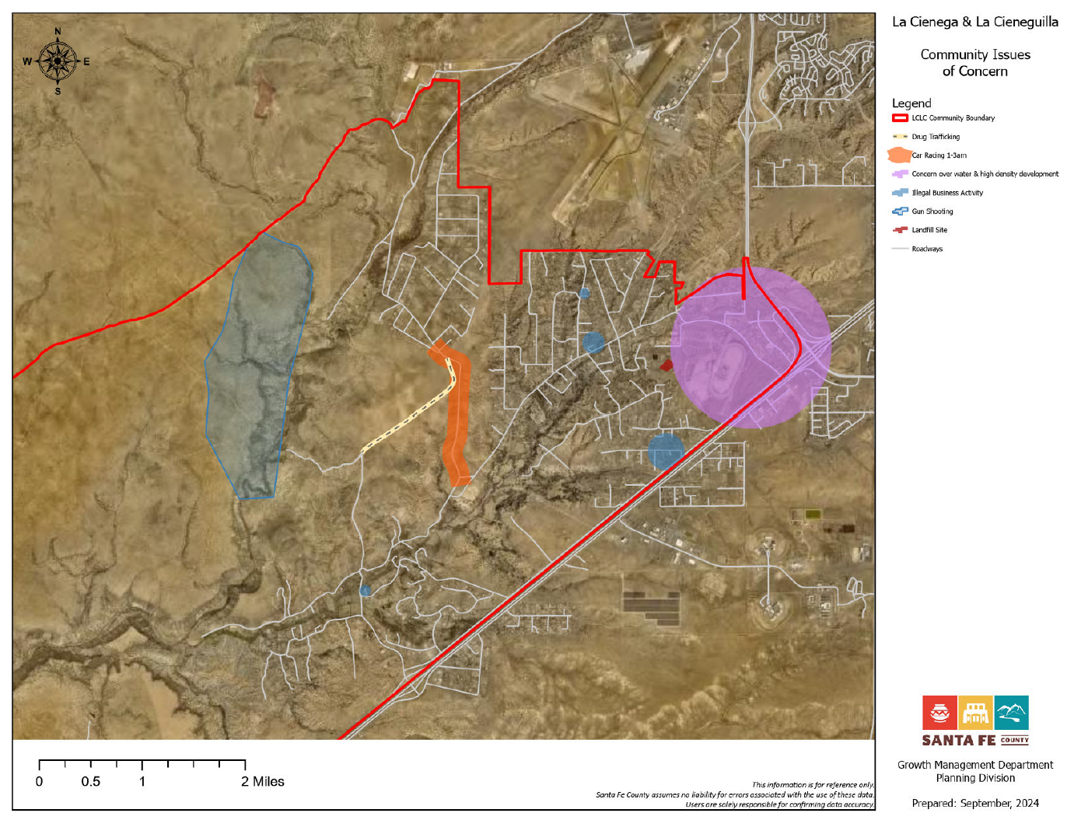

1.4 MAJOR RECOMMENDATIONS
Many recommendations of the 2001 and 2015 Plans have been implemented through a variety of public and private actions, zoning regulations, capital improvement projects and programs. Recommendations that have not been fully implemented and are still relevant have been brought forward in this update, combined with new ones. Major recommendations include:

- Implement La Cienega Watershed condition fully by seeking the extension of Santa Fe County water lines to serve existing and future residential and commercial uses in Upper La Cienega.

- Establish a regularly-scheduled bus route through the community that provides connections to the Railrunner Station and to City bus routes on Airport Road.
- Maintain the rural character of roads and increase pedestrian, vehicular and equestrian safety.
- Preserve and protect traditional agricultural and ranching activities through various means, including incentives such as site development standards, density bonuses, and transfers.
- Allow cluster development and density transfers in conjunction with agricultural, archeological and open space conservation easements.
- Ensure that any density increases and/or bonuses take into account all issues into consideration, including water, wastewater, neighborhood surroundings, access, traffic, utilities, history, etc.
- Establish a commercial district on properties on properties associated with the NM 599/I-25 Interchange and Eagle Ridge formerly known as the Santa Fe Downs.
- Establish community pathways and equestrian trails along existing road network to connect with existing and planned regional trail systems, open space and community facilities.
- Conduct a water/sewer feasibility study for the plan area to analyze utility service options to consider all possible methods of serving the area over the long term including on-site systems, (primarily well and septic), community systems and extensions of the Santa Fe County water and wastewater systems.
- Initiate Public Improvement District or other funding mechanisms to finance infrastructure projects in existing areas with deficiencies.
- Plan and take measures to mitigate potential hazards posed by fire and flooding including participating in fire and fuel reduction programs and programs that clear dead and downed trees.
- Provide support for the expansion of county resources for emergency response in a manner that ensures that resources and personnel to address emergencies are expanded to meet the demands of expanding population in the service area; and look at access issues for emergency response and how those issues can be mitigated.
- Conduct a study on existing utilities available to county residents and existing limitations on access to certain services including landline and cell phone reception, internet access, and upgrades to allow for use of solar power within the communities.
- Collaborate with the city of Santa Fe and Santa Fe county to formalize interactions with residents of this community who are impacted by city infrastructure located adjacent to the planning area.
- Collaborate with the city of Santa Fe and Santa Fe county officials to address contamination of the lower Santa Fe River from the Paseo Real Wastewater Treatment Plant including replacing the existing waste water treatment plant with a jointly managed facility between the city and county.

1.5 DOCUMENT GUIDE

1.5 PLANNING AREA BOUNDARY

1.5.1 Boundary Purpose

The physical boundaries of the Planning Area are designed to recognize the traditional uses of the land and how development would impact the communities. Expansion of the City of Santa Fe and possible annexation of the Planning Area’s communities threatened many of the grazing lands and open lands connecting the villages which are crucial to the fabric of the communities. Through discussion by the 2001 Planning Committee, historic and rural importance was assigned to these areas.

1.5.2 Boundary Status

The planning area boundary follows the La Cienega Traditional Historic Communities boundary that was established by Santa Fe County Ordinance 2000-07 (See Appendix) in accordance with State Law (NMSA 1978, Section 3-21-1) which recognizes the historic importance of the area and prevents annexation by the City of Santa Fe.

1.5.3 Boundary Description

The planning area is the same as the area included in the 2001 and 2015 Community Plan boundary. The boundary follows the upper edge of the La Bajada escarpment on the south, follows topographic features and County Road 56 C to the west and north, the southern airport boundary and NM State Highway 599 to the north and east, and Interstate 25 to the east and south. (See Map 1: La Cienega and La Cieneguilla Planning Area.). Within the core of the planning area the 1980 Santa Fe County General Plan delineated a Traditional Community Zoning District.

SECTION 1.6 COMMUNITY PLANNING HISTORY AND PROCESS

The Planning Area is comprised of Lower La Cienega, Upper La Cienega, El Cañon and La Cieneguilla and surrounding areas. These rural communities in Santa Fe County share a long, enduring history, a scenic rural environment and a tradition of working together through discussion, education, listening and negotiation to solve problems and plan for the future by creating a community plan that encourages sensible and sustainable growth. In the late 1990’s the communities began an in-depth community planning process that resulted in the adoption of the 2001 La Cienega and La Cieneguilla Community Plan and corresponding 2002-9 Ordinance.

Much has changed since the 2001 Community Plan and corresponding ordinance were adopted. Population has increased 27% from 3,007 people in 2000 to 3,819 people in 2010. Correspondingly, 261 new homes were added and commercial development in southern portions of the City of Santa Fe and areas adjacent to the valley has greatly intensified. In 2010, the NM Rail Runner Station at the interchange of NM 599 and I-25 just northeast of the plan area opened with over 200 parking spaces and bus connections to Los Alamos and Santa Fe, making it an important regional transit hub for northern New Mexico. These factors combined with the explosive residential growth of the 1990’s have resulted in a population size equal to or greater than many incorporated New Mexico communities and towns.

Additionally, Santa Fe County’s legal framework and policies for land use, growth management and development have changed since the 2001 Community Plan was adopted. In late 2010, the Board of County Commissioners, (BCC), adopted the Sustainable Growth Management Plan (SGMP). In December 2013 the BCC adopted the corresponding Sustainable Land Development Code (SLDC) which when in effect will replace the 1996-10 Land Development Code and implement many of the policies from the SGMP. Most significantly, the new code presents a shift from the County’s current hydrologic zoning, which regulates density based on water availability, to a fixed zoning scheme. To implement the new code and zoning scheme, the County will assign zoning districts and adopt a corresponding zoning map following criteria identified in the SGMP including water resources, proximity to public utilities, community character, existing and compatible land uses, densities and lot sizes. For areas such as La Cienega and La Cieneguilla covered by adopted plans and ordinances, the County will work with communities to assign base zoning districts and overlay zones as outlined in Chapter 9 of the SLDC. Both the SGMP and SLDC will guide land use and regulate development throughout the County for years to come.

In early 2011, in response to the adoption of the County’s new General plan (the SGMP), Planning Area community members recognized the need to revisit the 2001 La Cienega and La Cieneguilla Community Plan, and corresponding 2002-9 Santa Fe County La Cienega and La Cieneguilla Community District Ordinance. Over the course of several years, members of the community and the County worked together to assess changes in the area, update information, identify issues, and revise and develop strategies to manage growth and development in accordance with the SGMP and SDLC.

[Add a paragraph about the 2024-25 community planning process]

SECTION 1.7 EXISTING CONDITIONS & TRENDS

2.1 A BRIEF HISTORY AND DESCRIPTION OF THE PLAN AREA

The history of the Planning Area and its traditional historic communities of La Cienega and La Cieneguilla date back thousands of years. As the name Cienega (Spanish for marsh) implies, the La Cienega Valley contains marshlands formed by natural springs that have attracted passersby and settlers since well before the time of Christ. Archeological surveys conducted over the years yielded archaeological sites ranging from camp sites of the Archaic Period five thousand years ago to ruins of an early 20th century school houseschoolhouse. This high level of archeological site density is indicative of numerous ancient settlements throughout the valley. OverallOverall, the Planning Area has one of the highest concentrations of historic occupations in the Santa Fe vicinity.
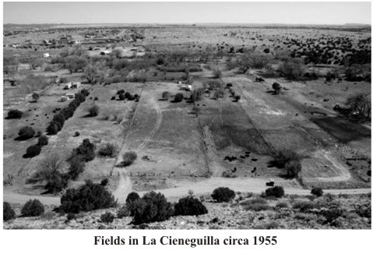
The oldest traces of human use can be found on the slopes overlooking the numerous springs in the area. The mesa escarpments are dotted with petroglyphs and rock etchings that date as far back as three thousand years, when American Indians took advantage of the ever presentever-present water so vital to us even today. About the time of Christ, people began living in pit houses presumably on a year roundyear-round basis. Over the centuries, people began the transition of living in surface structures made of puddled adobe or stone, or a combination.

At the time of Spanish contact in the late 16th century, there was mention of at least two considerably large Indian Pueblos in the Planning Area referred to as “La Cienega” and “La Cieneguilla”. La Cienega continued to be inhabited through the 17th century by Tano Indians. La Cieneguilla was abandoned by the Keres Indians in the early 1600’s but subsequently reoccupied by the Spanish in the 1630’s. The location of the Cieneguilla Pueblo is in the present village of La Cieneguilla whose mesas are adorned “with petroglyphs inscribed over thousands of years.” La Cienega is located on the mesa adjacent to the confluence of the Santa Fe River and La Cienega Creek.

The earliest known Spanish settlement in the valley is the ‘Sanchez Site” otherwise known as LA, 20,000 dating from 1630 to the time of the Pueblo Revolt in 1680. It is a very important site located in the southern part of the valley that was partially excavated in the 1980’s and is now owned and protected by El Rancho de Las Golondrinas. Other pre-revolt estancias are known to have existed at that time, although none have been located. Collectively the numerous archaeological sites constitute a concentration of historic resources that need to be protected and preserved. The Galisteo Basin Archaeological Sites Protection Act passed by Congress and signed into law on March 19, 2004 includes La Cienega and La Cieneguilla Pueblos and is in the process of developing a management plan that will offer federal protection for these sites. Other significant sites within the boundaries of the planning area may be worthy of inclusion in the Act. It is important to note that this protection is only on publically owned lands.

While the communities of La Cienega and La Cieneguilla are both located within the Planning Area, the Spanish settlement of each village was very different. La Cienega rapidly increased in population due to the fact that common lands were easily settled and the availability of water. The village of La Cieneguilla, along the Camino Real, was initially settled by Spanish colonists to the west of the Santa Fe River shortly after the arrival of Don Juan de Oñate to the area late in the 16th century. The east side of the river was the site of both historic and prehistoric Keresan pueblos.

The original grantee, Francisco Anaya De Almazan, was conferred title to over three thousand acres by Don Diego De Vargas in 1693. The property was sold in June of 1716 to the extended Montoya family. Increased population during the 19th century prompted the settlement of families to the east side of the Santa Fe River, in the vicinity of the then abandoned pueblo, as seen on the U.S. surveyor general’s map from the late 1800’s(below). Farming and ranching on the La Cieneguilla Land Grant was a major area of food production for the population in the Villa de Santa Fe.
Extensive settlement of La Cieneguilla did not occur until some 50 years after the Anaya De Almazan family sold the grant. Currently, the remaining traditional land of the grant is located near the mouth of the Santa Fe River.
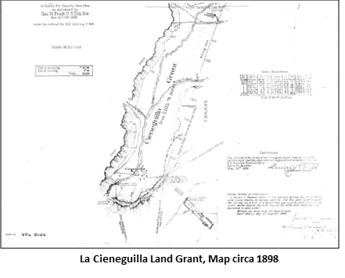

After the Spanish reconquest in 1692 and throughout the Spanish Colonial period, various place names are recorded for a number of ranchos in the Planning Area including “Guicú,” “Los Tanques,” “Las Golondrinas,” “El Alamo,” “La Capilla Vieja” and “El Cañon.” The springs that seep throughout the valley made these areas very desirable for ranching and grazing. In addition, El Rancho de Las Golondrinas was a major paraje (stopping place) on the Camino Real de Tierra Adentro that traversed along the Santa Fe River serving as the first stop leaving Santa Fe when traveling south and the last stop for travelers before entering Santa Fe coming north. Even today, remains of the trail ruts can still be seen in the La Cienega Valley. The names of the early Spanish settlers are ones that are prevalent today in the valley: Baca, Bustamante, C’ de Baca, Delgado, Gonzales, Montoya, Ortiz, Perea, Pino, Rael, Romero, and Sanchez to name a few.

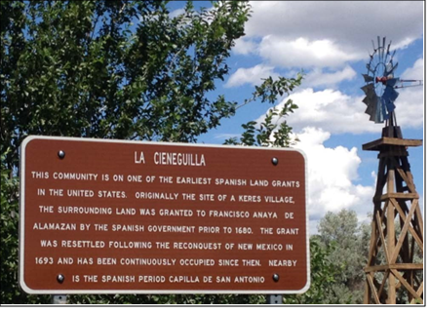

La Cieneguilla Historical Marker Sign 2015

The Planning Area continuedArea continued to be used for farming and ranching in the 19th century and up to the present. The valley was a busy place in the 19th century as reflected in the census of the time. By World War II, with the development of better roads, motor vehicle travel enabled the economy of the Planning Area to change. More and more people found work in Santa Fe and families sent their children there for schooling. By the early 1980’s, the settlement patterns of La Cienega and La Cieneguilla were changing dramatically; more affordable land was located in this part of the Santa Fe area where families could live. The area was caught in an incredible surge of residential development that included residential population growth and in-migration, Table 1 displays this growth. Although the rate of growth has slowed in recent years, the repercussions to the cultural landscape of the valley are ongoing.

What does this all mean? It means that the Planning Area has always been a desirable place for people to live, raise their families, grow their crops, graze their livestock and welcome strangers. It means that we in the valley have become stewards of a cultural landscape that has nurtured our forebears and welcomed recien emigrados (recent immigrants) to the valley for centuries. It means we have a responsibility to preserve as best we can the lay of the land, the water and its traditions, while at the same time allowing controlled growth to take place that respects one’s neighbors.

2.2 COMMUNITY PROFILE AND DEMOGRAPHICS

2.2.1 Population Growth
Total Population Growth in population for the plan area from 1990 to 20102010 to 2020 has been relatively high low for the County. As Table 1 describes, the La Cienega Planning Area CDP (census dedicated place), which includes most of the populated portions of the plan area, grew substantially between 2000 and 2010 (27%) however from 2010 to 2020 the population only grew 1.69%. The 27% population increase observed between 2000 and 2010, while substantial is actually a less dramatic increase than occurred in the 1990’s, though significantly greater than the population growth experienced in 2010-2020. Between 1990 and 2000 the population increased from 1,775 to 3,007 representing a 69% increase. In general, La Cienega Planning Area has a growing population as result of both residential population growth and in-migration, but the rate is slowing. As Table 2 describes, two decades of growth in the community has resulted in a population size equal or greater than many incorporated New Mexico communities and towns.

Table 1: La Cienega CDP POPULATION
La Cienega CDP Population changes between 1990 2010 & 20210

1990 | 2000 | 2010 | 2020 | Change 1990-2010 | Change 20002010-20210
no. of people | no. of people | no. of people | no. of people | % change | % change
1775 | 3007 | 3819 | 3885 | 69% | 271.69%
Source: 1990, 2000, and 2010 and 2020 Census |  | Census

Table 2: Population of other small New Mexico towns and communities
Community/Town | Population
Chama Village, Rio Arriba County | 1,022917
Agua Fria, Santa Fe County* | 2,913800
City of Santa Rosa, Guadalupe County | 2,85048
Town of Clayton, Union County | 2,645980
Village of Chimayo, Santa Fe and Rio Arriba County* | 3,0177
Town of Edgewood, Santa Fe County | 3,7356,174
La Cienega and La Cieneguilla, Santa Fe County* | 3,885
Village of Bosque Farms, Valencia County | 4,0203,904
Town of Taos, Taos County | 5,7166,474
Los Ranchos de Albuquerque Village, Bernalillo County | 56,874024
Source: 20210 Census
*Unincorporated communities within Santa Fe County

2.2.2 Housing Characteristics
Growth in housing units also is also relatively high for the County, as seen in Table 3. According to both the census and County data on residential structures, the number of units has increased 24% from approximately 1079 units in 2000 to approximately 1340 units in 2010. The percent of owner occupied units and rental units has remained the same while number units that are vacant has increased slightly to 6% but is relatively low compared to the County vacancy rate of 13%.

Table 3: Change in La Cienega Housing Characteristics – 2000 to 2010
 | 2000 |  | 2010 |  | 2020 | Change 2010-2020
 | no. of units % of total |  | no. of units % of total |  | no. of units % of total | no. of units % change
Occupied Housing | 1033 96% |  | 1259 94% |  | 1,483 38% | 226 17%
Vacant Housing | 46 | 4% | 81 | 6% | 100 2.5% | 35 | 23%
Owner Occupied | 800 | 77% | 966 | 77% | 1102 36% | 166 | 14%
Renter Occupied | 233 | 23% | 293 | 23% | 281 7.2% | 60 | 4%
Occasional Use Housing | 9 | 1% | 12 | 1% | 15 0.3% | 3 | 25%
Source: 2020 Census

2.2.3 Age Structure and Ethnicity
Compared with the community’s population and housing growth figures, other population characteristics, such as age structure and ethnicity have been more stable (see Table 4). The percent of the population that identifies as Hispanic or Latino has increased from 9% from 2000-2010 while the percent of the population that identifies as not-Hispanic or Latino has decreased by 9%. The percent of individuals under the age 18 has remained the same while the percent of population ages 50-64 has increased 6% and the percent over 65 has increased 3%. Continued increases the elderly population may increase the need for community services in the area.

Table 4: Change in Ethnicity and Age distribution between 2000 and 2010
 |  | Ethnicity
 | 20100 |  |  | 20210 | change 20100-20210
 | Nno. of people | % of total pop. | No. of people | % of total pop. | Change in pop. | % change
Hispanic or Latino | 2129 3069 | 7180% | 3069 2922 | 8075% | -940 147 | 444.7%
Non-Hispanic or Latino | 878 750 | 2920%  Age | 750 963 | 2025% | -128213 | -1528.4%
under 19 | 12921017 | 34% | 9401292 | 2434% | -275 352 | -27.2%
20-24 | 205182 | 56% | 262205 | 6.75% | 5723 | 27.813%
25-34 | 440458 | 15% | 435440 | 11.25% | -518 | -14%
35-54 | 11321025 | 304% | 10191132 | 26.330% | -11307 | -9.910%
55-64 | 477196 | 12.57% | 598477 | 15.412.5% | 121281 | 25.143%
65 & over | 273129 | 74% | 631273 | 16.37% | 144 358 | 131112%
Source: 20100 and 20210 Census

2.2.4 Employment
The limited amount of commercial development and community services in La Cienega Planning Area may limit employment opportunities available within the community. Most working residents travel outside the community for work. Average commute times are about 23% higher in La Cienega Planning Area than in Santa Fe County as a whole and most La Cienega Planning Area residents work in industries that are unevenly represented in the community. However, the significant number of residents who work from home in the community (about 8%) may mean that opportunities for home based businesses may ameliorate the spatial mismatch between jobs and housing in the community. Key employment characteristics are described in Table 5.

Table 5: 20210 Estimates of La Cienega CDP Community Employment Characteristics
Percentage unemployed | 3.26.1%
Percentage who work from home | 8.15.2%
Mean travel time to work | 26.42 minutes
Median income | $51,89165,549
Percentage employed in construction | 19.915.2%
Percentage employed in public administration |  | 18.07.0%
Percentage employed in educational services, heath care and social assistance |  | 17.513.9%
Percentage employed in professional, scientific, management, administrative, and waste management services |  | 8.212.5%
Percentage employed in arts, entertainment, and recreation, accommodation, and food services |  | 7.014.8%
Percentage employed in retail trade |  | 6.911.1%
Percentage employed in transportation and warehousing, and utilities |  | 6.94.3%
Percentage employed in other services (except public administration) |  | 4.89.4%
Percentage employed in finance, insurance, real estate, and rental and leasing |  | 3.510.3%
Percentage employed in agriculture, forestry, fishing and hunting, and mining |  | 3.40.5%
Percentage employed in wholesale trade |  | 1.90.0%
Percentage employed in public administration |  | 1.8%
Percentage employed in educational, health and social services |  | 1.8%
Percentage employed in information |  | 1.50.0%
Percentage employed in manufacturing |  | 0.51.1%
Source: 2006-20102020 American Community Survey 5-Year Estimates

2.3 HISTORIC & CULTURAL RESOURCES

La Cienega’s rich cultural heritage is evident in the continuation of agriculture production in the community, the continued use of the historic acequia systems, local building form and patterns, community traditions, and the many families with histories going back for generations. Historic structures including churches, cemeteries, capillas, homes, barns, corrals, and cisterns, dot the landscape and many are still in use and highly valued by community members. The community values historic resources and actively protects and maintains historic structures and by collaborating in the acquisition and management of historic sites and public lands.

Collectively the numerous archaeological sites constitute a concentration of historic resources that need to be protected and preserved.

Significant sites within the plan area include:

- La Cienega Pueblo and Petroglyphs- The La Cienega Pueblo dates to A.D. 1100- 1300. It contains over 140 rooms and over 1,000 petroglyphs. The site is not accessible to the public.
- La Cienega Pithouse Village- The La Cienega Pithouse dates to A.D. 700-900. It is not accessible to the public.
- La Cieneguilla Petroglyphs and Petrographs & Camino Real de Tierra Adentro- The Camino Real de Tierra Adentro provided connections among native peoples prior to European contact, and later between colonial Mexico City and Santa Fe. Extensive petroglyphs are associated with the trail.
- La Cieneguilla Pueblo- The La Cieneguilla Pueblo dates to 1325-1600. The Pueblo was abandoned and resettled and eventually had a Spanish and Mexican village built on it. It is not open to the public.

Since the 2001 plan was adopted, the Bureau of Land Management has made significant land purchases to expand their holdings in the Planning Area and further protect the community’s historical as well as natural resources. The agency, in cooperation with community members and other governmental bodies, has also developed a plan to manage the community’s land resources. Portions of La Cienega and La Cieneguilla also are covered by the “La Cienega Area of Critical Environment Concern,” a BLM designation that formally signifies a need for land management to protect “national significant cultural resources as well as riparian, wildlife and scenic values.”

Other public lands significantly contribute toward preserving the community’s historical resources.
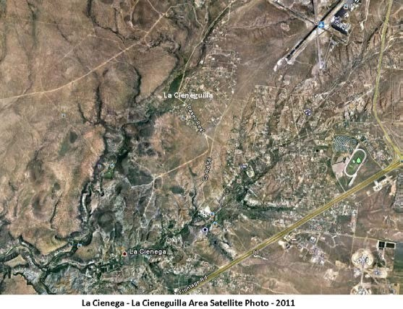Santa Fe National Forest land, BLM land, and Santa Fe County Open Space land all contain portions of the Camino Real. Although only the BLM petroglyph site has interpretative resources to facilitate public visitation of historical resources, all public lands in the area are managed with an objective to protect the community’s uniquely valuable cultural resources.

In addition, El Rancho de Las Golondrinas Living Museum, located on a historic local hacienda, has been operated by a local nonprofit organization for over fifty years. This historic rancho, now a living history museum, dates from the early 1700s and was an important paraje or stopping place along the famous Paseo Real, the Royal
Road from Mexico City to Santa Fe. The
museum also includes and protects the “Sanchez Site” dating from 1630 to the time of the Pueblo Revolt in 1680. Partially excavated in the 1980’s, it is the earliest known Spanish settlement in the valley. Other pre-revolt estancias are believed to have existed in the area at that time, although none have been officially identified.

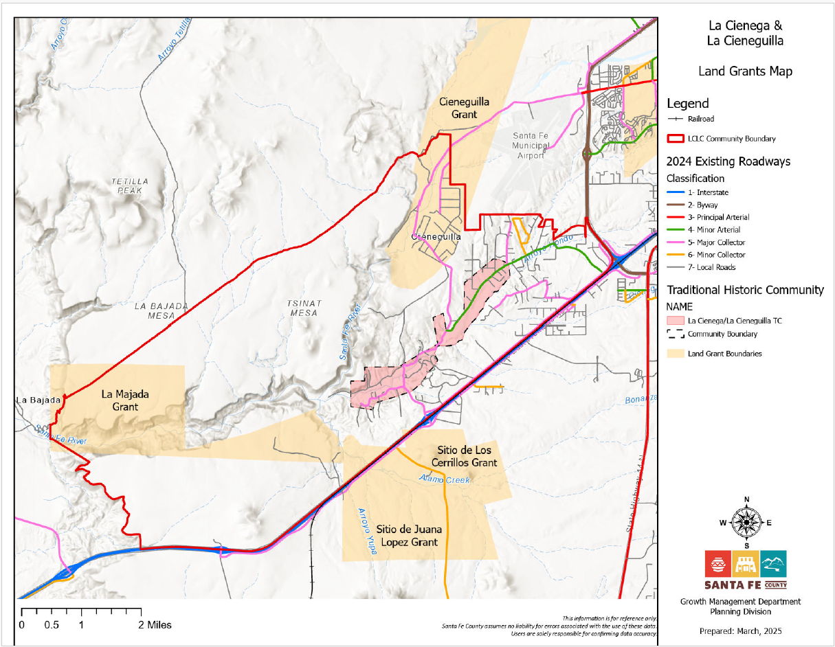
Add label

CHAPTER 2.1. LAND USE

2.4 EXISTING LAND USE & DEVELOPMENT TRENDS (p. 24)

2.4.1 Historic Development Trends

Traditionally, the rural and agricultural character of the La Cienega and La Cieneguilla Planning Area has shaped local settlement and land use patterns. Communities were formed along waterways to ensure irrigation for crops while upland areas were used commonly for grazing, wood collection and other household purposes. Early settlement by pre-pueblo and pueblo communities was characterized by compact housing areas near water sources. Beginning in the 1600’s, Spanish, Mexican and United States immigrants expanded development along the waterways and acequia systems as the population grew. Housing units were typically clustered in familial and community compounds. The primary land uses were for housing, irrigated agriculture and grazing. This type of land use required coordinated management and stewardship practices to maintain shared water resources and common lands or ejidos for livestock, timber and other uses. These agricultural and community traditions have defined where people built homes and how the community grew well into the 1900’s.

2.4.2 Recent Development Trends

In the 1970’s through 1990’s urban pressures from the City of Santa Fe’s growing population as well as internal growth from settled families spurred rapid residential growth in the plan area. New development intensified in upland areas near the intersection of NM State Highway 599 and Interstate 25 as well as in La Cieneguilla. Growth has also occurred in Upper and Lower La Cienega where traditionally irrigated lands have been converted to housing sites. The Planning Area became an attractive community for Santa Feans looking for the rural amenities of quiet living, low traffic, and open spaces.

From 2000 to present, growth is still influenced by close proximity to the City of Santa Fe, its desirable rural and historic character, a market preference for low-density single family housing, and low initial development costs relative to many other areas proximate to the City of Santa Fe. Increase in employment associated with the Community College District, the Airport, the National Guard and new commercial growth in Southwestern Sector of the City of Santa Fe may also be a contributing factor. Other factors may include proximity to transportation facilities including easy access to I-25, NM 599, NM Route 14 and the opening of the New Mexico Rail Runner Express station in 2010.

New development trends continue to pressure the Planning Area’s traditional rural character, farm fields, running acequias, and open spaces. The demand for new housing drives up real estate prices as well as property taxes on undeveloped and agricultural property, thereby making agricultural uses less viable. Community members have expressed that they feel overpowered by development and a lack of local control over land use decisions. One of the primary intents of the Plan is to protect and maintain the rural character and non-urban style development that makes the area special to residents while providing for community input in future land use decisions.

2.4.3 Residential Land Use

With the exception of the public lands, a few private ranches, Las Golondrinas Living History Museum and Eagle Ridge formerly known as the Santa Fe Downs Property, land uses in the planning area continue to be predominantly low-density, single family residential with a few large and medium sized parcels remaining in agricultural use. From 1990 to 2010, an estimated 404 new housing units were developed in the plan area, representing annual growth rate of 6%. With the exception of the Las Lagunitas subdivision in Lower La Cienega, most of the development occurred on existing lots, small subdivisions of fewer than 5 lots, lots created by family transfers, and infill of a large pre-1980 subdivision in La Cieneguilla, (see page 21, Figure 4: Existing Land Use Map).

Several factors will likely influence the rate of residential development in the plan area:

- Available Land, especially the transfer of private lands to public conservation lands. The transfer from private to public lands has significantly reduced the amount of land in the planning area available for single residential development.

- Limited Water Resources. In recent decades, several factors in the larger watershed and water supply of the region have come into play that are having and will continue to have impact on the plan area water supply. Decreases in rain and snowfall and increased temperatures have contributed to longer-term drought conditions. Several new studies and reports have confirmed continued drawdown of the aquifer generally, with increases in some isolated areas. Availability of regional water supplies through County and/or community systems may also be limited. Water quality concerns from various types of contamination also raises issues about the future water supply for these communities.

- Market Conditions. Between 2000 and 2010, the number of housing units in the planning area increased 24%, down from a 60% increase between 1990 and 2000. The slower pace of new development in recent years partly reflects the impact of the national recession. According to data from the Santa Fe Association of Realtors, home sales in the broader southwest Santa Fe County region (inclusive of La Cienega and La Cieneguilla, Madrid and Cerrillos) fell over 50% between 2005 and 2012 while median values decreased about 14% during the same period. County-wide, the number of building permits for new single family homes issued between 2005 and 2011 fell about 83%. Also a according to American Community Survey estimates, between 2000 and 2010, the median home value in La Cienega climbed about 56%. Incomes, however, haven’t necessarily increased. More people today are spending more of their incomes on housing in the planning area than ten years ago. According to the American Community Survey estimates, 45% of all 2011 mortgage holders in La Cienega and La Cieneguilla and 43% of all renters have housing costs (a measure which includes mortgage, rent, as well as estimate of utilities and other costs) that are 35% or more of their household incomes.

- Zoning and Legal Regulations. Santa Fe County’s adoption of the Sustainable Growth Management Plan and Sustainable Land Development Code represents a significant change in how development occurs. Establishment of zoning districts determines maximum densities, and water use for new residential development is restricted to 0.25 acre feet per household, which in most cases will be more restrictive than the water allocations permitted by the Office of the State Engineer.

- County Purchase of Santa Fe Canyon Ranch. In 2009, Santa Fe County acquired 470-acres of the Santa Fe Canyon Ranch property (also known as La Bajada Ranch) composed of several additional large parcels which comprise a total of approximately 1300 acres. The County has established a steering committee to review development options and potential uses. A 2010 survey of residents conducted by the County revealed a community preference for the property to be preserved as open space. Given the amount of time that has passed since the last survey was conducted a new survey should be conducted to reflect the current community preferences prior to any development.The Master Plan was revised in 2014 to remove the large parcels and the remaining Master Plan consists of 470 acres.

- Home Occupation Businesses: Home occupation businesses continue to play an important economic role in the community. About 8.1% of residents work from home according to American Community Survey 5-year estimates. Small home-business scaled business operations include agriculture, a lodging facility, a furniture maker, and an upholstery shop among others. While home businesses have the potential to increase opportunities for commercial and employment services, concerns remain about traffic, industrial uses of land and their neighborhood impacts.

2.4.3 Agricultural Land Use

The rich legacy of agricultural production in the planning area includes grazing in dry upland areas as well as harvesting food, herbs, and tree crops along the waterways and acequias. Today, agricultural traditions are highly valued by community members and continue to reinforce the planning area’s rural heritage and historic character. Many residents tend gardens, livestock and fruit trees which yield substantial harvest for their household consumption. Even so, conversion of irrigable agricultural land to residential uses and home sites combined with declines in water flows in the acequia systems and groundwater contamination have led to a decrease in agricultural production.

2.4.4 Commercial Land Use
Commercial services and employment opportunities in the community are limited. Other than RV and mobile home parks, open-yard commercial operations, a small number of home-based craft studios and shops, there are no grocery stores, gas stations, or retail services in the plan area. As Table 6 makes clear, the number of commercial establishments is low relative to the number of commercial establishments in other small communities in the County.

Table 6: Commercial Land Use
Community | % of parcels in commercial use
Pojoaque | 1.7%
Arroyo Seco | 6.2%
Agua Fria | 2.27%
La Cienega | 0.72%
Source: Santa Fe County

The amount of commercial services in the plan area will be heavily influenced by utility extensions, water resources, transportation improvements, land use, and zoning regulations. Factors including changes in ownership or land use could have significant impact on the surrounding community and future development proposals. Major factors influencing commercial development include:

- Medium to Large-Scale Commercial or Quasi-Commercial Properties: A small number of medium-to-large scale business currently operate within the Plan area. In the Planning Area there are three properties that have current Master Plans with zoning approved from the Board of County Commissioners. These properties include:

  - Eagle Ridge formerly known as the Santa Fe Downs: The Eagle Ridge property has a Master Plan and has traditionally hosted recreational or semi-commercial land uses. Currently, the property hosts concerts, and allows organized league play on the irrigated, grassy infield. The property is adjacent to most of the other commercial establishments in the community which is mostly located in Upper La Cienega and Eagle Ridge is expected to produce a master plan in the near-term that proposes more intensive development on the property.

  - Several properties between the Eagle Ridge formerly known as the Santa Fe Downs and the NM 599 / I-25 Interchange are used for open yard commercial and RV or mobile home parks.

  - Ojo Santa Fe: Ojo Santa Fe has a Master Plan and has lodging, restaurant, and retreat facility. The property has extensive gardens and water features and in the past has provided gallery space.

  - MCT: MCT has a Master Plan and is a commercial waste management facility that sorts and temporarily stores construction site waste and maintains a fleet of trucks and storage/collection containers on site.

  - Las Golondrinas: Las Golondrinas is the only living history museum in New Mexico and is located within the planning area. Las Golondrinas hosts a number of community events including Renaissance Fair, Harvest Fest, Spring Festival, Fiesta de los Ninos, the Wine Festival, the Beer & Wine Festival and Spirits of New Mexico among others.

  - Green Tractor Farms, La Capilla Hops Farm, and Rey Romero Farms sell their produce commercially.

- Adjacent Commercial Development and other Uses Adjacent to the La Cienega Planning Area: Several properties adjacent to the Planning Area have been developed or are slated for intensive development. These include:

  - Santa Fe Regional Airport.

  - The Pavilion business park, 371 acres located along N.M. 599 near the airport. This property is directly adjacent to the boundary of the La Cienega and La Cieneguilla Planning area.

  - 23 acre Komis property at northeast intersection of I-25 and N.M. 599.

  - Las Soleras, mixed use commercial and residential development, 550 acres located northeast of the outlet mall development.

  - National Guard complex on approx. 1,000 acres located across I-25 from the Las Estrellas/racetrack area.

2.4.5 Community Facilities

For the size of the population of the plan area there are also relatively few community facilities. There are no medical clinics, public schools or limited developed parks in the community. However, the community does host County facilities including the La Cienega Community Center, Fire Station and the Transfer Station; and there are a couple of churches and cemeteries that provide a variety of services to the community.

In general public funding at both the state and County level have increased recently, however, appropriate levels of funding for community facilities will continue to influence the ability for the community and the County to adequately meet the needs of this growing community. The community has been very active in identifying needs and seeking funding. Eagle Ridge will be allocating acreage for the community to create a community center and/or park as part of their master plan. The community should work with the Board of County Commissioners to seek Capital Outlay to obtain

funding for a new Community Center with associated outdoor recreation facilities.

2.4.6 Conservation, Community Stewardship, and Open Space Use

Settlement in the La Cienega and La Cieneguilla Planning Area has traditionally been focused on rural, agricultural economies and land use practices. Communities formed along waterways to ensure irrigation for crops while upland areas were shared in common by the community for grazing, wood collection and other purposes. This system required coordinated management and stewardship practices to maintain the common areas. The system also allowed for common lands between communities and spacing of development to allow for enough resources to support each community. Areas traditionally used as common lands continue to be lost to new development. While these common lands were often privately held, development effectively removes them from the undeveloped landscape and reduces areas for grazing and hiking. The common undeveloped lands also helped define individual villages by forming buffer areas between communities and signified rural, agricultural and historical characteristics of the La Cienega and La Cieneguilla Planning Area. Residents of La Cienega and La Cieneguilla have always considered these lands to be integral and essential parts of the community and continue to collaborate with private landowners, the BLM, the County and the State Land Office in the management and stewardship of these cherished areas.

Major conservation land uses include federal, state, and County holdings as well as properties that function to conserve historic and natural resources such as the El Rancho de Las Golondrinas Living Historic Museum and the Leonora Curtin Wetland Preserve, managed by El Rancho de las Golondrinas. Since 2001 over 1000 acres has been transferred from private property to public property and is now under the control of the Bureau of Land Management and Santa Fe County Open Space. This transfer from private to public lands has significantly reduced the amount of land in the planning area available for residential development. The public lands contribute greatly to protecting the community’s natural setting, resources, cultural heritage, scenic amenities and recreation value.

Public lands in La Cienega and La Cieneguilla encompass approximately 46% of the planning area. They include Santa Fe County Open Space property, Bureau of Land Management properties, US Forest Service land and lands managed by the New Mexico State Land Office. Each agency operates under various management objectives and not all lands have been completely inventoried or have had management plans developed to date. An inventory of public lands within the Plan Area includes:

- Bureau of Land Management: In 2004, the United States Congress passed the “Galisteo Basin Archaeological Sites Protection Act” in recognition of the unique historical value of the basin’s archeological resources. The Act designates four sites in La Cienega and La Cieneguilla as “Galisteo Basin Archeological Protection Sites” and directs that sites should be protected and preserved: La Cienega Pueblo and Petroglyphs; La Cienega Pithouse Village; La Cieneguilla Petroglyphs/Camino Real de Tierra Adentro; and La Cieneguilla Pueblo. The BLM is the lead agency in managing La Cienega and La Cieneguilla’s archeological resources and most of the community’s archeological resources recognized in the Galisteo Basin Archeological Sites Protection Act are located on agency land. The agency has increased their land holdings in La Cienega substantially since the adoption of the 2001 community plan and has developed a management plan for its La Cienega and other northern New Mexico land holdings. While much of the agency’s management focuses on historical resources preservation, BLM lands are also managed for habitat values and support community uses such as grazing. The BLM Petroglyphs/Camino Real de Tierra Adentro is one of the few developed interpretive sites on public lands in La Cieneguilla.

- Forest Service Lands: Forest Service lands in the Planning Area provide grazing opportunities under the Caja del Rio grazing allotment (the allotment extends beyond the community planning area and supports in excess of 500 head of cattle). The portions of the Santa Fe National Forest in the La Cienega and La Cieneguilla community planning boundary do not have any developed recreational sites..

- State Lands: State Trust lands encompass nearly 750 acres of the planning area. They border public lands managed by the Federal Bureau of Land Management and developed private lands. While State Trust lands have limited trails, they do not have other developed recreation sites or interpretation resources. State Trust lands currently host several agriculture leases and one commercial lease as follows:
  - Agricultural Lease 386 acres gm 2828 Reynaldo Romero
  - Agricultural Lease 258 acres Robert Romero gs2291

  - Agricultural Lease 40 acres Barbara Stein gm 2892
  - Commercial Lease .35 acres BL 1037000 Connie Rivera Chavez effective date 6/25/2011

- County Lands: County open space properties include holdings in La Cieneguilla and La Cienega:
  - In La Cieneguilla
    - A part of the property at La Cieneguilla is included in a site boundary for the Galisteo Archaeological Sites Protection Act, under the designation for the La Cieneguilla Petroglyphs and management of the property for historic preservation is provided for by a Memorandum of Agreement between the County and BLM.
    - The County owns and manages approximately 100 acres of the riparian corridor along the Santa Fe River and regularly removes non-native trees and plants native trees. The County also has an agreement with the Santa Fe Girl’s School to use the part of the property along the river for outdoor education and limited water quality monitoring.
  - In La Cienega
    - El Peñasco Blanco in La Cienega includes the Springs and restoration work at Los Carrizales. This property is open to public (access is only possible via horseback or foot), but at the wishes of the La Cienega community, the property lacks any interpretative or directional signage.
    - Santa Fe Canyon Ranch: Santa Fe County acquired the 470-acre Santa Fe Canyon Ranch property and facilities in 2009. The County has not developed a plan for developing the property, however a 2010 survey of residents conducted by the County revealed a community preference for the property to be preserved as open space or developed with low-intensity land uses such as recreational facilities.

- Pueblo Lands: Santo Domingo Pueblo owns approximately 3500 acres located at the southwest corner of the planning area.

- El Rancho de Las Golondrinas Living History Museum: El Rancho de Las Golondrinas Living History Museum: El Rancho de Las Golondrinas is a living museum of Spanish Colonial life in the 17th century in New Mexico. The museum encompasses 193-acres of a former encampment on the Camino Rael and former ranch dating to 1710. The ranch includes a vast number of historic structures restored and added to the site in the 1930s including at least three acequias, an 18th century placita house complete with defensive tower, a 19th century home and all of its outbuildings, a molasses mill, a threshing ground, several primitive water mills, a blacksmith shop, a wheelwright shop, a winery and vineyard, a morada, descansos, a Campo Santo and an Oratorio. The museum is
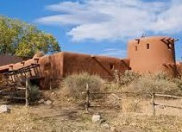
open to visits from the public and is regularly rented for large events and for filmmaking. They museum and its land are owned and managed by the El Rancho de Las Golondrinas, Inc. a non-profit organization.

- The Leonora Curtin Wetland Preserve: The preserve is a 35-acre habitat preserve with picnic areas, trails, and interpretive guides. The area includes a spring-fed pond and significant species diversity. It is
managed by El Rancho de Las Golondrinas and is open to the public.

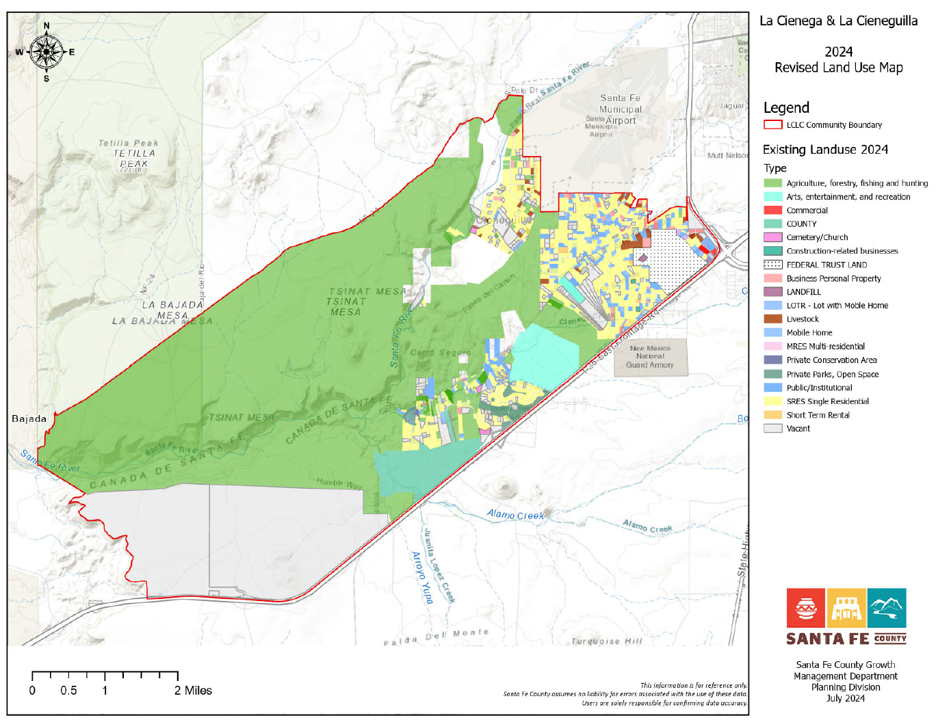
Figure 2 LC & LC Existing Land Use Map

SECTION 2.1.2. LAND USE PLAN AND GROWTH MANAGEMENT (p. 75)

5.1 INTRODUCTION

The Community Land Use Plan is made up of several components that are interrelated and when viewed as a whole provide a framework to guide development decisions, zoning and regulations, utility extensions and capital improvement projects. The components include:

- Future Land Use Map and Categories which will be used to guide the establishment of base zoning districts and corresponding overlay zones.
- Traditional Agricultural Lands Preservation and Protection Map and recommendations which will be used to guide the establishment of an Agricultural Overlay Zone to incentivize and promote the conservation and use of irrigated agricultural land and open space.
- Priority County Water Hook-Up Area Map and recommendations based on existing regulations pertaining to the La Cienega watershed conditions, County water extension policies and current and planned alignment of County water lines.
- Roads and Transportation Plan that includes a map, text and graphics illustrating a proposed route for a commuter shuttle and recommended rural road profiles and improvement guidelines as well as emergency evacuation routes.
- Corresponding Community Facilities, Open Space and Trails Map and recommendations.

5.2 SUSTAINABLE GROWTH MANAGEMENT GUIDELINES

Guidelines for growth and development based on the principle of sustainability reflect a number of changes in the ways that zoning densities are determined. Many of the original components of the La Cienega and La Cieneguilla Community Plan incorporate sustainability. Preservation and stewardship of the traditional uses of the land are important aspects of sustainability and watershed restoration, as are principles of protecting water resources (in both quantity and quality), and supporting the viability of traditional occupations including agriculture and grazing. In addition to these existing components, sustainability and watershed restoration address the broader use of all resources, including energy consumption, recycling, and the economic stability of the community.

The County’s Sustainable Growth Management Plan (SGMP) outlines principles based on long-term sustainability that will guide land use, and provides a framework for zoning for the County’s Sustainable Land Development Code (SLDC). These principles include consideration of water availability and use, terrain, proximity to existing development, energy consumption, and economic viability. Many of the original components of the 2001 La Cienega and La Cieneguilla Community Plan incorporate these principles. This plan update reinforces those principles and supports the goals and policies of the SGMP and in fact implements many of the strategies identified in the SGMP.

In conjunction with the SGMP policies and the SLDC, the following future land use map and provisions are intended to ensure compatibility among various land uses, to protect existing property rights pertaining to lot size and density, provide flexibility and certainty, conserve local water resources, protect scenic features and environmentally sensitive areas, enhance rural development patterns, delineate areas to incentivize agricultural preservation while accommodating the anticipated natural growth of the community and the potential for appropriate commercial development.

The land use categories are consistent with the Future Land Use Categories in the SGMP but are described in greater detail to capture the community’s goals for the plan area and the area’s unique charter. Once adopted The La Cienega and La Cieneguilla Future Land Use Map, (see page 67), corresponding land use categories and provisions refine and amend the SGMP policy framework and Future Land Use Map and as such shall guide future zoning and development decisions.

Development types, such as clustered developments and accessory dwelling units are identified as a means to encourage compact development, encourage historic development patterns and accommodate a variety of lifestyles including multi-generational families living together.

Many provisions and recommended standards identified in this plan are accommodated in appropriate sections of the SLDC.

5.3 LAND USE PLAN AND GROWTH MANAGEMENT GENERAL PROVISIONS & GUIDELINES

The following general provisions and guidelines should guide the drafting and adoption of a La Cienega and La Cienega Community District to amend Chapter 9 Community Districts of the SLDC and Official Zoning Map.

Restricted Land Uses based on Water Quality Protection

New development that poses a risk of spills and potential to contaminate surface and ground water systems shall not be permitted within the Planning Area. Non-permitted uses will include gas stations, asphalt batch plants and asphalt production plants, large-scale mining, any warehouse which stores or transfers chemicals, large-scale agricultural operations which stockpile manure or have manure lagoons (e.g.: dairies, horse parks or stables, chicken farms), waste oil recycling, septic tank pumping waste disposal, grease trap waste disposal, large-scale chili processing plants, cheese processing plants, gasoline storage facilities or transfer stations, auto repair facilities, car washes, sludge disposal fields, mortuaries, and slaughter houses.

Restricted Development Areas

Restricted Development Areas simply delineate all of the areas where development will be severely restricted. This can be based on the FEMA maps, the SGMP official maps and the community identified scenic features and environmentally sensitive areas. For example La Cienega Creek, Arroyo Hondo and Alamo Creek, and lower Santa Fe River and associated bosques could be delineated on a map using FEMA flood plains.

Steep Slope Areas

These are areas with greater than 30% slope.

Floodplain Areas

These are the 100-year floodplains that have been mapped by FEMA. Santa Fe County also generally prohibits development within a 75-foot buffer adjacent to the mapped FEMA floodplain boundary,which will also be included.

Wetland Areas And Riparian Habitat

The National Wetlands Inventory will be used for wetland areas and the New Mexico ReGAP Vegetative Land Cover data will be used for riparian areas. “Riparian areas” are the willows, cottonwoods, etc. that are typically found near streams, but do not occur in the water-saturated soils that characterize wetlands.

Archaeological Sites

Archaeological sites identified under the Galisteo Basin Sites Protection Initiative shall be protected.

Stream And Arroyo Buffers

Streams will have at least a 25-foot buffer based on the current County Land Development Code requirements.

Critical Habitat Areas

These are typically defined as areas that are essential to the maintenance of viable populations of endangered or threatened animal species. Likely areas that may be included as Critical Habitat Areas are usually within the wetland, riparian, and floodplain zones.

5.4 LAND USE PLAN AND GROWTH MANAGEMENT KEY ISSUES

- Community residents have identified that family transfers and variances are sometimes used to divide properties below the minimum lot sizes to avoid subdivision regulations and procedures, contrary to the intent of the variance. This allows for increased density on small lots and places higher demands on local water resources to accommodate the new development. More careful examination of the potential impacts of increased densities on local water resources as well as on infrastructure and the area's rural character is necessary before exemptions and variances are granted.
- The rapid development and subsequent changes in land uses, primarily from agricultural to housing, impacts property values and increases tax burdens. This development has benefited some property owners, particularly in the case of large-scale developments. However, the development has also increased economic pressure on families and small-scale landowners to follow the same pattern which has led to piecemeal subdivision of the Planning Area at the expense of the community character. Community residents have identified that continued and uncontrolled development, especially on the south side of Santa Fe,threatens to destroy the rural nature of the community. Additionally, rapid development places strains on limited local natural resources, including water.
- The Planning Area includes various zoning districts including the Traditional Community Zoning District. The maps which depict these different zones, particularly the Traditional Community Zoning District, are interpreted on a case-by-case basis which has led to confusion on individual zoning decisions. Thus, enforcement is complicated because of unclear boundaries between the various zoning areas.
- Due to increased growth and concerns regarding water quality in the Planning Area, some community members have called for extension of County water and/or wastewater systems into the Planning Area. However, if these systems were expanded in the Planning Area it might be possible to increase housing densities to areas served by both sewer and water. The increased housing densities would lead to urban style intensive development which would further threaten the rural character of the communities in the Planning Area. It would be advisable to extend water and sewer to mobile home parks and other more densely developed areas in phases and residents impacted by water quality issues and to prioritize serving existing residents. Further the community supports the adoption of resolutions by the county for the planning area that would prevent the ability of developers to tie into county water for dense or large-scale development.
- Zoning and density decisions are largely influenced by water quality and availability, and the adequacy of septic systems. This is an appropriate approach in the Planning Area due to the need to balance water resources with development. However, the rural character of the communities in the Planning Area is intrinsically linked to development patterns and zoning decisions. Community members in the Planning Area have expressed the importance of including specific consideration of important elements such as local infrastructure, traffic and other impacts of development on the rural communities along with the critically important water resources.
- In the past two decades, zoning changes and land use policies designed for the entire County have helped to direct new growth in the Planning Area. While growth and change are recognized as inevitable and often positive, the rapid development in the Planning Area has also negatively impacted the quiet, rural character of the community. Community members have expressed frustration and exasperation at decisions and policies impacting the community in which they feel community concerns were not addressed or considered. This has led some members of the community to feel a sense of disenfranchisement at the community level and served to discourage their participation in community and County level decision-making.
- The current regulations for setbacks (the distance between structures and the property line) in most Zoning Districts are considerably stricter than the County standard. This has led to many variance requests for both new and existing structures.
- The Board of County Commissioners adopted commercial cannabis regulations in 2021. There are mixed opinions in the community concerning commercial cannabis.

5.5 LAND USE PLAN AND GROWTH MANAGEMENT KEYS TO SUSTAINABILITY

- Increased awareness of the importance of maintaining rural and agricultural character of the communities in the Planning Area.
- Protection and maintenance of clean air and water as community priorities in the Planning Area.
- Incorporate sustainable land practices which preserve the rural, agricultural, ranching, and traditional ways of life within the community.

5.6 LAND USE PLAN AND GROWTH MANAGEMENT GOAL

Create a land use plan to protect the natural and historical resources and rural character of the communities in the La Cienega Valley while at the same time position the community to leverage its location adjacent to regional and interstate highway systems, regional transit systems and the airport to increase economic viability and increase opportunities for employment and access to resources within the planning area.

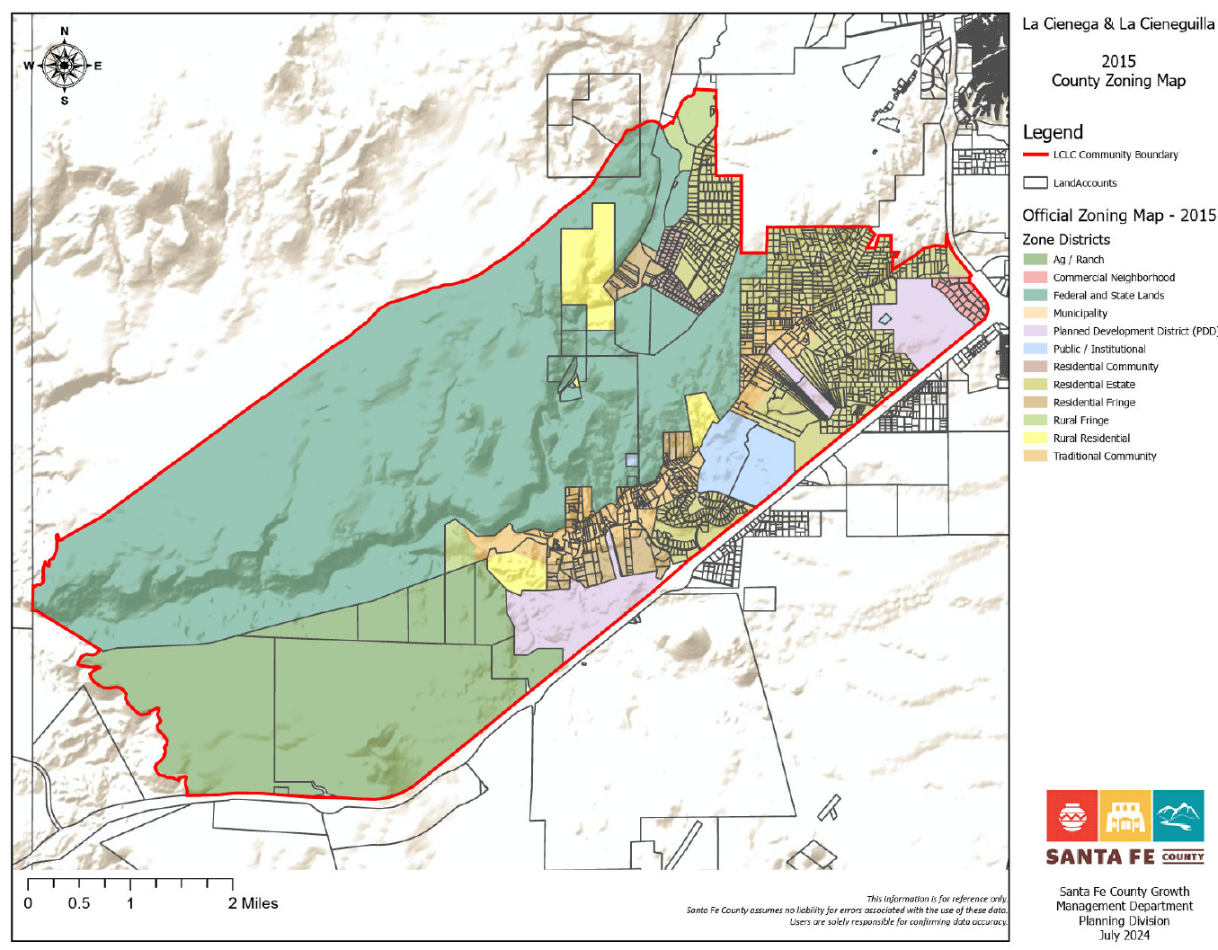

Figure 7 La Cienega and La Cieneguilla LZoning Map

5.7 LAND USE MAP AND LAND USE CATEGORIES

In conjunction with the SGMP policies and Chapter 2 Planning, of the SLDC, the following land use categories and corresponding land use map (on the previous page) have been established for the La Cienega and La Cieneguilla Planning Area.

Federal and State Public Lands
Federal and State Lands land use category applies to the western half of the planning area, which is primarily under the management of the BLM with a smaller portion under the control of the Forest Service. The area should continue to provide opportunities for hiking, grazing, hunting, mining limited to existing operations and a natural setting for wildlife and flora. State Land is a large undeveloped property owned and managed by the State Land Office. It should continue to provide opportunities for grazing and hiking. Due to its central location and easy access off Paseo Real, a portion of the area should be considered as a possible site for active outdoor recreation facilities including playing fields.

 Public /Institutional

The Public/Institutional designation pertains to the area associated with the El Rancho de Las Golondrinas Museum and the Leonora Curtin Wetland Preserve. This area should continue to conserve the natural and historic resources and manage visitor impacts with designated operating hours and coordinated traffic management on days with special events

 Agricultural/Ranch

The Agricultural and Ranch land use category applies to portions of the plan area that are associated with the historic ranch operations. The area includes approximately 3,500 acres adjacent to Santo Domingo Pueblo, the adjacent six tracts averaging 140 acres in size for a total of approximately 900 acres. The large tracts should continue to support ranching and associated activities.
Incentives in the form of density bonuses and reduced minimum lot size should be used to encourage compact development in conjunction with major conservation easements.

Rural Fringe

The Rural Fringe land use category applies to portions of the plan area associated with ranch operations. These areas are largely undeveloped.

Incentives in the form of density bonuses should be used to encourage compact development in conjunction with major conservation easements.

Rural Residential

The Rural Residential land use designation covers several largely undeveloped agricultural tracts in the plan area, including large grazing properties west of La Cieneguilla. These areas should continue with primarily agricultural uses. Due to the large tracts under single ownership, if residential development is proposed, there is an opportunity to support planned compact residential development in conjunction with conservation easements that set aside land for the purpose of preserving contiguous agricultural land, major archeological sites and natural open space as well as trail easements for community pedestrian and equestrian connections to regional trails and open space.

All new major residential subdivisions and developments should be required to submit a master site plan that protects adjacent properties, provides an environment within the layout of a site that contributes to a sense of community, preserves and enhances natural amenities and cultural resources; protects the natural features of a site that relate to its topography, shape, and size; and provides for a minimum amount of open space to serve the subdivision or development, creates pedestrian paths and trails; and provides an efficient arrangement of buildings, circulation systems, and infrastructure.

Incentives in the form of density bonuses and reduced minimum lot size should be used to encourage compact development in conjunction with hooking up to County water and the establishment of major conservation easements.

Residential Fringe

The Residential Fringe land use designation covers sections of the plan area south of the Traditional community.

Residential Estate

The Residential Estate Land Use Category is designated for areas associated with contemporary residential subdivisions in both La Cienega and La Cieneguilla. This plan anticipates continued infill on the remaining scattered vacant lots; and supports primarily single- family residential development with options for agricultural related uses, home occupations and businesses.

All new major residential subdivisions and developments should protect adjacent properties and provide an environment within the layout of a site that contributes to a sense of community, preserves and enhances natural amenities and cultural resources; protects the natural features of a site that relate to its topography, shape, and size; and provides for a minimum amount of open space to serve the subdivision or development, pedestrian paths and trails; and provides an efficient arrangement of buildings, circulation systems, and infrastructure.

Residential Community
The Residential Community designation applies to only a contiguous residential area in La Cieneguilla that is almost completely built out on existing 1 acre lots created in the late 70’s. No additional areas are proposed to have this zoning designation.

Traditional Community

The Traditional Community Land Use Category is designated for the historic village areas of La Cienega. It is characterized by the historic acequia irrigated farmlands and a concentration of historic homes and traditional development patterns. Agricultural lands and acequias are the defining cultural features of the area and should be preserved and expanded through incentives zoning techniques. The La Cienega and La Cieneguilla Traditional Community Boundary was designated in 1980. In 2001 the boundary was surveyed and was incoroporated in the original La Cienega and La Cieneguilla Plan. The current boundary is proposed to expand along the southwest section to include approximately 113 acres of traditional agricultural land.

The La Cienega Creek and surrounding bosque are the defining natural features of the area. The creek is the primary surface water source for the area and the bosque provides a ground water recharge zone for several springs as well as an important wildlife corridor and riparian habitat. It should be protected from new development and accessible to the community for maintenance and restoration.

The area consists of primarily single-family residential and small scale agricultural development, consistent with historic development patterns and uses. Community facilities, institutional uses, agricultural uses, home businesses and occupations should be allowed anywhere in the area.

Incentives to promote preservation of agricultural land, should be encouraged through the use of land use mechanisms such as TDR’s, conservation easements to preserve contiguous agricultural lands.

 Planned Development (PDD).

Planned Development Districts are included as a land use category in order to recognize existing Master Plan approvals for properties that do not fit a single land use category. Properties in a PDD may be built out in accordance with their approved master plans.



Neighborhood Commercial

The purpose of the Neighborhood Commercial district is to allow for low-intensity convenience retail and personal services, as well as office uses, which are intended to serve and are in close proximity to individual residential neighborhoods.

5.9 GENERAL PROVISIONS AND GUIDELINES

Limitations on the Scope of This Plan
The adoption of this plan is not intended, nor shall it in any way operate, to obligate any entities identified in this plan, including Federal, State, LCVAand Santa Fe County in providing resources, initiating support or implementing any project, program or strategy.

Density Transfers
• Density transfer(s) generally are used to protect community assets including but not limited to wetlands, open spaces, springs, watercourses, riparian areas, agricultural lands, acequias, traditional community centers, archeological sites, historical and cultural sites and multigenerational family housing compounds. This could allow developments to transfer minimum lot size densities from an entire piece of property to a specific area of the property in order to protect important community resources such as those listed above. For example, if a developer chooses to develop a 10 acre tract in the Traditional Community Zoning District under permitted .75 acre lot size zoning, the county code would allow the developer to divide the land into 13 individual parcels with one dwelling unit per .75 acre parcel. Under density transfers, the developer would be able to cluster the gross density of 13 units on a portion of the property, leaving the rest of the property open and undeveloped.

Home Occupations and Businesses

• The Community Plan recognizes the importance of individuals and families to operate small businesses from their homes. Mixed use development consisting of development that house both residential and non-residential uses on the same property and or in the same structures should be permitted as part of a home occupation. Small-scale arts & crafts and galleries already exist in the community as was previously demonstrated through gallery tours. The Plan determines that home occupations are appropriate throughout the Planning Area and supports the continuation of existing home businesses and small commercial operations in the Planning Area.

Cell Towers and Antennas
• Standards and regulations for cell towers provided in the SLDC should be reviewed for appropriateness. It should be noted that unique standards and regulations for the plan area may be preempted by federal law which limits permitting authority for cell towers. Cell towers should be placed away from migratory paths of birds and in areas that do not negatively impact the viewshed and should be kept to the minimum height required to operate to the extent possible.

Family Transfers
• Because local families are one of the great community resources of the La Cienega and La Cieneguilla Community Planning Area, lots created by inheritance or family transfer should be supported as provided by the SLDC.

Land Protection
- Open spaces set aside for density transfer or other easements for the protection of community assets, as described above, should interconnect to similar sites or potential sites on adjacent properties whenever possible.
- Narrow roads and driveways should follow the natural terrain without creating large cut and fill areas and should be designed with more natural edges, using shoulders, ditches and grassy swales rather than curb and gutter.
- Native vegetation should be preserved, when possible, on development sites and local native plants used for landscape buffers and screening.

Acequia Protection
- Development should be set back at least 15 feet from the maintenance right of way of the traditional acequias to maintain the integrity.
- Applications for development within twenty-five feet (25') of an acequia should be reviewed by the affected Acequia Association prior to the issuance of permits. The County should work with the Acequia Associations to develop a contact list for review of proposals.
- The Overlay amendment process should consider adding language referring to the relevant State statutes that create acequia protections.

Ridgetop Protection
- In order to more effectively protect the horizons surrounding La Cienega and La Cieneguilla, ridgetops in the Planning Area should not have unnecessary development.

Tres Rios Ranch Rezoning
- Based on community feedback in 2024, the Planning Committee requests to rezone portions of the property known as Tres Rios Ranch so that both of its parcels are fully classified as the Traditional Community Zoning District.

Noise and Lighting
- Noise and lighting standards should be strictly enforced to protect the quiet nature and dark skies of the community.

Community Notification of Water Impacts
- Development should ensure adequate water resources.

SECTION 2.3. AGRICULTURE & RANCHING

3.3 AGRICULTURE (p. 45)

3.3.1 Introduction

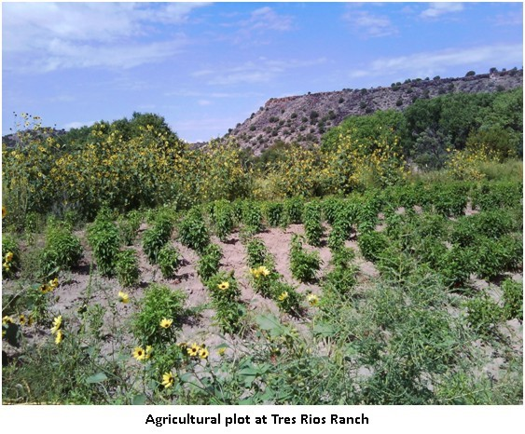
Farming, ranching, and the acequia irrigation systems have been the defining characteristics of land use and settlement of communities in the La Cienega and La Cieneguilla Planning Area for hundreds of years. The presence of ojos or springs that formed the area's cienegas or marshes have been tapped by settlers to irrigate crops, water livestock, and sustain households. The agricultural and community traditions formed around acequias have defined where people built homes and how the community grew since at least the early 1600s. Collective maintenance and management of acequias was a primary basis of community governance along with stewardship of both land and water resources needed to sustain the communities. The waterways and irrigation of fields has also led to the development of unique and vibrant riparian ecosystems. The rich legacy of agricultural production in the Planning Area includes grazing in dry upland areas as well as harvesting food, herbs and tree crops along the waterways and acequias.

Agriculture and associated farm activities are part of the history, culture, economic base and tradition of the area. Additionally, the agricultural economy is still an important component of the plan area and the County as a whole. Many residents have both full-time employment outside the agricultural sector and engage part time in tending to the orchards, vegetable farms and pastures of the plan area which contributes to the household food budgets and a diverse economy. A number of residents still earn their living entirely from farming. Without taking steps to revitalize local agriculture, residents fear that continued development will eliminate the option of farming in the valley and the communities will permanently lose agriculture along with the rural character of the Planning Area. Maintenance of agricultural production and protection of agricultural land are primary goals of this Plan. (See Maps 5 & 6 – Irrigated Agricultural Lands)

According to a hydrographic survey of the area completed by the State Engineer's Office in 1976, approximately 150 acres of land were potentially irrigable by community acequias, surface water sources such as springs, streams and rivers. Out of that 150 acres of acequia irrigated farmland, an estimated 80 acres are actively under cultivation. There are lands used for grazing located primarily on the large ranch holdings and public lands in the plan area.
Several factors will continue to positively and negatively influence agricultural production in the plan area:
- The growing demand for organic locally grown food by Santa Fe County residents and visitors has steadily grown. The Santa Fe Farmers Market provides a local venue for selling produce.
- New technologies applied to weed control and water conservation.
- Continued conversion of agricultural lands into home sites.
- Continued drought conditions and the drawdown of water supplies.
- A labor force that is aging.
- The selling off of water rights associated with the acequia systems.

The demand created for new housing drives real estate prices up as well as property taxes on undeveloped property. Higher property taxes and low returns from agriculture create economic pressure on Planning Area residents. The pressure encourages the sale and development of land traditionally used for agricultural purposes. Once land is converted to housing, it is virtually eliminated from future use in agriculture.

Local residents continue to look for viable means to preserve agricultural lands and protect them from development. Potential avenues include:
- Transfer of Development Rights Programs
- Conservation Programs
- Land Trusts
- Institutional Ownership
- Traditional Community Preservation Programs
- Bylaw provisions for acequias that require approval of the acequia prior to any transfer of water rights off the acequia as permitted by NMSA Section 73-2-21(E).
- Water banking provisions
- Restrictive covenants that prevent transfer of water rights from land.
- Establishment of recorded documents memorializing the acequia infrastructure and historic easement as established by statute to help protect and provide notice of the location of existing acequia works.

3.3.2 Agriculture Key Issues

- Agricultural land, including irrigated fields, orchards, and grazing areas, are being lost to new development. This significantly alters the local communities, as agricultural activities are integral parts of the rural character and historical heritage of the La Cienega and La Cieneguilla Planning Area.
- The changing agricultural economy and decreased use of agricultural lands helps encourage the conversion of farmlands to other development. A lack of education and promotion of economically viable agricultural practices exacerbates this problem for the typical small-scale farmer in the Planning Area.
- Lands managed by the Bureau of Land Management and the New Mexico State Land Office (NMSLO) currently provide opportunities for agricultural uses, such as grazing, within the Planning Area. However, if these lands should change to private ownership through land swaps or state development, they could be removed from use in the communities' traditional grazing practices.
- The drop in spring flows in and near the Planning Area has dramatically impacted local acequias and has made the practice of irrigation difficult because there is less water available for irrigating than the total number of irrigable acres. Residents and longtime irrigators have identified the drop in available water for irrigation as one of the biggest obstacles to maintaining agriculture in the area.

3.3.3 Agriculture Keys to Sustainability

The Community supports a number of the keys to sustainability expressed in the County’s Sustainable Growth Management Plan (SGMP), including:
- SGMP Goal 14: Preserve, support, promote and revitalize agriculture and ranching as a critical component of the local economy, culture and character.
- SGMP Strategy 14.1.5: Create an inventory of agricultural lands and conduct a land suitability analysis to identify agricultural potential and determine high priority of protection for agricultural soils and other sensitive arable lands, especially historical agricultural land with water rights.
- SGMP Policy 14.2: Support the practicality of agricultural uses to include financing tools to support viability of agriculture.
- SGMP Strategy 14.2.1: Create a transfer of development rights program for agriculture and ranch lands.
- SGMP Strategy 14.2.2: Assess and develop resource tools such as conservation easements, improvement districts, development of impact fees and grants to support the viability of agricultural uses.
- SGMP Strategy 14.2.3: Coordinate with local communities and organizations to promote the development of agricultural products and markets, including the development of farmers markets, buy-local campaigns, and a local products website to market and distribute fresh goods.
- SGMP Strategy 16.1.1: Develop education programs and outreach to support agriculture and ranching. Include materials on organic farming, year-round farming and better range management practices.

In Addition, the Community Plan includes these area-specific agricultural keys to sustainability:
- Protect all agricultural lands in the Planning Area.
- Maintain and enhance active agricultural production in the Planning Area.

5.11 TRADITIONAL IRRIGATED AGRICULTURAL LAND PRESERVATION (p. 82)

Maintenance of agricultural production and protection of agricultural land are primary goals of the community. Conversion of irrigated land into home sites often results in land that is no longer irrigated and left fallow shrinking the overall health of the agricultural lands. As an important connection to the history and an important aspect of the community’s rural character, the irrigated agricultural lands of the valley deserve special design guidance and incentives to individual property owners who continue to keep and/or assemble land for agricultural uses.

There is a need to promote the integrity of historic agricultural lands in the valley by incenting individual property owners to assemble and set- aside consolidated tracts of irrigated agricultural land. The strategy is to increase the value of irrigated agricultural lands by establishing zoning incentives, density bonuses, and transfers in conjunction with agricultural conservation.

LCLC Traditional Irrigated Agricultural Lands Maps in Figure 4 and 5 identify parcels that contain irrigated lands as identified by the OSE Santa Fe River Hydrographic Survey of 1972. Of the total acreage, approximately 150 acres are identified in the 1972 OSE Survey as surface or acequia irrigated land and should be considered as qualifying Traditional Irrigated Agricultural Lands, for which residential density bonuses and/or transfers can be established.

It should be understood that the parcels depicted on the map include land that is not currently or historically acequia or surface irrigated land. Buildable areas that employ density bonus’s should be encouraged to locate outside of the Traditional Irrigated Agricultural Lands; this reflects traditional patterns in the acequia landscape where prime farmland was preserved for farming. Development, including residential development, was relegated to the drier areas, the ejidos & altitos, above the acequia systems.

Residential Density Bonuses and Transfers

- On properties where irrigated agricultural land is preserved (by conservation easement, set aside, or other means) from any future development, properties may qualify for a residential density bonus (increase in the number of dwelling units allowed by the base zoning district or overlay) and/or the right to transfer density in the form of dwelling units to qualifying developments (See TDR Program above).

- Preserved agricultural lands should be registered as conservation easements or no build-areas recorded on the plat.

- Residential density bonuses and transfers will allow for increases to base zoning densities for residential development and in many cases decreases in minimum lots sizes.

- In order to accommodate density bonuses the County should first develop minimum regulations for the divisions of land as well as site development standards and regulations.

- Regulations and standards for land division and site development should include provisions for the following:

  - Development in the set-aside of Qualifying Traditional Irrigated Agricultural Land, ("no build area" and/or agricultural conservation easement):

  - Land used for roads, parking and private yards should not be counted as part of the set aside. No buildings or structures should be permitted in the set aside except as incidental to agricultural uses such as green houses, sheds or corrals. Underground and above ground utility easements and land accommodating septic systems, acequias, drains or laterals can be counted as part of the set-aside.

Development in Buildable Areas:

Procedures, regulations and standards based on the intent and purpose of the underlying land use designation or base zoning districts should be established to regulate and guide development with increased density due to the use of density bonuses. Particular attention must be paid to water supply and wastewater treatment in conjunction with density and soils suitability. It is anticipated that high performing septic systems and shared wells or hook up to County or community water and waste water systems will be necessary for increased density on most sites.

Incentives should be increased for density bonuses that are transferred to qualified developments outside of parcels associated with the Traditional Irrigated Agricultural Lands.

Density bonuses in the form of residential units should be established if development right is transferred to a qualifying development outside of a parcel associated with Traditional Irrigated Agricultural Land. Transfer of the development right should be submitted as part of the development application for the qualifying development and include the set-aside of qualifying Traditional Irrigated Agricultural Land in the form of an agricultural conservation easement and/or no-build area depicted on an approved site plan or subdivision plat.

5.10 TRANSFER OF DEVELOPMENT RIGHTS (TDR) PROGRAM (p. 80)

The purpose of the TDR Program TDR’s is for the conservation of natural, scenic, and/or agricultural qualities of open land, areas of special character or specific historic, cultural or aesthetic interest or value, or encviironmental protection such as watershed, steep slopes, floodplains, etc. The following are suggested guidelines for the creation of a TDR program. Actual program regulations will l be developed in conjunction with the County, based on current conditions.

A TDR program will be developed in order to preserve:

- Traditional agricultural lands for agricultural use.
- Archeological or cultural sites as identified by Federal or New Mexico State registry.
- Other sites as determined by future community review and amendment of this Plan.
- Open Space property.

Participation in the TDR pProgram will beis voluntary, and no development restriction or other penalty should be imposed by non-participation.
.
The initial implementation of the TDR program should prioritize the preservation of traditional agricultural lands for agricultural use.

The program should identify Sending and Receiving Areas (SAs and RAs) within the La Cienega Planning Area.

Sending Areas (SAs)

SAs are specific properties eligible to send or transfer their development rights to other properties. Each property shall be evaluated by means of professional appraisal or other acceptable valuation method. The valuation should be used to determine the number of development rights, or Development Units, for the property. The valuation is not necessarily the “selling price” or “market value” of the property or the Development unit.

Proposed Sending Areas:

A) Traditional Agricultural Lands

- Properties identified as having traditional agricultural lands should be identified and mapped. A land parcel need not be identified as 100% traditional agricultural land to be qualified for the TDR program. The portion of a qualifying land parcel that is identified as having traditional agricultural use shall be used to determine the Development Units available. For example, if a five acre parcel has two acres of traditional agricultural land, the two acres shall be used in calculating the number of Development Units available to the parcel. Development rights transferred from the parcel should only affect the two acres of agricultural land, and the remaining three acres of the parcel should maintain base zoning density.

- To qualify as traditional agricultural land, the land must be identified as having long-term agricultural use. Surface irrigation water rights from current or past acequias, or traditional use of acequias waters with or without identified rights, may be used to identify qualifying lands.
Traditional surface water irrigation from local streams and rivers, whether by acequia or not, may be used to identify qualifying lands. Other means of qualification of lands may be employed.

B) Archeological or Cultural Sites

- Properties identified as having archeological or cultural sites should be identified and mapped. A land parcel need not be identified as a 100% archeological or cultural site to be qualified for the TDR program. The portion of a qualifying land parcel that is identified as having an archeological or cultural site should be used to determine the Development Units available.

- To qualify as an archeological or cultural site, the site must be identified by federal or New Mexico registry of such sites. Sites note currently identified by federal or state registry may become eligible if they are included in future Federal or State registries.

C) Open Space
▪ Properties or portions of properties can qualify for the TDR program to maintain continuous sections of open space for viewscapes, and trails.
o La Bajada Ranch may be used as a sending area to maintain open space.

D) Tres Rios Ranch portions included in the Traditional Community
▪ To preserve this site for historical and agricultural uses the site has been identified as a Sending Area.

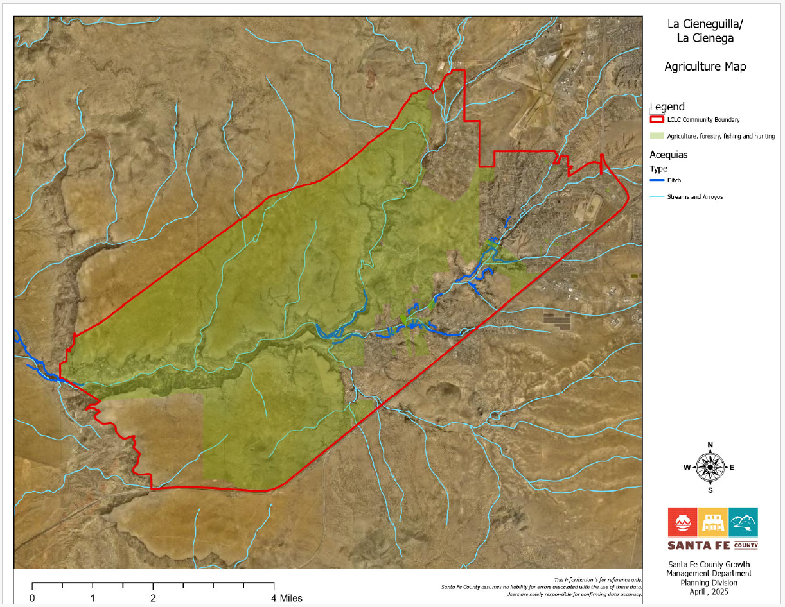
ADD LABEL
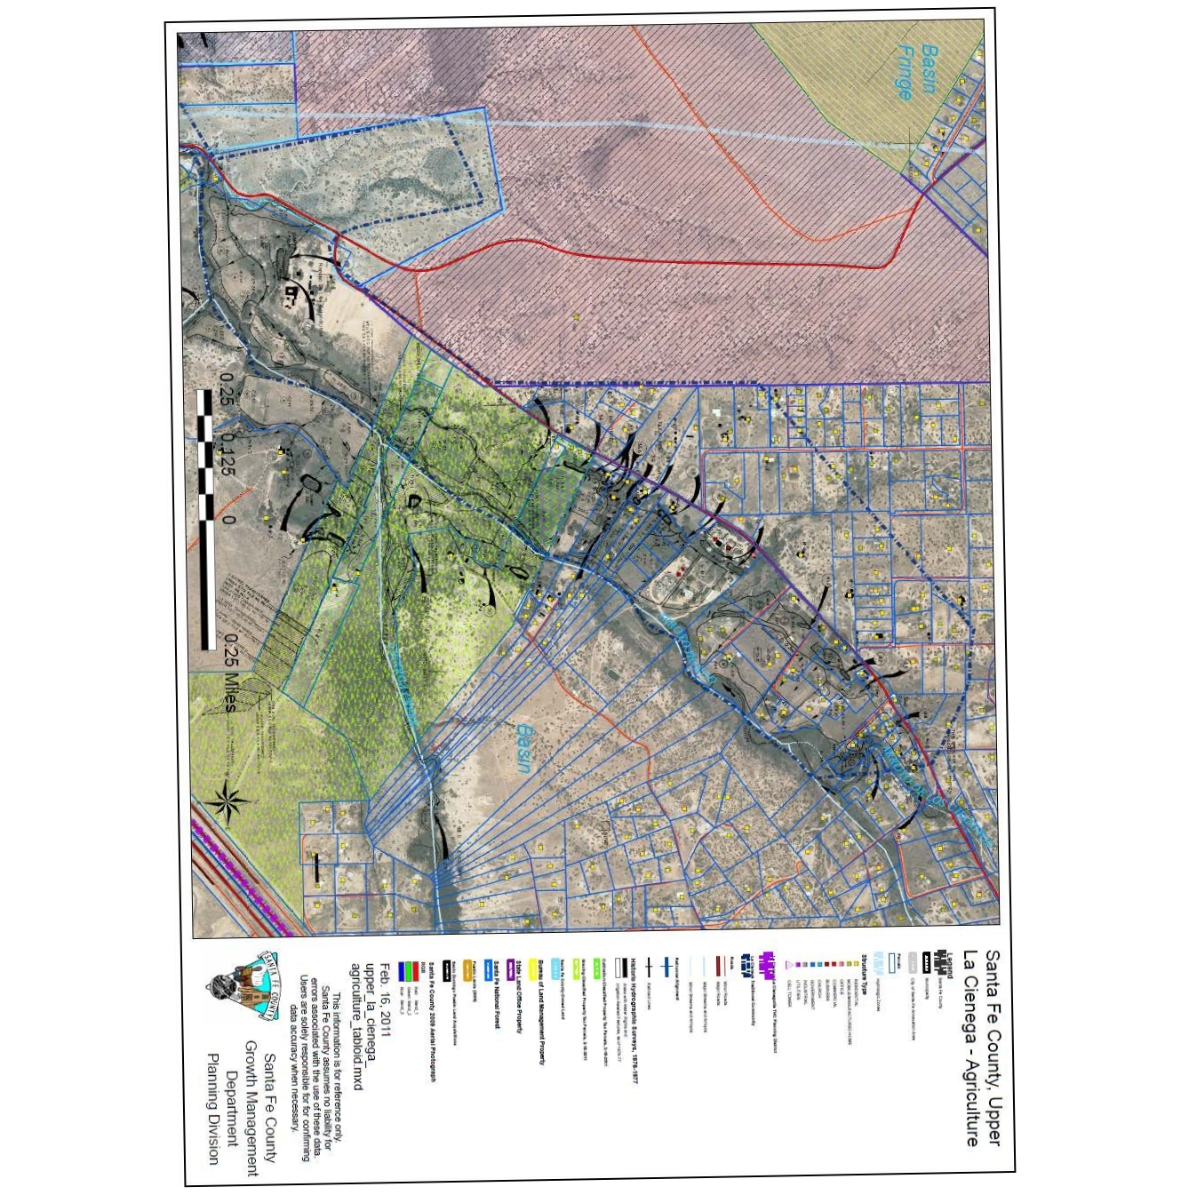
Figure 4 Upper La Cienega Agriculture Map.

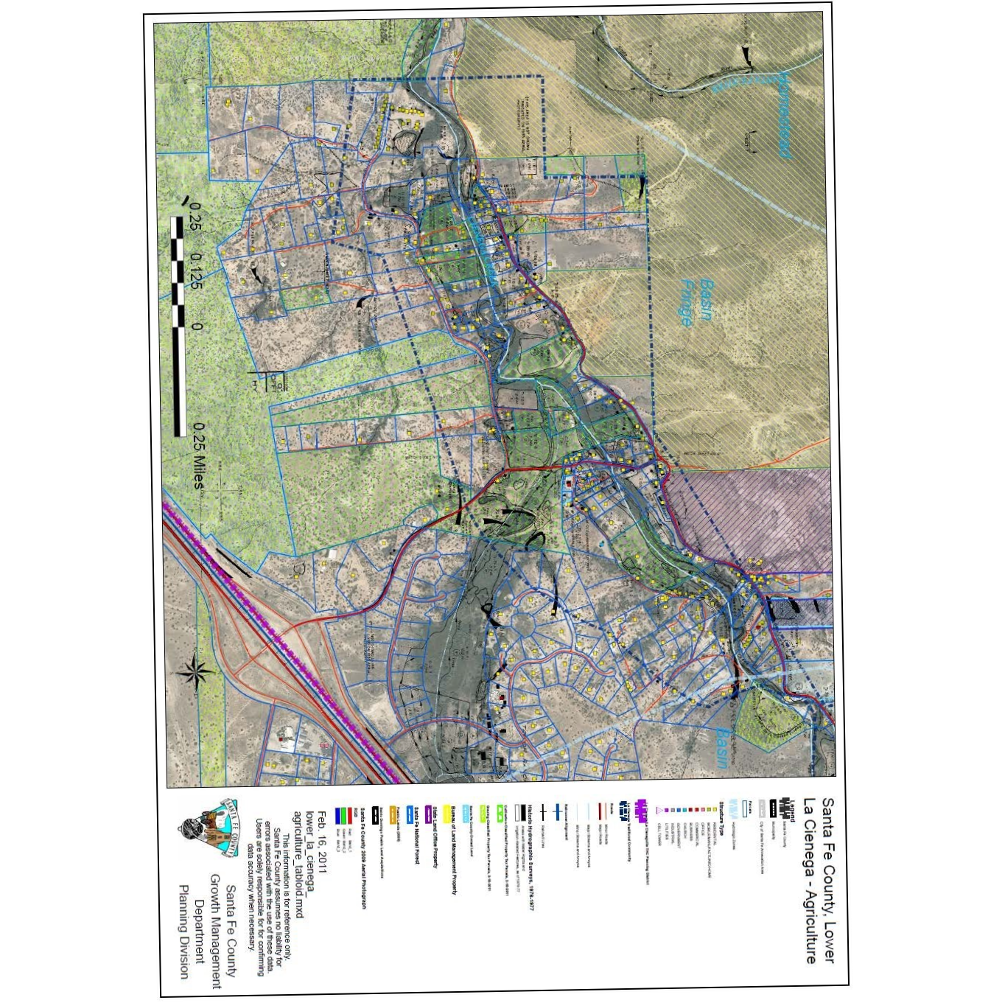
Figure 5 Lower La Cienega Agriculture Map

CHAPTER 2.4. OPEN SPACE & RESOURCE CONSERVATION

3.7 COMMUNITY OPEN SPACES, TRAILS & PARKS (p. 61)

Note: Some portions of the “community facilities” content is not open space-specific and will be moved to a different section of the Plan.

3.7.1 Open Space

Areas traditionally used as community open spaces are being lost to new development. While these common land areas are often privately held, development effectively removes them from the undeveloped landscape which has traditionally been used for grazing, riding and walking and has helped define individual villages by forming buffer areas between communities. The development pressures threaten the traditional rural character of the Planning Area characterized by farm fields, acequias, and open lands. The open lands and buffers between development are significant characteristics of the rural, agricultural and historical identity of communities in the La Cienega and La Cieneguilla Planning Area.

Open spaces and undeveloped areas in the La Cienega and La Cieneguilla Community Planning Area include County open space property, Bureau of Land Management properties and lands managed by the New Mexico State Land Office. Open space areas throughout the Planning Area contain significant ecological and cultural resources that have not been completely inventoried, and some areas have not had management plans developed to date. It should also be noted that extensive study has been conducted on the adjoining BLM designated Area of Critical Environmental Concern (ACEC) and that the BLM has cooperated with community members in developing management strategies. Residents of La Cienega and La Cieneguilla have always considered these lands to be integral and essential parts of the communities. The Plan supports continued and enhanced joint management between community members, private landowners, the BLM, the County, and the State Land Office.

La Cieneguilla Open Space

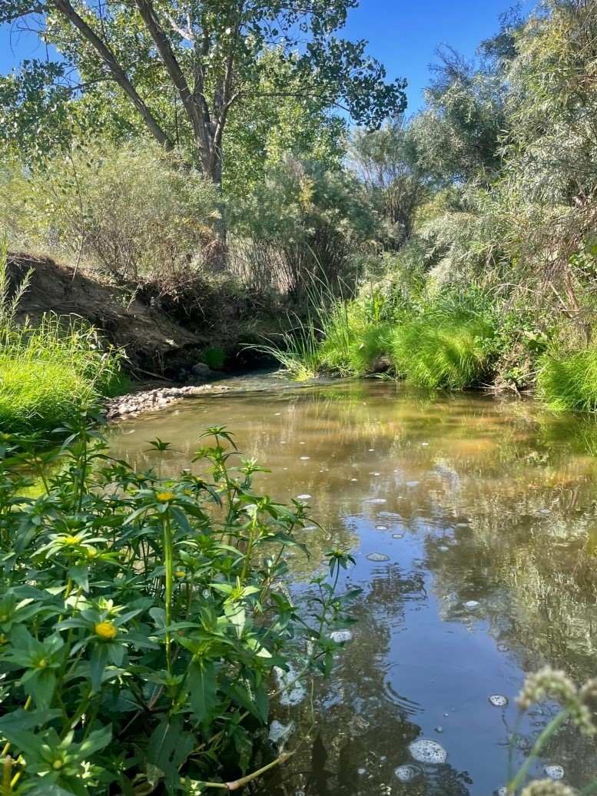

La Cieneguillla Open Space comprises two parcels equaling 150 acres that extend from the east riparian zone of the Santa Fe River northwest to the HIPICO equestrian event center and bounded on the west by County Road 36C. In the late 1990s, these parcels – along with adjacent parcels now owned by the Bureau of Land Management – were slated for subdivision development by a private landholder, Santa Fe Land Partners L. P. As a result of extensive efforts by local citizens, who were alarmed at the potential loss of valuable open space that significantly contributes to the traditional character of the La Cienega and La Cieneguilla communities, Santa Fe County purchased what is now La Cieneguilla Open Space in late 1999, making this the first open space acquired for the county’s Open Space, Trails, and Parks program.
La Cieneguilla Open Space preserves the region’s scenic beauty, rural landscape, diverse natural resources, connection to public land, and potential for interpretation, education, and outdoor recreation. The open space includes important wildlife habitat, especially in the riparian zone along the Santa Fe River. Notable species include Narrowleaf Milkweed (Asclepias fascicularis), upon which the Monarch butterfly (Danaus plexippus) is reliant for reproduction. To guide management of these resources, Santa Fe County, in cooperation with Ecotone Landscape Planning, LLC, developed the La Cieneguilla Open Space Management Plan in 2016.

El Peñasco Blanco Open Space

This open space within the traditional village of La Cienega is comprised of three parcels totaling 93.4 acres along the north side of Los Pinos Road: Las Golondrinas parcel, El Peñasco Blanco parcel, and El Tanque parcel, which is separated by a private lot to the west and includes a large irrigation pond that feeds into an acequia. El Tanque and El Peñasco Blanco parcels were identified by La Cienega Valley Association as potential county open space when put up for sale by the landowners’ heirs. Las Golondrinas parcel had been under ownership of El Rancho de Las Golondrinas living history museum. As it directly borders the El Peñasco Blanco parcel, the county identified preservation of this portion of the museum’s property – either through a conservation easement or acquisition as county open space – as a prerequisite for simultaneous protection of El Peñasco Blanco. Santa Fe County purchased El Tanque Parcel in 2002. Following three years of negotiations, the county completed the purchase of the remaining two parcels in 2005.
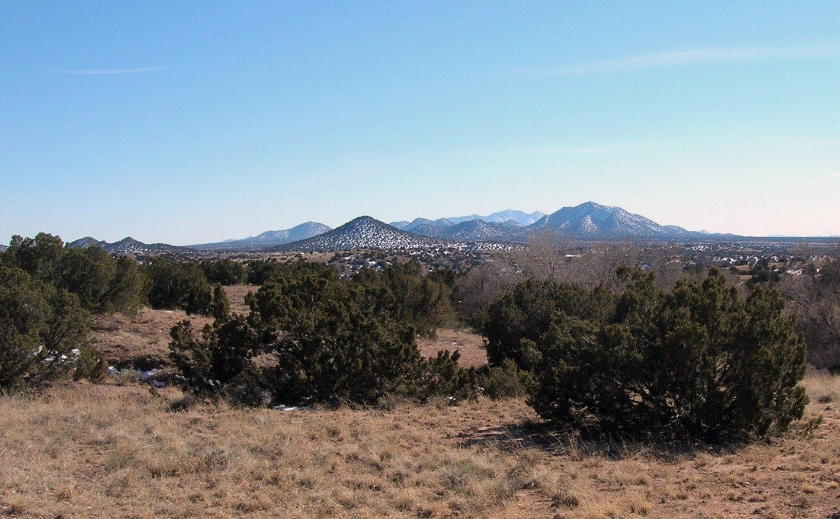
El Peñasco Blanco Open Space protects La Cienega’s traditional landscape and offers views of the Cerrillos Hills and Ortiz Mountains.
Local community members including the heirs to El Tanque and El Peñasco Blanco parcels, along with county staff and resource professionals, identified numerous objectives and values for supporting the preservation and protection of El Peñasco Blanco Open Space. The property connects the community of La Cienega to other public lands (Bureau of Land Management and New Mexico State Lands), opening opportunities for future trail networks. The property’s unique natural beauty includes the white and gray rock formations from which the open space gets its name, which served as an important landmark for those traveling along El Camino Real de Tierra Adentro. Las Golondrinas parcel includes a perennial spring and riparian corridor, sustaining plants and wildlife. Lastly, the protection of these parcels preserves the historic viewshed from El Rancho de Las Golondrinas living history museum, which helps the traditional community retain its historic landscape, and makes it possible for museum visitors to feel immersed within earlier eras of this region’s human occupation.

3.7.3 Community Open Space and Facilities Key Issues

- Lands managed by the Bureau of Land Management (BLM) and the New Mexico State Land Office (NMSLO) currently provide open space opportunities within the Planning Area. However, if these lands should change to private ownership or control through land swaps or state leases, they might be removed from the communities' traditional open space and buffer areas.
- Open space areas throughout the Planning Area including the County open spaces, BLM lands and NMSLO lands require a coordinated, community-based management plan to maintain and protect these resources while allowing for community uses.
- New development on private lands threatens to build over many of the buffer areas and traditional open spaces which help define the rural character of the community.
- Use of off-road vehicles and firearm discharge/target shooting in unauthorized areas as well as garbage dumping on open lands in the Planning Area have also been identified as problems. BLM is currently planning to relocate the target shooting area near the Planning Area to a more suitable and safe location.

3.7.3 Community Open Space Key Issues

Community members support a number of the key issues expressed in the County’s Sustainable Growth Management Plan (SGMP), including:

- SGMP Goal 44: Ensure that adequate public facilities and services are provided and maintained.
- SGMP Goal 45: Equitably finance facilities and services.
- SGMP Policy 44.2: The provision of new infrastructure and facilities should be coordinated with existing infrastructure and facilities and should maximize use of existing facilities’ capacity to the extent that any exists.
- Protect and maintain all open space areas as an integral part of the community.
- Provide ecologically and culturally sensitive management of open spaces and trails in the Planning Area.

5.14 PARKS, TRAILS & OPEN SPACE (p. 94)

The following locations and functions are identified to assist in planning for a future parks, trails and open space network that serves the La Cienega and La Cieneguilla communities.

Central Plan Area

A developed community park should be designed and established as part of the proposed community center on State Land Office land in the central plan area. Additionally, a pedestrian and biking trail with some educational signage should be developed to connect the community center to adjacent County Open Space land. The community park and trail should be scaled and programmed to serve residents of La Cienega and La Cieneguilla. This trail may be connected to the City of Santa Fe’s Santa Fe River Trail system and throughout the communities of La Cienega and La Cieneguilla.

La Cieneguilla

A neighborhood scale semi-developed park should be developed in conjunction with any new subdivision on the large undeveloped 40-acre tract located off of Paseo Real. The park should be scaled and programmed to serve residents of La Cieneguillla.

Upper La Cienega

A neighborhood park should be developed in conjunction with expected new development in the commercial district associated with Eagle Ridge formerly known as the Santa Fe Downs property. It should preferably be located in the transition area from higher density/commercial land use and adjacent existing residential areas south and west of the commercial district. It should be scaled and programmed to serve the existing residents of upper La Cienega and the future residents of the commercial district.

Lower La Cienega

Dedicated community open space with trails should be developed in conjunction with expected new development associated with Santa Fe Canyon Ranch. There is a potential to provide trail linkages for pedestrians and equestrians to regional trails associated with Arroyo Hondo and Alamo Creek as well as links through Tres Rios Ranch to BLM land in western portion of the plan area. Open space and trails in this area should be scaled and programmed for the La Cienega and La Cieneguilla communities as well as any future residents.

Southeastern Plan Area

A pedestrian, biking and equestrian trail parallel to but offset from the I-25 West Frontage Road should be developed from Entrada La Cienega to Eagle Ridge formerly known as thethe Santa Fe Downs.

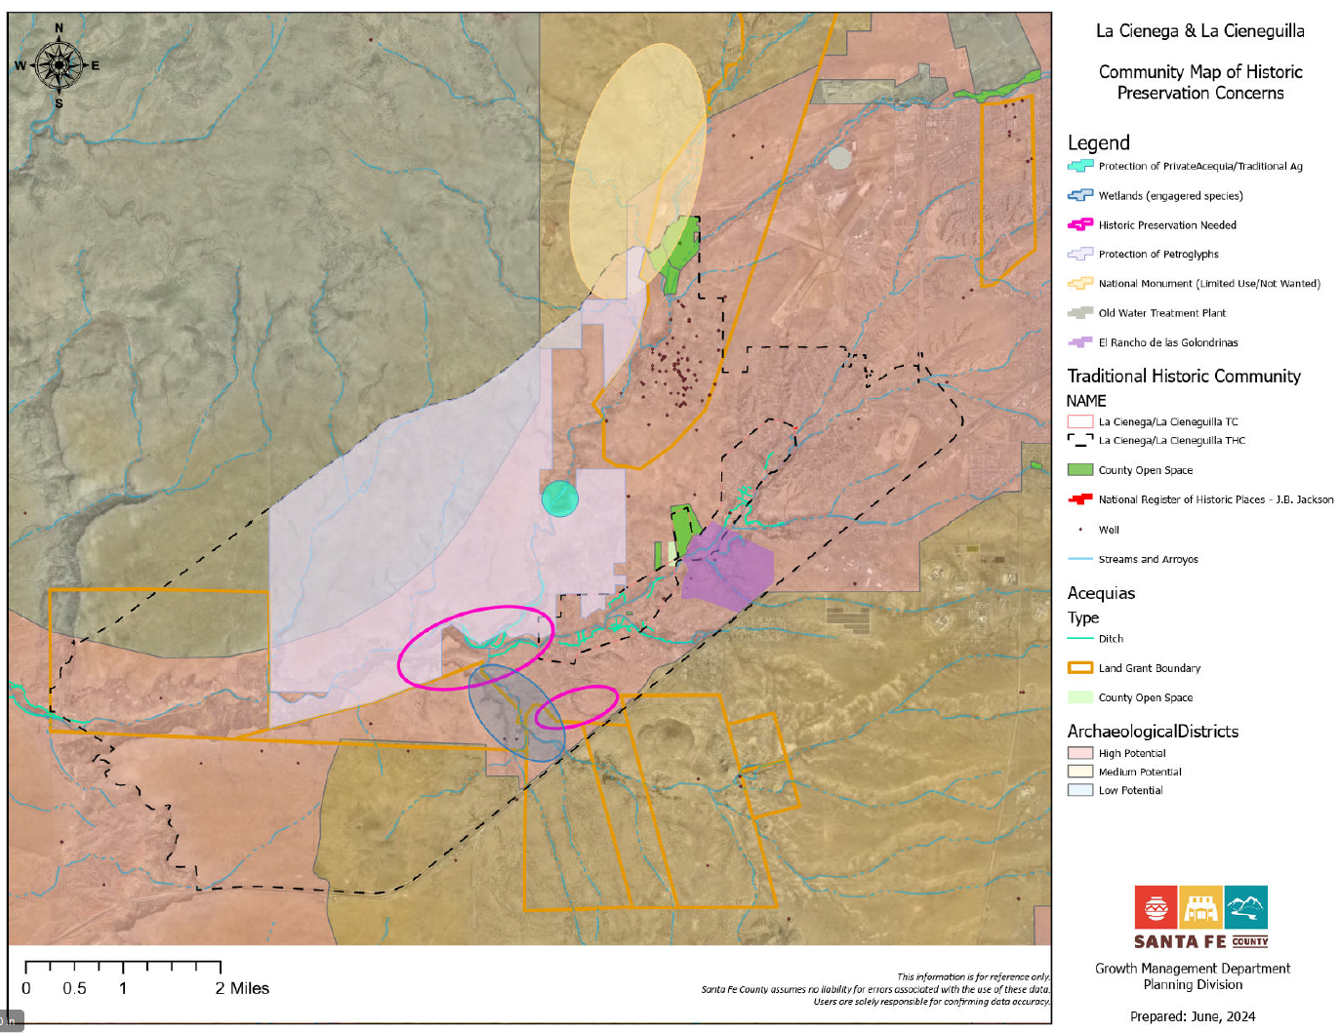
Sections mentioning “La Bajada Ranch” in the 2015 Plan
NOTE: create an entire La Bajada Ranch sub-section
(p. 25)

- County Purchase of Santa Fe Canyon Ranch. In 2009, Santa Fe County acquired 470-acres of the Santa Fe Canyon Ranch property (also known as La Bajada Ranch) composed of several additional large parcels which comprise a total of approximately 1,300 acres with an approved master plan for 156 single family residential units with a gross density of 2.58 acres per unit. The County has established a steering committee to review development options and potential uses. A 2010 survey of residents conducted by the County revealed a community preference for the property to be preserved as open space or developed with low-intensity land uses such as recreational facilities. The Master Plan was revised in 2014 to remove the large parcels and the remaining Master Plan consists of 470 acres slated for potential development.

TDR Sending Areas (p. 86)

C) Open Space
▪ Properties or portions of properties can qualify for the TDR program to maintain continuous sections of open space for viewscapes and trails.
o La Bajada Ranch may be used as a sending area to maintain open space.

TDR Receiving Areas (p. 87)

- La Bajada Ranch tracts owned by Santa Fe County comprising approximately 470 acres.
  - The development density is limited by on-site water resources, as specified by the La Cienega Ordinance 2002-9. Application of TDRs may be used to increase the limit established by on-site water resources. Increased density allowed by TDRs in this manner shall require imported water. Use of TDRs to increase density by importation of water shall not exceed more than 110% of the maximum density specified by the Land Use category.
  - If non-residential uses are permitted through master planning or other means, the application of TDRs may be used to increase the maximum lot coverage as established by on-site water resources. Increased density allowed by TDRs in this manner shall require imported water. The density may be adjusted as the TRD program is developed in order to promote and encourage the viability of the program.
  - Valuation of the tracts should be used to determine the number of Development Units required to increase density through the use of TDRs. A specific ratio shall be determined for the number of Development Units needed to import water for each residential unit or Mixed Use density unit.

CHAPTER 2.5. PUBLIC SAFETY

3.5.3 Fire Protection
The La Cienega and La Cieneguilla Planning Area is served by the La Cienega Fire District which is responsible for providing fire and emergency medical services to the communities of La Cienega, Rancho Viejo, Cochiti Pueblo, Cochiti Village, Valle Vista, the Santa Fe Community College. Its two stations are located outside the plan area and within the plan area at #18 Camino San Jose. The district responds to approximately 450 fire and EMS calls a year with 10 certified Firefighter/EMT's serving approx. 70 sq. miles, a major interstate, large residential development and an ever-increasing commercial development area along state highway 14. The district assists and receives aid from other agencies including NM State Forestry, US Forest Service, the City of Santa Fe, Cochiti Pueblo, Sandoval County Fire Department, as well as other Santa Fe County Districts.

The La Cienega Volunteer Fire Department was originally started approximately twenty-eight years ago because several of the residents, who were also farmers at the time, would burn off / clear fields in preparation for yearly planting. These fires would sometimes get out of control in the La Cienega Valley bringing them (the residents) together to fight the field fires with whatever resources and personnel they had available. The department started with a garage donated by a resident/member for housing of a 4x4 brush truck on loan by the forest service. Years later, on land donated next to the community center, the members/residents built the current substation (then main station) with donated building materials and labor. Members were trained to basic firefighter levels (no certifications available) however no medical/first aid was available at the time. The organized volunteers responded to approximately 10 calls a year with a used fire engine and borrowed firefighting equipment.

3.5.4 Public Safety Key issues

- The communities of the Planning Area have seen a dramatic increase in population over the past two decades. The increase in residents and home sites has outstripped fire protection infrastructure development. This has led to a lack of accessible and adequately functioning fire hydrants throughout the Planning Area.
- Five of the eight working fire hydrants in the planning boundary do not have adequate water pressure to meet fire suppression needs.
- The working fire hydrants are not positioned to provide timely service to all parts of the Planning Area.
- The La Cienega Fire District does not have enough volunteer members from the Planning Area. More local volunteer firefighters would improve its ability to provide timely responses to emergencies.
- Developments and subdivisions in the Planning Area have been created with commitments to develop adequate fire protection services to new residences and subdivisions. The actual installation of such facilities was not often observed at the community level in the past and residents have expressed concern that facilities may not be fully developed or may not be in proper working order.
- Permits for burning agricultural fields are necessary for local farmers yet are difficult to plan due to potential conflicts.
- Riparian areas throughout the planning area have a build up of growth and need clean up to mitigate fire risk.

3.5.5 Community Services Keys to Sustainability

The Community supports a number of the keys to sustainability expressed in the County’s Sustainable Growth Management Plan (SGMP), including:
- SGMP Goal 28: Establish and maintain an all-hazard emergency response plan for Santa Fe County.
- SGMP Goal 29: Preserve and protect public health, safety, welfare and property through adequate provision of law enforcement, fire and emergency response, and emergency communication services.
- SGMP Goal 30: Establish and maintain an 911 public education/community outreach program.
- SGMP Goal 31: Obtain and utilize the latest in emergency communications equipment and technology.

In Addition, the Community Plan includes several area-specific keys to sustainability:
- Improved fire safety throughout the La Cienega and La Cieneguilla Planning Area.
- Increased membership of Planning Area residents on the La Cienega Volunteer Fire Department.

CHAPTER 2.6. TRANSPORTATION

3.4.1 Introduction

Significant changes have occurred since the adoption of 2001 Plan that influence traffic conditions and transportation options for the community. New public transit services available just north of the plan area have increased connectivity to the wider region and enhanced the mobility of mobility-restricted residents. Continued residential growth in the plan area has led to increased daily traffic volumes on many roads and the community continues to be concerned about road safety and traffic violations. Residents in some neighborhoods of the plan area have petitioned the County to considered traffic calming measures to increase safety for all users including seniors and children. Similarly, communities across the state are examining their road networks for ways to strengthen overall health of the residents by preventing accidents and increasing opportunities for exercise in the form of walking, horseback riding or bicycling.

3.4.2 Roads

The planning area's roads are often narrow and winding. They were created over several centuries, beginning with the Camino Real de Tierra Adentro from Mexico City to Santa Fe and have been continually developing to serve increasing populations while also following natural contours of the landscape.

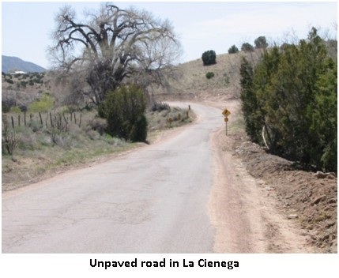
The majority of roads in the planning area are County owned and maintained. The planning area is accessed from the northeast by the I-25 Frontage Road and Los Pinos Road (CR 5), from the northwest by Paseo Rael, (CR 56) and from the southeast on Entrada La Cienega. Access from Interstate Highway 25 is provided at three intersections: at NM 599, at Exit 271 and at the Waldo exit to the south, near the La Bajada precipice.

The County conducts minor repairs of its roads on a regular basis. Overlays and repaving occur less frequently. Several years ago, the Board of County Commissioners established the Road Advisory Committee. The Board re-established a Transportation Advisory Committee via Resolution 2013-13 which consists of 13 community volunteers, appointed by the Commission, who represent areas throughout the County. The Committee meets monthly and advises staff on road conditions or problems in their respective areas. Additionally, the Committee prepares an annual Road Improvement Priority Program which lists the County's priority projects. The program is provided to the legislative delegation and becomes the basis for most of the projects funded by the legislature. County Road projects in the plan area are identified on the County’s Road Surface and Proposed Road Maintenance Projects Map (SGMP 2010), page 40. All Road planning should account for drainage from the roadways onto adjacent properties and take steps control drainage from roadways where needed.
Future and on-going transportation studies, plans and projects adjacent to the plan area present potential impacts and/or opportunities for the plan area. These include:
- The extension of Jaguar to NM 599 (Veterans Memorial Highway) which will provide a major connection to I-25 and the relief route to new and growing developments associated with Tierra Contenta. A major interchange at the intersection of Jaguar and NM 599 just south of the airport which will serve the planned Pavilions Development and possibly access to the Airport.

- A study conducted by NMDOT and completed in 2009 proposed new interchange at the signaled intersection of NM 599 and I-25 West Frontage RD as well as the extension of the frontage road in the right-of way paralleling the south side of NM 599, the realignment of the I-25 West Frontage Rd and a new local access road providing access to properties associated with Erica Road and Santa Fe Downs. This project is on the NMDOT and Santa Fe MPO list and will be started when funding becomes available.

- The SGMP Future Road Network Map shows a proposed study of a future road extension between State Highway 14 approximately 1 mile south of the Penitentiary to the interchange at I-25 and Entrada La Cienega.

- The City of Santa Fe is in the process of creating a new exit off of 599 directly to the Santa Fe Regional Airport.

3.4.3 Traffic

The main source of traffic is from local residents with additional traffic generated by several tourist sites located in the planning area. Numerous large and small businesses and home occupation businesses located throughout the planning area generate additional traffic. Due to its proximity to Santa Fe, the area also receives some tourist traffic from "scenic drives" to enjoy the rural character and setting. Presently there are three relatively major generators of traffic in the plan area that generate traffic during specific events; Ojo Santa Fe, Las Golondrinas and Eagle Ridge formerly known as the Santa Fe Downs property.. Both are accessed via the I-25 frontage road. With the exception of the Transfer Station accessed off of Camino Capilla Vieja, major generators of traffic are not anticipated nor zoned for the interior of the plan area.

3.4.4 Traffic Accidents

Between 2006 and 2011 there were 167 traffic accidents. The roads with the highest accident frequency were Los Pinos Road (51 incidents), County Road 56 (26 incidents), and Paseo Rael (11 incidents). The areas around Los Pinos Road and Tierra Hermosa, Los Pinos Road and the Frontage Road, and Los Pinos Road and Camino Colores appear to have the highest frequency of traffic accidents. Steps should be taken to alleviate traffic at these intersections and other options such as stop lights or round abouts should be researched to make these areas safer.

3.4.5 Public Transportation and Transit

The NM Rail Runner Express commuter train station is located near the intersection of NM 599 and I-25, with current rail access to the City of Santa Fe, and south to Bernalillo, Albuquerque, Belen, and stops in between.

The station is within 1 mile of 3% of the plan area (43 parcels including Eagle Ridge formerly known as the Downs) but there is not an easy pedestrian trail or bicycle route connecting the area with the station.

Currently the plan area does not have public transportation or bus routes through the area. The closest connection to NCRTD buses is the Rail Runner Station where NCRTD buses pick up passengers for routes to the National Guard Facilities. The Santa Fe Trails bus service also has scheduled pick-ups at the station providing connections to a variety of locations in the City of Santa Fe. Another connection closer to the northwestern portion of the plan area and within a mile of La Cieneguilla to the Santa Fe Trails Bus System can be made at a bus station on Airport Road just east of its intersection with NM 599.

The Board submitted a Transit Plan to NCRTD in May 2015 which included a La Cienega and La Cieneguilla Pilot Route which is anticipated to begin in February or March 2016.The 2011 Transit Plan considered by the Regional Planning Authority identified the possibility of future transit services in La Cienega. Their recommendation for future transit services suggested the La Cienega and El Rancho de Las Golondrinas areas southwest of Santa Fe represent a potential future transit service market. Based on this recommendation, further discussions should be conducted with the La Cienega Valley Association and the developers of the La Cienega Farmers Market to develop a transit connection from the City of Santa Fe as well as transit connections from the Rail Runner Station at NM599.

A resolution approved by the County Commission in May of 2012 also recognized that residents of the plan area could benefit from a NCRTD bus route through the community. A Blue Bus route is proposed to start in 2016 and will go through the Planning Area and connect with existing routes at NM599. The specific routes and stops will be determined through a public input process in the months leading to the buses running.

Several plans for adjacent developments present potential impacts and/or opportunities for the plan area. The MPO Bicycle Master Plan identifies on-road and off-road bike lanes and trails in the plan area. On-road bike lanes which will require road widening are shown for both Paseo Rael and Los Pinos Rd. Both the Arroyo Hondo Trail and the Los Chamisos Trail are identified as key elements of the future regional bikeways network although it shows the trails stopping short of the plan area. Additionally, future bikeways planning for the proposed Pavilion development, adjacent to the airport and plan area on the north, will include bicycle paths along the Arroyo de Los Chamisos.

3.4.6 Transportation Key Issues

Key issues from the 2015 plan are still relevant today:
- Vehicles often travel at high speeds along the roads in the planning area. The majority of roads are quite narrow with sharp turns. The high vehicle speeds create hazardous conditions for other vehicles, pedestrians, and others sharing the roadways.
- Pot holes and poor road conditions exist on many roads throughout the planning area due to a lack of maintenance.
- Roads in the planning area are subjected to frequent washouts and erosion damage due to runoff from the arroyos, poor drainage and a lack of engineered drainage planning, the Santa Fe River, and other drainage problems.
- As the area has grown and tourist destinations have developed, increased traffic including large trucks and busses have created new safety hazards for residents, pedestrians, and livestock on the narrow roads and lanes within the planning area.
- Senior citizens, the disabled, and others who do not drive or have access to transportation lack mobility both within the valley and for trips to Santa Fe.
- Blind and sharp curves often do not have guard rails or other protections.
- Many roads leading to area homes have insufficient access for fire safety and emergency vehicles.

3.4.7 Transportation Keys to Sustainability

The Community supports a number of the keys to sustainability expressed in the County’s Sustainable Growth Management Plan (SGMP), including:
- (SGMP Goal 32) Coordinate with Local, State and Federal governments and transportation organizations to develop a cohesive, safe, and efficient transportation network and transit opportunities to serve County residents, workers, employers and visitors.
- (SGMP Goal 33) Expand safe, convenient and efficient public transportation services to encourage reduction in automobile trips and provide mobility for all people, including underserved populations.
- (SGMP Goal 34) Ensure safe, context-sensitive design standards for transportation improvements that reflect local preferences and the needs of all types of transportation users.
- (SGMP Strategy 34.5.1) Coordinate with the NMDOT to determine what types of traffic calming best management practices can be implemented along state highways which pass through communities in Santa Fe County.
- (SGMP Strategy 35.4.1) Establish a process for evaluating low-water crossings based on traffic volume, road type, runoff volumes, and conjunctive use of the drainage by wildlife and other traffic safety considerations.

In Addition, the Community Plan includes several area-specific keys to sustainability:
- Improved road and bridge infrastructure that maintains the rural character of the Planning Area.
- Improved drainage to prevent bridge and roadway washouts and flooding.
- Roadways that are safe and include traffic calming measures.
- Alternative transportation systems that do not rely on auto commuting.
- Signage that maintains the rural character of the Planning Area.
- Accessible public transportation services for Planning Area residents.

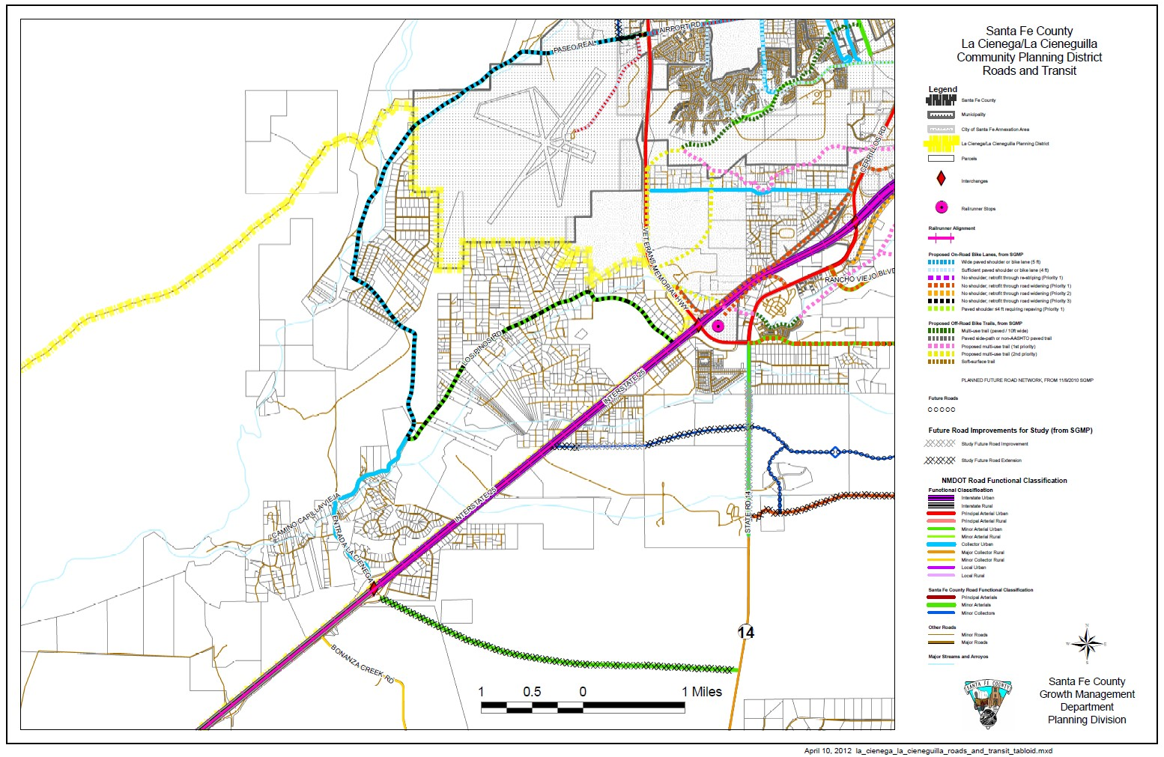
Figure 6 Plan Area Roads & Transit Information Map
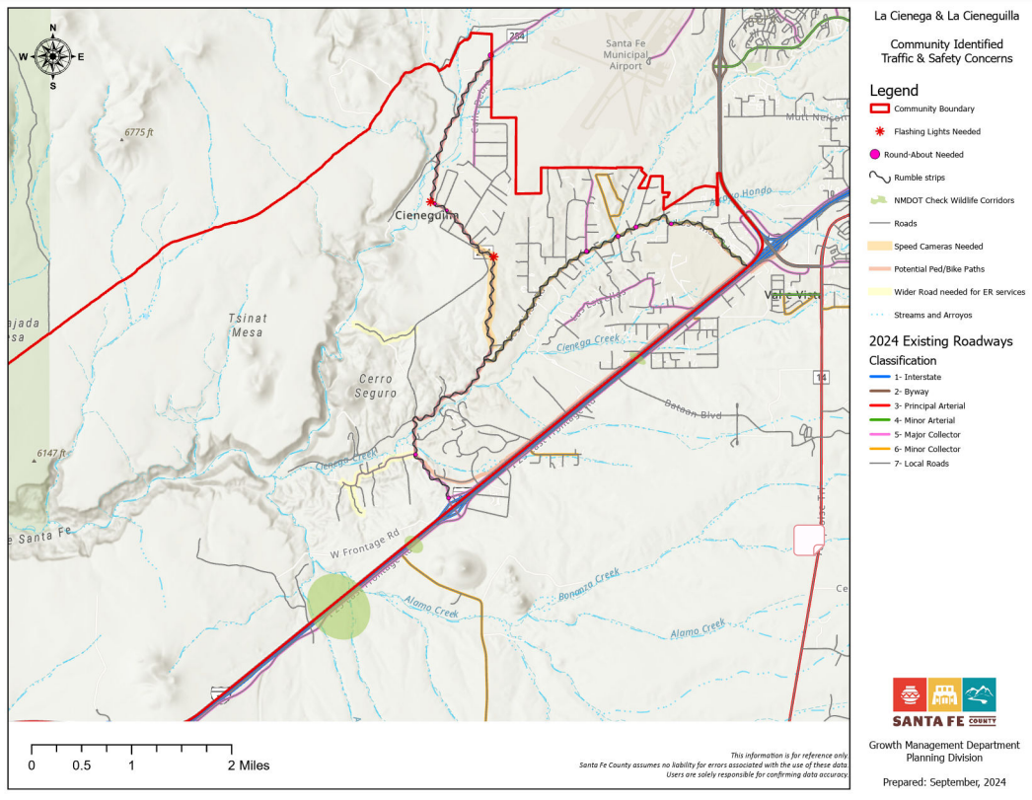

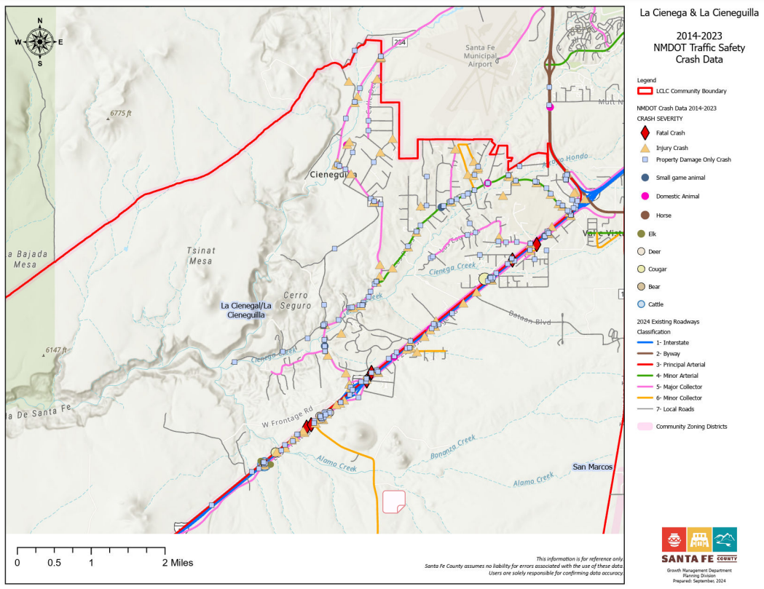

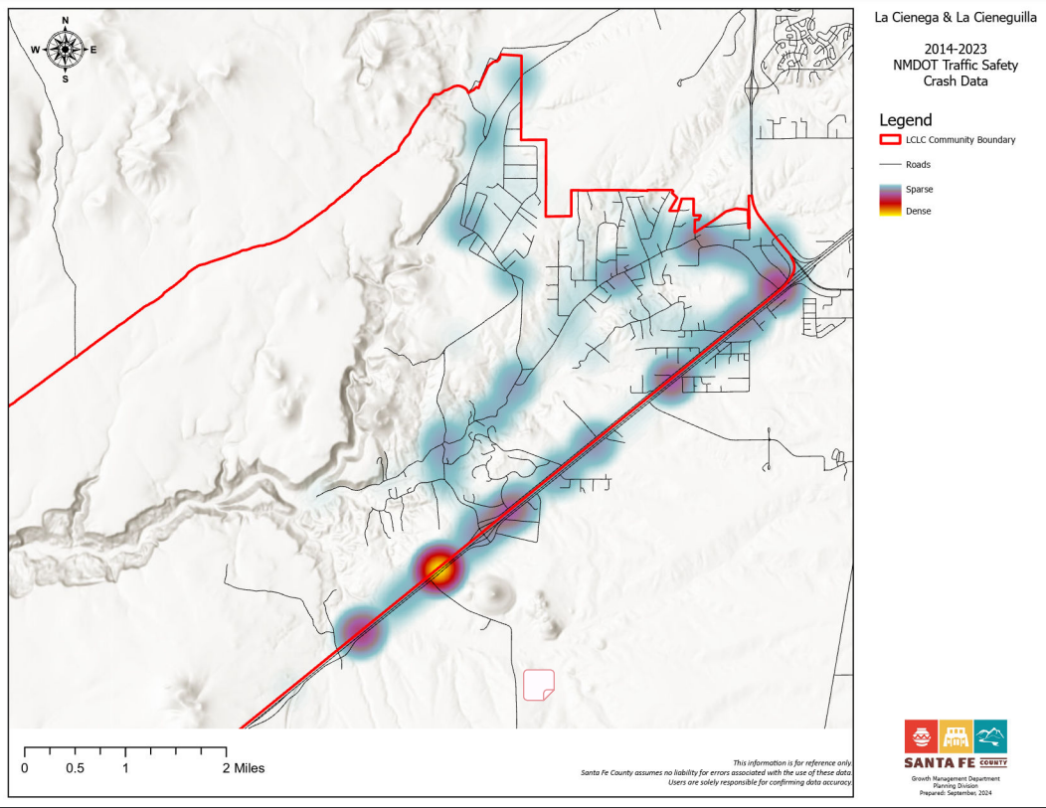

5.13 TRANSPORTATION AND ROADS (p. 86)

In addition to the goals, strategies and objectives for roads and transportation in Section IV, the following framework should be considered in all future road projects and maintenance routines for the plan area. SLDC design standards for roads should be reviewed as part of the drafting and adoption of the Community District. Road design standards should be communicated in a clear graphic representation of desired road profiles for each area type. Implementation of design standards for roads should be accomplished through amendments to the SLDC Chapter 9 La Cienega and La Cieneguilla Community District and associated overlay zones.

The County Roads and Planning divisions should work with community to determine/refine area type and identify unique contextual elements that will influence the design beyond those generalized below. These might include the church, community center, natural features such as large “heritage” trees, creeks, springs & arroyos, historic features such as archeological sites, acequias, bridges, and miscellaneous structures.

Users

Roadways in the plan area serve a variety of users including pedestrians, bicyclists, horse back riding, motor vehicle drivers and passengers. Selecting the appropriate treatment of the roadway to accommodate all users, (including children and the elderly) can influence the overall health of the community by preventing accidents while increasing opportunities for exercise in the form of walking or bicycling.

There may be a latent demand above observed pedestrian and bicycle volumes in the plan area because pedestrian and bicycle facilities do not yet exist or are substandard, or do not provide complete connectivity to key community locations such as the community center or church. Future pedestrian and bicycle facilities including paths, crosswalks, and transit stops should be considered in evaluating new or changes in land development, including any potential attractors such as schools, parks and retail uses.

Area Types

Roadways in the plan area traverse three distinct environments; rural open lands, traditional community areas, and rural developed areas, and are characterized by differing land uses, densities and topography with changes in the amount of pedestrian, bicycle and vehicle use. Land use dictates the function of a road; as land use changes along a road the roads functions also change. Roadways should be designed in a manner that serves the existing land use while supporting future land use goals. Traditionally, roadways have been classified either as “rural” or “urban.” It is important to recognize that a roadway’s formal classification as urban or rural (which is determined from census data using periodically-adjusted criteria adopted by the United States Office of Management and Budget) may differ from actual site circumstances or prevailing conditions.

Rural Open Lands

- This area type is associated with public conservation or open space shown on the future land use map, where the roadway travels through range land or other open space. There are few access points along the roadway and little or no development. Design constraints tend to involve topographic, environmental, scenic or historic resources. Pedestrian, bicycle and transit activity is usually infrequent and of low volume. However, there may be potential latent demand for bicycle accommodation on low-volume roadways traversing scenic rural areas.

- Most of Paseo Real from the intersection with NM 599 to the intersection with Los Pinos Road passes through rural open lands. It is currently a 2 lane paved road maintained by the County with a 35 mph speed limit through the plan area. A portion of Paseo Rael goes through La Cieneguilla in an area with single family homes, however very few of the properties front or have access directly onto Paseo Rael.

- The SLDC Official Map Functional Classification for Paseo Real is Collector Urban. SLDC Design Standards applied to collector urban classification requires 11’ lane width, two 5’ sidewalks, two 5ft on-road bike lanes and a Right Of Way (ROW) of 45-72 feet.

Traditional Community

- This area type is associated with the more compact built-up areas based on traditional acequia settlement patterns. Varied building setbacks, and frequent driveways and intersections are common. Individual property frontage is generally less than 200 feet. Right-of-way is usually constrained by the built environment. Pedestrian activity is generally moderate. At this time bicycle activity is low but often generated to, from, and within the traditional community. An important safety consideration for design is the often rapid transition between rural open lands or rural developed areas to a traditional community area.

- Major roads in this area include portions of Los Pinos and Entrada La Cienega. SLDC Official Map Functional Classification for the two major roads is “Minor Arterial Urban”. SLDC Design Standards applied to Minor Arterial (SDA-2) classification requires 12’ lane width, two 5’ sidewalks, two 5ft on-road bike lanes and a ROW of 60-100 feet.

- Minor roads include Camino C de Baca, Camino San Jose and Camino Capilla La Vieja. SLDC Official Map Functional Classification for these roads is “Local.” SLDC Design Standards applied to Local (Urban SDA-2) classification requires 10’ lane width, one 5’ sidewalk, and a minimum ROW of 34-48 feet.

Rural Developed

- This area type is associated with the low-density residential development based on contemporary subdivisions and occasional commercial uses. Buildings generally have large setbacks from the roadway. Occasional driveways require a driver to be more alert for entering and exiting vehicles than in rural open land areas. Pedestrian and bicycle activity are more frequent than in rural open lands area, but generally of modest scale.

- Major Roads in this area type include, Calle Debra, Camino Montoya in La Cieneguilla, Cerro Del Alamo, Sunset Road, Nancys Trail, Paseo De Angel, and Las Estrellas in upper La Cienega. The SLDC Official Map Functional Classification for these roads is “Other Major Local or Collector Road Not Officially Classified”. Although there are no SLDC Design Standards for this classification, standards that apply to Local (Urban SDA-2) classification requires 10’ lane width, one 5’ sidewalk, and a minimum ROW of 34-48 feet.

Potential Regional Commercial Node

Presently there are three relatively major generators of traffic in the plan area; Las Golondrinas Historic Museum during events primarily on weekends, Ojo Santa Fe property during regular business hours and Eagle Ridge formerly known as the Santa Fe Downs property when it is hosting events. Traffic for these generators is adequately accommodated via access from the I-25 Frontage Road, but additional access may be needed as Eagle Ridge is further developed.

Additional major generators of traffic are not anticipated nor zoned for the interior of the plan area. However, major traffic generators are expected if the area designated as commercial mixed-use is fully developed with urban densities and infrastructure. This area has large tracts of land, high visibility, close proximity and easy access to regional (NM 599) and interstate highway systems (I-25), the airport and regional transit systems including the Express Rail Runner Commuter Train and North Central Regional Transit Authority buses. Roads and circulation in this area should evolve as part of larger efficient, safe, multi –jurisdictional, multi-purpose circulation plan that encompasses land and facilities associated with the I-25/NM 599 interchange, the Airport and the Rail Runner Station.

Traffic Calming Measures

Residents living along Camino Capilla Vieja would like to see speed humps or other traffic calming measures to slow traffic. Several other areas in La Cienega have expressed an interest in traffic calming measures. Review and possible implementation of the County‘s Traffic Calming Policy, Resolution 2013-102, should be initiated at the neighborhood level. Once traffic calming has been implemented, monitoring of the performance of the project should be undertaken to assure that speeds have indeed been reduced, and to provide valuable lessons for future traffic-calming projects.

Transit Options
Currently, NCRTD’s Route 260 is temporarily suspended. There are no other transit options within the planning area.

3.6 AIRPORT (p. 57)

3.6.1 Introduction

The La Cienega and La Cieneguilla Planning Area is located directly south and southwest of the Santa Fe Municipal Airport. The airport was established in the 1950's and has expanded over the years as the region has grown. The airport currently serves as the main air traffic facility serving commercial, private and military aircraft in north central New Mexico. All of the populated areas in the Planning Area are within a 5-mile radius of the municipal airport. Current flight patterns for landing and departing from the facility regularly direct aircraft over the Planning Area.

The communities of La Cieneguilla and Upper La Cienega are located directly adjacent to the airport's southern boundary and a large portion of the Planning Area's population lives within two miles of the airport boundaries. These residents and communities have received rapid growth over the past two decades. Simultaneously, as demand for air service from the Santa Fe region has grown, airport operations have intensified. The proximity of these communities to the airport has led to increasing impacts from airport operations. Residents in the Planning Area have strong concerns that possible airport expansion will exacerbate the existing noise and disturbance problems. One intent of this plan is to develop stronger planning and communication between the Planning Area communities and the Santa Fe Municipal Airport in order to minimize and/or eliminate the airport's impacts on these communities.

3.6.2 Airport Key Issues

- The current Santa Fe Municipal Airport flight patterns and flight schedules create nuisances from noise as well as safety concerns for Planning Area residents.
- Training exercises conducted by the Air National Guard at and near the airport facility generate noise and vibrations due to low flying helicopters and jets.
- Expansion of airport facilities including increased or intensified use by commercial, residential and military aircraft will likely exacerbate existing noise and safety problems.

3.6.3 Airport Keys to Sustainability

- Mitigation of airport operation’s impacts on the surrounding communities in the Planning Area.
- Alteration of aircraft flight patterns to minimize flights over populated portions of the Planning Area.
- Adoption of a noise mitigation program by the Santa Fe Regional Airport.
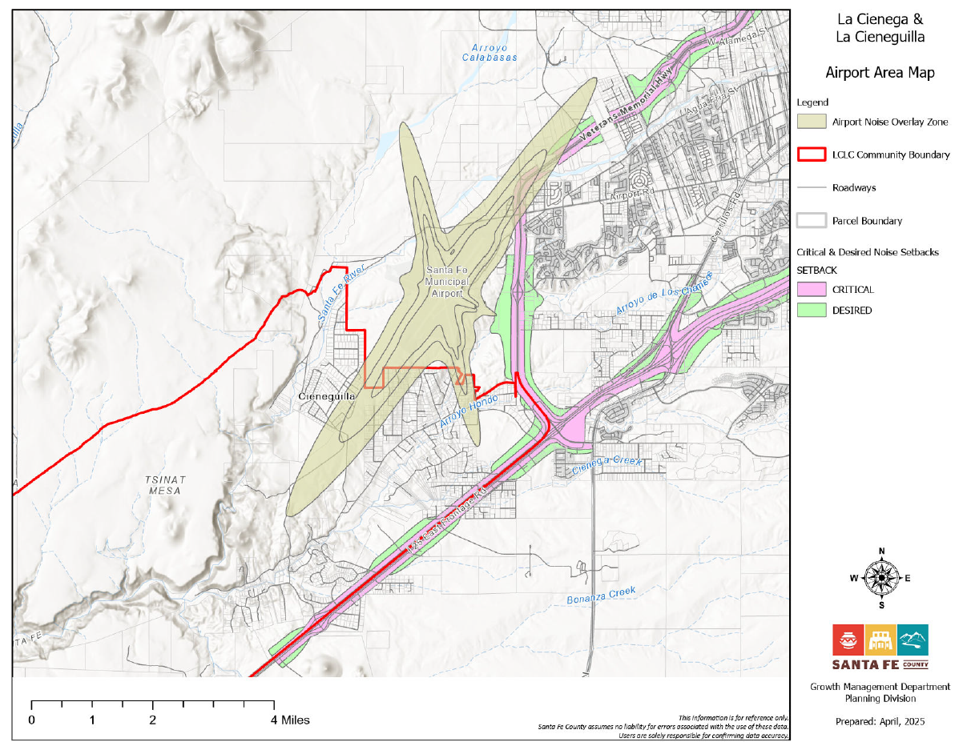
ADD LABEL

CHAPTER 2.7. WATER

3.1 WATER RESOURCES (p. 32)

3.1.1 Introduction

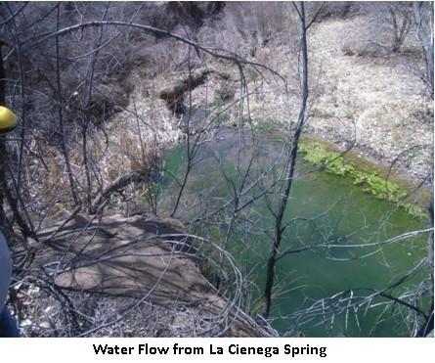
For centuries, the availability of water in the La Cienega and La Cieneguilla valleys has been a primary factor for area settlement by Native American, Spanish, Mexican, Territorial and United States settlers. Surface water is found in springs, streams, and river that the area is named after. Surface water has traditionally been used for domestic purposes, to water livestock, power mills and irrigate crops. By the mid-20th century, domestic use of the streams, rivers and acequias, or ditches, was minimized due to recognition of bacteriological cotangents, contamination and depletion of the aquifer. Household consumption from naturally-filtering springs continued, but there are now few if any remaining springs with sufficient quantity of flow to support a home. Following World War II, most valley households began replacing spring boxes with conventional wells, electric pumps and pressure tanks. The proliferation of water wells has been a major factor in altering the character of the valley communities. Traditional land and water use for agricultural purposes have been rapidly converted to serve residential development.

Due to residential and commercial growth in the basin including upstream communities in the greater Santa Fe area, substantial drawdown of the aquifer is occurring. The combined effect of aquifer mining throughout the basin as well as increased local demand for water has created a serious threat to ground and surface water resources in the La Cienega and La Cieneguilla Planning Area. While this Plan is applicable to the established Planning Area, it must be recognized that the water resources in the plan area are intrinsically tied to the entire basin. This includes large developed areas of the City of Santa Fe and Santa Fe County including the Community College District, areas east of I-25 associated with the Penitentiary, National Guard, Valle Vista neighborhood, and other developments in the Turquoise Trail area.
Since the 2001 Plan was adopted several factors in the larger watershed and water supply of the region have come into play that are having and will continue to have impact on the plan area water supply.
- Decreases in rain and snowfall and temperature increases have contributed to short and medium-term drought conditions.
- Several new studies and reports have confirmed continued drawdown of the aquifer with increases in isolated areas.
- The Buckman Direct Diversion project (BDD) has come on-line bringing a source of imported surface water from the Rio Grande to both the City and County water utilities. This has the potential to decrease the rate of ground water depletion by replacing service areas currently dependent on wells with the imported water supply.
- Dramatic increases in beaver populations along the Santa Fe River have impounded water, reducing surface water available to downstream irrigators, and likely increasing ground water infiltration

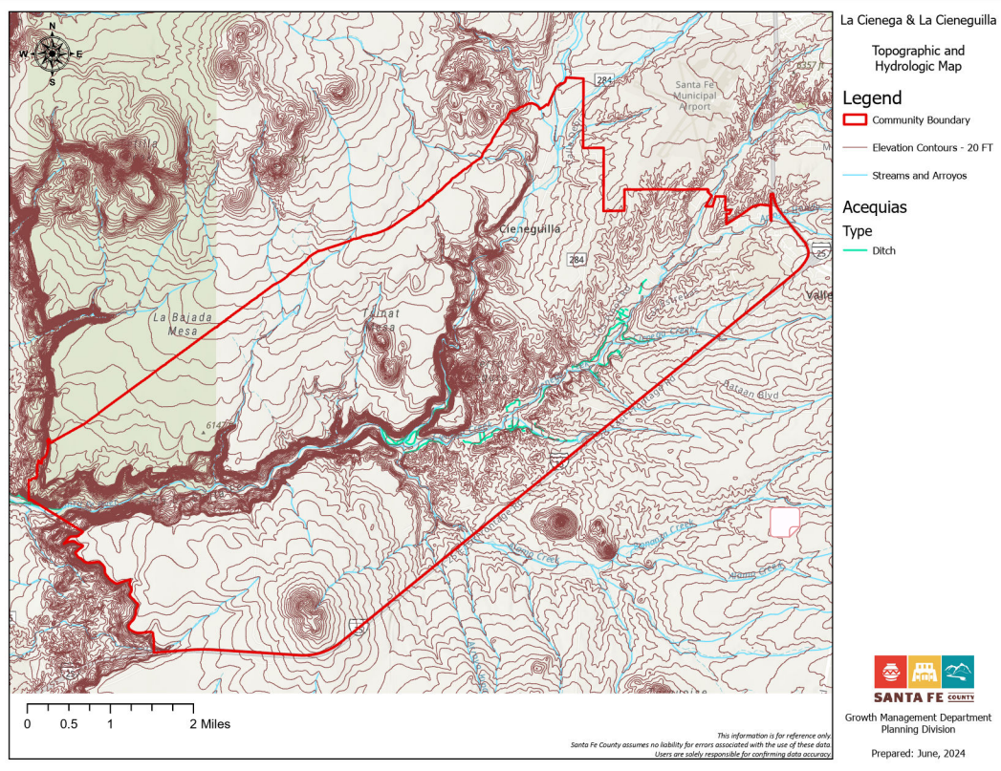

3.1.2 Area Hydrology: Rivers, Creeks, Springs, Arroyos, Flood Plains, and Wetlands

The river, creeks, springs, major arroyos and their tributaries provide a surface water drainage system which forms regional and local hubs of riparian zones, springs, and wetlands. The creeks and their tributaries are mostly intermittent streams due to the complex interaction of geology, ground water and climate of the area.

Santa Fe River, La Cienega Creek, Arroyo Hondo, and Arroyo Chamiso
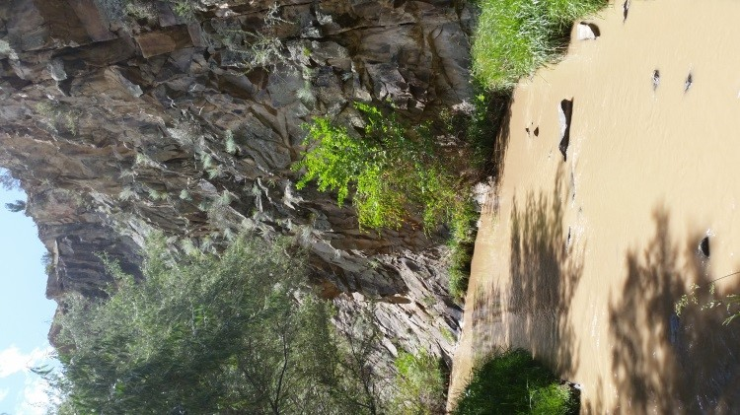
Santa Fe River 2015

The Santa Fe River runs diagonally through the plan area from the northwestern boundary to the southern boundary. It enters the plan area south of City of Santa Fe Wastewater Treatment Plant (WWTP) through a shallow meandering river channel traversing County Open Space crossing Paseo Rael (sometimes under the road, sometimes over the road) flowing through the agricultural lands of La Cieneguilla and into a narrow canyon of basalt eventually joining the Cienega and Alamo creeks in the southern portion of the plan area.

The Santa Fe River below the WWTP is a perennial stream, primarily due to effluent release from the plant. In 1996 the 12.7 mile stretch of the Santa Fe River between the WWTP and Cochiti Pueblo, including the portions running through plan area, was classified as impaired due to low dissolved oxygen levels, high pH, high chlorine levels, high ammonia levels, and high sedimentation. Water quality in the reach below the WWTP has improved since the revegetation.

Effluent released from the WWTP benefits downstream irrigators, including the community of La Bajada,

and provides semi-consistent flows in the river to replace the flow from area springs which are now virtually depleted. Due to the current release point, this benefit to irrigators does not extend to the Upper and Lower La Cienega area acequias or springs and does not appear to provide wide-spread recharge. During the summers of 2011 and 2012, the effluent flow was retained by beaver dams created at the wetland area near the City of Santa Fe Municipal Airport which resulted in reduced flow and less water for irrigators (see Trends below).

Management of effluent from the City ‘s WWTP and beaver activity on City and County property associated with the effluent will continue to impact flow in the Santa Fe River and irrigators that divert off the river. In addition, the City of Santa Fe is proposing to install a pipeline connecting the WWTP to the BDD in order to obtain return flow credits, which in turn will allow the City of Santa Fe to pump more water from the BDD. This however has the potential to reduce flows in the lower Santa Fe River by around 50% of their existing flows. An alternative that should be explored is to see whether the lower Santa Fe River can remain intact and return flow credits can be applied for using the natural drainage back to the Rio Grande that already exists through the lower Santa Fe River. This would save millions of dollars and eliminate the need to build a pipeline between the WWTP and the BDD and would eliminate the detrimental impacts to irrigators off of the lower Santa Fe River from a reduction in stream flow.

The communities of La Cienega and La Bajada have been diligent in advocating that the City of Santa Fe adjust their water release schedule and volume to accommodate the needs of downstream irrigators and will continue to do so in cooperation with other partners.

Arroyo Hondo enters the plan area at its junction with NM 599. Arroyo Chamiso enters the plan area near the eastern boundary of the Airport. Both traverse in a southwestern direction, joining each other in Upper La Cienega. Cienega Creek enters the plan area under Interstate I-25 in Upper La Cienega where it runs west joining Arroyo Hondo just above the north boundary of El Rancho de Las Golondrinas. The intermittent Alamo Creek enters the plan area under Interstate-25 along the southern boundary of Santa Fe Canyon Ranch where it runs west to join the Santa Fe River and Cienega Creek near the western portion of the aptly named Tres Rios Ranch.

Trends in the Area Hydrology

Since the adoption of the 2001 plan, a number of trends/events have either affected or are likely to affect the community’s water resources:

- Based on the increase in households, the number of ground water wells increased, which has an impact of withdrawing more acre-feet of water per year.
- Work in the late 1990’s and 2000’s to restore the stretches of the Santa Fe River on City of Santa Fe and County-owned land, while increasing water quality, has led to dramatic increases in the beaver population. Beaver activity has impounded enough water to impact downstream irrigators. Beaver populations need to be monitored and managed and impoundments need to be controlled.
- The Santa Fe-Pojoaque Soil and Water Conservation District grant provided for the removal of nonnative vegetation on Santa Fe County Open Space property along the Santa Fe River in La Cieneguilla and at Los Carrizales in La Cienega.
- The New Mexico House of Representatives passed House Memorial 74 requesting that the City of Santa Fe and Santa Fe County work together to ensure sufficient river flows to La Bajada and La Cienega.
- Santa Fe County passed Resolution 2011-191 requesting that the City of Santa Fe release additional effluent to the Santa Fe River to support agricultural production in La Cieneguilla and La Bajada.
- Santa Fe River Traditional Communities Collaborative formed with the goal of promoting the health of the Santa Fe River and the traditional communities that depend on the river. The initiative is the result of partnership among La Cienega community members, La Cieneguilla landowners, the community of La Bajada, the Santa Fe Watershed Association, Forest
Guardians, the City of Santa Fe, County of Santa Fe, Santa Fe-Pojoaque Soil and Water Conservation District and federal agencies with land holdings in the community. The broad mission of the group is to promote the health of the Santa Fe River as well as the communities. In the near-term, the group will be working toward developing a plan for mitigating the impoundment of water associated with beaver activity on public lands.

3.1.3 Acequias

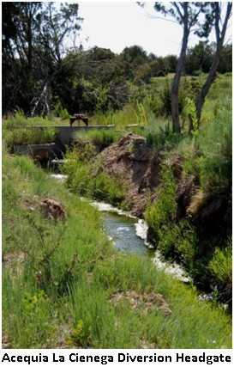
Traditional agriculture in the planning area has historically been sustained by spring-fed acequias and, to a lesser extent, diversions of the Santa Fe River. The ojos y ojitos or natural springs filled ponds formed by construction of earthen dams which store water to be directed into an acequia. These gravity-fed acequia systems have remained basically unaltered for centuries. By the 1990's greatly diminished flows of area springs necessitated the addition of supplemental ground water irrigation wells to maintain flows and acequia system integrity. Additionally, reduced flows in effluent in the Santa Fe River due to the beaver dams (see above) are a major concern to effected acequia associations and communities. The communities of La Cienega, La Cieneguilla and La Bajada have been diligent in ensuring that the City of Santa Fe adjust their water release schedule and volume to accommodate the needs of downstream irrigators and will continue to do so in cooperation with other partners.

There are three acequia associations and four private acequias in the valley that provide water for irrigation. According to a hydrological survey of the area completed by the State Engineer's Office in 1976, approximately 150 acres of land are potentially irrigable by community acequias. Conversion of irrigable agricultural land to use residential in conjunction with declines in water flows in the acequia
systems have led to a decrease in acreage under agricultural production.

La Acequia de La Cienega delivers water to 98.6 acres of irrigated land of which approximately 40 acres are currently being farmed. Some of the acreage traditionally used for irrigation has been developed for other purposes; some of it lies fallow. The acequia is entitled to use approximately 294 acre-feet of water per year (one acre-foot equals approximately 325,850 gallons of water). However, due to dramatic declines in water flow from the springs that feed the acequia, an irrigation well has been employed since 1998 to provide a supplemental water source to maintain the ditch integrity.

La Acequia de El Guicu traditionally serves approximately 41 acres of irrigated land. The acequia currently irrigates approximately 25 acres. The El Guicu is entitled to approximately 123 ac-ft of water per year. The ditch has an irrigation well to supplement spring or surface flows.

La Acequia de La Capilla (formerly known as the La Acequia de El Molino ) has approximately 7 users and is currently irrigating approximately 20 acres.

The valley also supports four private acequias: the El Canon, La Capilla Vieja, Los Pinos, and Romero ditches.

The mayordomos of the two largest acequias, La Cienega and El Guicu, report that it is currently not possible to supply water to all of the potentially irrigable acres along their acequias due to low flows from springs. Residents report that one of the reasons for a decline in local agricultural production is the lack of adequate and reliable water flows in the acequias. Residents believe that a primary reason for low flows is the depletion of ground water supplies throughout the Santa Fe watershed.No studies to date adequately illustrate aquifer depletion and resulting potential impairments, however, the County in coordination with LCVA and community stakeholders are currently implementing a water planning and springs restoration project. Additionally, a reduction in treated effluent releases to the Santa Fe River from the WWTP during the peak summer months and reduced flows from beaver activity are a major concern to the private acequias, which irrigate directly from the Santa Fe River.

3.1.4 Private Water Wells

Throughout the La Cienega and La Cieneguilla Community Planning Area, most homes and businesses receive water from private domestic wells. In the Upper La Cienega area and parts of La Cieneguilla, many lots share a well with 1-4 other homes. Several homes still use springs for drinking water. According to OSE data, as of July 2011, the plan area included approximately 146 one-household domestic wells, 28 multi-household wells and 30 irrigation/stock/sanitary wells. All property owners with wells, who have requested a building or development permit with Santa Fe County since 1996 are required to install water meters on their new wells (or in the case of shared wells, meters on each dwelling unit or primary structure), record monthly meter readings, and provide an annual report of monthly readings to the County Hydrologist.

Lots Subject to the La Cienega Watershed Conditions

The La Cienega and La Cienega Planning District Ordinance implemented many of the strategies identified in the 2001 Community Plan pertaining to water resources including reaffirming and refining the “La Cienega Watershed Conditions.” County parcel data shows that out of approximately 1,645 private parcels in the plan area, approximately one quarter (385 parcels) are subject to watershed conditions with the majority concentrated in Upper La Cienega. The watershed conditions require residential property owners to hook up to County water services, when service is available within 200 feet of the property line of land being divided and all commercial development applications to hook up regardless of distance. Additionally, owners have waived their right to protest the implementation of an improvement or assessment district. An estimated 709 parcels are not subject to the watershed conditions. For 509 parcels it is unclear whether they are subject to the watershed conditions due to missing information on the plats. The County has not extended water lines to serve the majority of those properties. As a result, the use and number of private domestic wells using ground water has increased to accommodate the increased number of households.

3.1.5 Community Water Systems

La Cienega Mutual Domestic Water Association

The La Cienega Mutual Domestic Water Association (LCMDWA) was founded in the early 1970's and serves a large portion of Lower La Cienega. The domestic water system uses approximately 21.7 acre feet of water per year. In order to become a member of the system, one must contribute water rights to the LCMDWA.

The membership cost includes a one-time start-up fee plus the cost of hooking the system to one's home. The monthly user fee includes up to 4,000 gallons per month; use above 4,000 gallons incurs an additional fee. The LCMDWA does not have capacity for commercial use hook-ups and provides limited capacity for fire protection.

In 2000, the LCMDWA served approximately 112 households with a system capacity that could accommodate 25 additional meter hook-ups. In 2012, the LCMDWA served approximately 135 households with an average use per household of 0.16 acre-foot per year.

Other Community Water Systems

Wild & Wooley Trailer Park Community Water System. This water system in Upper La Cienega is based on 72-12-1 sanitary well designated for commercial use with a diversionary use right up to 3 acre-feet. The extension of County water services in this area is anticipated in the future. As of 2012, the trailer park’s is a County wastewater utility customer.

La Cienega Water Users Community Water System. This community system in Lower La Cienega is associated with the former Lakeside mobile home park, located at the end of Paseo C de Baca. It is primarily used to supply water to the residence of the park and has a diversion of 5.1 acre feet. Per a 2013 settlement agreement with the County, the County is required to provide the community with water services.

3.1.7 County Water System

In 1998, Santa Fe County water service was extended to serve the Las Lagunitas subdivision and down La Entrada to Camino San Jose providing service to one fire hydrant at the Community Center. In 2004, the water line was extended further to include the Paseo C de Baca area to La Lomita. This line extension was an encroachment onto the LCMDWA water service area. The LCMDWA is currently trying to appropriate this water line on Entrada La Cienega from the County to better serve its customers and provide a looped system along with improved fire protection for the community through a joint powers agreement it has with the County. The LCMDWA serves water to both the fire department and Community Center.

In 2025, the number of active County utility hook-ups in the plan area is approximately 73 active accounts in the Las Lagunitas subdivision.

At the direction of the BCC (SF County Resolutions Nos. 2006-93 & 2011-162) and with 2013 Water Trust
Board funding support, the Utility has nearly completed the design of a looped water service line for the Camino Loma, La Lomita, and Cielo Del Oeste (Lower La Cienega) area. The line extension is expected to be serving customers by 2016.

The County system is piped to provide water supply to the LCMDWA system, under an agreement with the County.

Wherever County water lines are extended within the planning area, properties with the watershed conditions are required to hook up. Other residents may hook up to the County water utility according to costs and conditions set forth in the then current line extension and customer service policies and ordinances.

Other notes on the County Water System and County water management with respect to the planning area:
- The County provides approximately 275 acre-feet/year of water to the State Penitentiary, thus reducing the depletions to the shallow Ancha/Tesuque Formation aquifer in the area.
- The County owns surface water rights associated with the Guicu acequia, which should be transferred to the LCMDWA to offset the County’s use of the LCMDWA water to serve the Community Center and the La Cienega Fire Department or otherwise retired from use.
- The County adopted via Resolution No. 2012-58, a policy that allows small, public or private water systems to seek water-related technical assistance or water supply service from the County Utilities. The community water systems within the planning area may avail themselves of the services. Qualified systems may or may not be connected to the BDD Rio Grande surface water supply; if not connected to the BDD water supply, water systems run by the County may continue to be supplied using local ground water sources.
- County water systems that rely on ground water include the County Public Works Complex, the Romero Park, and the Caja del Oro system, which serves La Familia Medical Center, the Nancy Rodriguez Community Center, and the Agua Fria fire station. The County has not been pumping its water rights from the Hagerman well since approximately 2011.
- County Water Service Areas established as part of the SGMP (2010) include portions of Upper and lower La Cienega.
- The County continues to analyze the amount of uncommitted water supply available for providing service outside of the SDA-1 area.

3.1.8 Water-related Policies, Programs, Resolutions, Ordinances, and Activities
The list below identifies the various actions that, community members, local governments, and other stakeholders have taken in order to support sound water resource management in the planning area.

Maintaining and Enhancing Santa Fe River Flows
- Santa Fe County passed Resolution No. 2011-191, requesting that the City of Santa Fe release additional effluent to the Santa Fe River to support agricultural production in La Cieneguilla and La Bajada.
- In 2012, the New Mexico House of Representatives pass House Memorial 74 requesting that the City of Santa Fe and Santa Fe County work together to ensure sufficient river flows to La Bajada and La Cienega.
- The City of Santa Fe, Santa Fe County, NM Game and Fish Department, and Bureau of Land Management analyzed the following alternatives for delivering water from the Santa Fe River to La Bajada:
  - trucking potable water from La Cienega to La Bajada reservoir;
  - pipe potable water from La Cienega distribution line to La Bajada;
  - control beavers with birth control;
  - o control beavers with beaver deceivers;
  - buy out farmers' crops;
  - drill a supplemental well in La Bajada;
  - sharing of shortage priority of diversion among and within acequias based on crop type;
  - coordinating irrigation diversions.
The city's reports of the alternatives analysis describes that none of the alternatives appear to have high feasibility.
- Local residents and other stakeholders formed the Santa Fe River Traditional Communities Collaborative, with the goal of promoting the health of the Santa Fe River and the traditional communities that depend on the river. The group is developing a plan for mitigating the impoundment of water associated with beaver activity on public lands. The initiative is a partnership among La Cienega community members, the community of La Bajada, the Santa Fe Watershed Association, Forest Guardians, the City of Santa Fe, County of Santa Fe, and federal agencies with land holdings in the community (Bureau of Land Management and US Forest
Service).
- The County 2002-09 Ordinance includes a provision that all projects plans that propose restoration, enhancement or creation of new riparian areas shall:
  - be legally noticed;
  - submit a hydrologic report to the County hydrologist describing proposed projects' likely effects on evapo-transpiration, infiltration, and recharge;
  - show compliance with existing terrain management and floodway regulations; and
  - demonstrate no net impact on traditional water uses.
Projects on ephemeral streams shall demonstrate how occasional flows will be managed to support wetlands.

The communities of La Cienega and La Bajada, in cooperation with other partners, continue to advocate that the City of Santa Fe adjust their water release schedule and volume to accommodate the needs of downstream irrigators.

The City of Santa Fe also submitted an application for return flow credits with the Office of the State Engineer. The City of Santa Fe is proposing to install a pipeline connecting the WWTP to the BDD in order to obtain return flow credits, which in turn will allow the City of Santa Fe to pump more water from the BDD. This however, has the potential to reduce flows in the lower Santa Fe River by around 50%. An alternative that should be explored is to see whether the lower Santa Fe River can remain intact and return flow credits can be applied for using the natural drainage back to the Rio Grande that already exists through the lower Santa Fe River less evapotranspiration losses. This would save millions of dollars and eliminate the need to build a pipeline between the WWTP and the BDD and would also eliminate the detrimental impacts to irrigators off of the lower Santa Fe River from a reduction in stream flow.

Conjunctive Use, Sustainability, and Back-up Supplies
- The County’s Conjunctive Use Management Plan identifies the County’s commitment to importing water to the basin to alleviate the use of domestic wells.
- The County continues to participate in a public process to work with the communities of La Cienega and La Cieneguilla to develop plans to minimize water used from the planning area and in watersheds that impact area acequias.
- In 2014 the County’s Water Policy Advisory Committee, considered the high cost and onerous permitting requirements of aquifer-storage and recovery (ASR). Upon the WPAC’s recommendation, the BCC approved Resolution No. 2015-14, which recommends that the County Utility pursue back-up supply to the BDD water supply via in-basin ground water wells, since the BDD has been off-line an average of 17 percent each of the last four years.

Water Right Acquisition
- Per Resolution No. 2006-57, the County acquires or requires developments to acquire water rights necessary to serve future water utility customers.

The Community would like to continue to work in developing a water plan for the County water utility that addresses:
- Recharge of the area aquifer and springs;
- Reduced pumping of County held wells in or near the Planning Area;
- Planning future expansion of the county water system to manage withdrawals from wells near the Planning Area to achieve a sustainable ground water supply and recharge of the area aquifer to prevent or mitigate depletion of the aquifer;
- Investigating and actively pursuing other points of diversion that would reduce impact on the Planning Area;
- Investigating and pursuing the possibility of using effluent to supplement acequia flows and;
- Coordinating a cooperative process with the community and all water interests to minimize impacts of future water use on the Planning Area; and
- Incorporate County “growth area” zones to further define areas that may have future access to County water systems.

3.1.9 Water Resources Key Issues

- Limited water is available to meet both domestic and agricultural needs in the Planning Area. Continued approval of development applications in the Planning Area creates an atmosphere where many local residents feel as if they are forced to compete with new developments for limited water resources. As a result, many residents oppose new development. This serves to hinder all potential development, regardless of scale and leads to community division rather than coordinated planning for development that is determined to be appropriate by local residents.
- The Community Planning Committee has identified issues regarding enforcement of density requirements based on water availability within the Planning Area. Dwellings have been permitted in the Community Planning Area without regard to approved water resource estimates.
- Area residents have identified that property division through family transfer splits and variances are being used to divide properties below the minimum lots sizes. (See Map 2: La Cienega and La Cieneguilla Existing Land Use for information on existing sub-minimum lots and other lot size data.) These newly subdivided lots are often developed for rental or sale. This allows for increased density on small lots which places new demands on local water resources to accommodate the new development. While the community supports the family transfer process, it is felt that more careful examination of the potential impacts of increased densities on local water resources is necessary before variances are granted.
- Large commercial and institutional entities and the proliferation of apartment complexes on the south side of Santa Fe, or in or near the Community Planning Area, are high volume water users (Map1: La Cienega and La Cieneguilla Community Planning Area for more information). The high volume use threatens the limited water resources in the Planning Area as well as the La Cienega and Santa Fe River watersheds. Public records at the Office of the State Engineer (OSE) have documented instances of water use exceeding permitted rights for both institutional and commercial entities in or near the Planning Area.
- Both wells and water rights that affect water resources in the Planning Area and the La Cienega and Santa Fe River watersheds have been actively sought by the City of Santa Fe, the County and private entities. Use of these water resources would further draw down local water supplies. Without adequate protections for local water resources, continued draw down and aquifer mining in the La Cienega and Santa Fe River watersheds threatens to deplete or impair existing water resources for Planning Area residents. All new development in the county should be subject to increased water restrictions including rainwater harvesting for all exterior landscaping excluding lands containing acequia water rights for surface irrigation.
- The Traditional Community District of La Cienega currently has more users drawing water through private wells than the recommended density based on the critical population estimates outlined in the 1980 County General Plan. The critical population estimates were established to define a maximum population carrying capacity for local water resources but were removed from the County's 1999 Growth Management Plan. The Sustainable Growth Management Plan and complimentary code both support planning for centralized sewer and water systems in the Traditional Community in order to accommodate the increased population. Continued development in the area without regard to the limited water supplies threatens the Planning Area and watershed surface and ground water resources of all communities in the Planning Area.
- Documentation of aquifer drawdown as demonstrated by decreased stream flows of La Acequia de La Cienega are presented in a 1994 report by W. Fleming that was commissioned by the County. The Fleming report clearly states that the aquifer is being depleted as evidenced by the dropping water flow from springs between 1966 and 1994. Residents confirm these dramatic decreases in spring flows over the past three decades. Aside from USGS monitoring of La Acequia de La Cienega, no data collection systems are in place to measure and document actual impacts to La Cienega and La Cieneguilla area water supplies.

3.1.10 Water Resources Keys to Sustainability

The Community supports a number of the water resource keys to sustainability expressed in the County’s Sustainable Growth Management Plan (SGMP), including:

- SGMP Goal 38: Land use and development should be consistent with water management, environmental and hydrological capabilities and constraints.
- SGMP Goal 39: New development will incorporate water conservation and reuse.
- SGMP Goal 40: Water conservation will be required to maintain a sustainable water supply and reduce County-wide per capita water consumption.
- SGMP Goal 41: Protect ground water as the County’s secondary source of water to serve as a back-up supply.
- SGMP Goal 42: Provide for a sustainable long-term water supply capable of meeting current and future needs.

In addition, the Community Plan includes several area-specific watershed keys to sustainability:

- Work to provide that an adequate quantity of surface and ground water is available for domestic and agricultural use in the Planning Area.
- Collect and analyze demographic and hydrographic information to help guide development decisions in the Planning Area and the La Cienega and Santa Fe River watersheds.
- Reduce aquifer depletion in the Planning Area and La Cienega and Santa Fe River watersheds.
- Implement water conservation throughout the Planning Area and La Cienega and Santa Fe River watersheds.
- Periodically monitor water use to limit ground water depletion and over consumption.
- Help protect the water resources and the associated rights of the Planning Area communities.
- Optimize aquifer recharge.
- Help protect senior water rights in the Planning Area.
- Connect certain portions of the Planning Area to County Water.

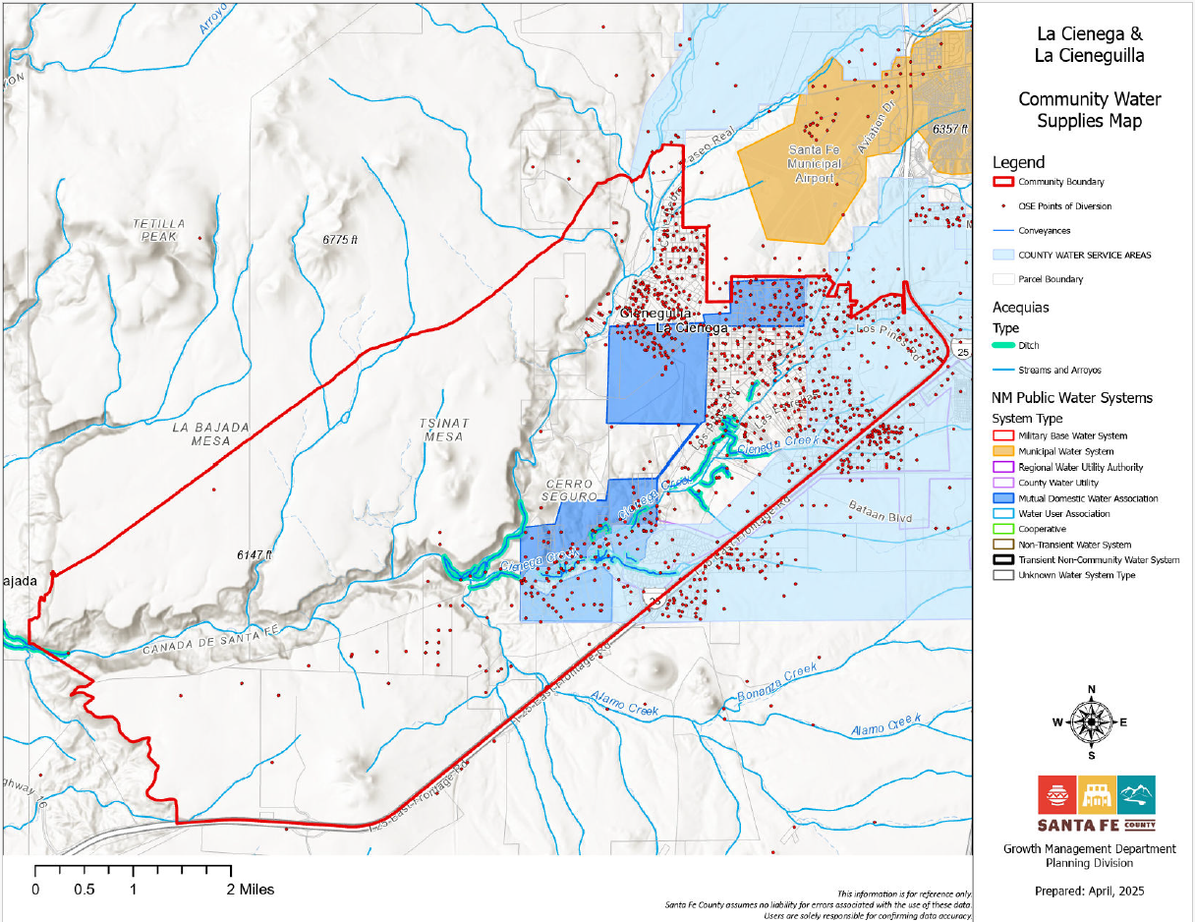
Figure 3 Community Water Supplies

3.2 WATER QUALITY AND WASTEWATER

3.2.1 Introduction

Latrines and cesspools were the traditional wastewater systems in the area. Septic tanks and leach fields to treat increasingly higher volumes of wastewater in the valleys have gradually replaced these systems. Currently, almost all development in the plan area uses septic systems to dispose of wastewater. The modernization of wastewater treatment systems has provided limited improvements to wastewater treatment in the Planning Area. Increased commercial and residential development continue to pose a risk of ground water contamination due to the large number of septic systems, areas with high concentrations of active and aging septic tanks, improperly functioning septic systems and pollution from increased runoff. Existing systems leach to the surface, especially during dry weather, and leak into waterways.

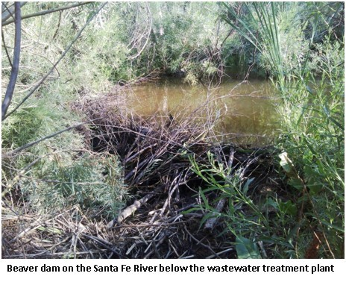
Additionally, as discussed in the water resources section, effluent from the City of Santa Fe's wastewater treatment plant is released into the Santa Fe River near La Cieneguilla. While the effluent benefits downstream irrigators and provides semiconsistent flows in the river, community members have expressed serious reservations as to the consistency of facility operations as well as the potential for effluent to contaminate local water resources in the planning area. Thus, the potential benefits for effluent to recharge Planning Area aquifers should be explored and must be balanced with clean and safe procedures to protect area water resources.

Protection of the Plan Area's water resources from further contamination and maintenance of historic stream flows in the La Cienega Creek and Santa Fe River are critical goals of this Plan.

3.2.2 Community and County Sewer Systems
In 2014, The Wild and Wooley Mobile Home Park constructed a wastewater forcemain (pipeline) and a lift (pumping) station. The pipeline was deeded to the County as public infrastructure, while the pumping station remains private. The project was funded privately and there is a pro-rated repayment provision to the owner of the Wild and Wooley for anyone seeking to connect to the pipeline within the next 10 years.

LCLC COMMUNITY PLAN

3.2.3 Water Quality and Wastewater Key Issues
- Increased commercial and residential development pose a risk of ground water contamination due to the large number of septic systems, improperly functioning septic systems and pollution from increased runoff. Existing systems leach to the surface, especially during dry weather, and leak into waterways.
- Commercial and residential development create a risk of surface contamination through increased runoff from impervious surfaces due to the potential for pollution from roadways, parking lots and increased turbidity in surface water from increased flow.
- In 2023 wells in the planning area were discovered to contain levels of Per- and polyfluoroalkyl substances (PFAS) above permissible drinking water standards. PFAS are a group of chemicals known to cause certain adverse health impacts. LCVA worked with the County to provide educational materials to residents in the planning area and held monthly meetings to address various PFAS related topics. The County is currently in the process of conducting a study to identify the sources and spread of PFAS, which is set to be completed in August 2025. Once that study is complete the County and Community will need to consider the recommendations provided by that study, which are likely to include PFAS mitigation and continued monitoring of the water table to track to spread of PFAS. Currently it is recommended that all residents in the planning area test their wells for PFAS and/or obtain filtration systems that will remove PFAS from any water that is used for human consumption.
- Ordinance 2002-09 restricts certain land uses based on water quality protection; primarily those that pose a risk of spills and potential to contaminate surface and ground water systems such as gas stations, asphalt batch plants and asphalt production plants, large-scale mining, any warehouse which stores or transfers chemicals, large-scale agricultural operations which stockpile manure or have manure lagoons (e.g.: dairies, horse parks or stables, chicken farms), waste oil recycling, septic tank pumping waste disposal, grease trap waste disposal, large-scale chili processing plants, cheese processing plants, gasoline storage facilities or transfer stations, auto repair facilities, car washes, sludge disposal fields, mortuaries, and slaughter houses.
- Treated Effluent Management Plan: In 1998, the City of Santa Fe adopted the Treated Effluent Management Plan which provided an allocation formula for the 11,000 acre-feet of water that the city projected the WWTP to produce annually. Actual annual effluent production has fallen far below initial projection and the allocation formula has required adjustment. The average volume of effluent discharge from the Santa Fe City waste treatment plant was 3.64 million gallons per day for 2009 and 2010. Volumes were higher from November through March, averaging 4.59 million gallons per day. Volumes were lower from April through October, averaging 2.96 million gallons per day. June volumes were lowest overall, averaging 2.52 million gallons. Records for effluent discharge are kept at the City’s waste treatment facility headquarters, currently at 73 Paseo Rael, Santa Fe, NM 87507. In 2013 the City of Santa Fe created the Reclaimed Wastewater Resource Plan (RWRP), which replaces the 1998 Treated Effluent Management Plan (TEMP).
- The Planning Area is located at the downstream end of the Santa Fe watershed. The area's natural springs and ground water supplies are hydrologically connected to both underground and surface water flows. This interconnectedness of water systems leads the area's environment to be sensitive to alterations in natural water flows, water withdrawals and septic or other water introductions.
- The Environment Department enforces wastewater disposal and septic systems standards but does not always have the resources to monitor or enforce violations if they occur. The County does not have the authority to consistently enforce wastewater discharge requirements following granting of development permits. This allows for the potential of septic systems being installed in the Planning Area on small lots so that the intent of protecting ground water through existing regulations may not always be met.
- The increasing population is served mainly by septic systems. This increases the probability of future ground water contamination through overcrowding of lots and increasing density levels that pose a risk of contamination by placing septic tanks too close to existing water resources.
- State regulation 20.7.3.902 NMAC, Operation and Maintenance Requirements and Inspection Requirements At Time Of Transfer, requires inspection of residential treatment systems at the time of sale of the property. This regulation is largely ignored and rarely enforced.
- Permits for new construction do not require mapping of adjacent properties for septic and waste treatment systems or wells, springs, water courses, etc.
- Beaver dams below the City of Santa Fe Wastewater Treatment facility are obstructing the flow of effluent to downstream users in lower Cienega, La Cieneguilla and La Bajada.

3.2.4 Water Quality and Wastewater Keys to Sustainability
- Ensure adequate quality of water available for domestic and agricultural use in the La Cienega and La Cieneguilla Planning Area.
- Pursue regulations the require future development to protect and enhance local water quality.
- Regularly monitor ground water quality for contaminants including but not limited to PFAS.
- Protect ground water through installation of affordable, safe and effective wastewater treatment systems throughout the Planning Area.
- Strive for legal, safe recycling of wastewater.
- Seek the highest level of protection against water resource pollution and degradation from all potential commercial, institutional, and residential sources of pollution.
- Develop cooperative educational and management programs between all parties regarding wastewater disposal in the Planning Area, including potentially a sewer maintenance district.
- The County should pursue additional funding on behalf of residents in the planning area and enact regular timelines for continued PFAS monitoring in the planning area to continue tracking the spread of PFAS in the water table and to enact mitigation measures where such measures are feasible.

5.12 WATER SERVICE PRIORITY AREA & LA CIENEGA WATERSHED CONDITIONS (p. 84)

This Plan establishes a priority area for implementing the La Cienega Watershed Conditions as outlined in Santa Fe County Ordinance 2002-09 and the extension of Santa Fe County Water Utilities which is identified on the Recommended Priority Area Water Connection Map (page 86). The priority area is in close proximity to existing County water pipes and development, both residential and commercial, is expected to be fully built-out in the next ten years. The intent is to serve Upper La Cienega and La Cieneguilla in order to reduce ground water depletion, negative effects on downstream users and to fully implement the La Cienega Watershed Conditions.

Utility service to the plan area should provide an appropriate level of service and maintain rural character that is important to the area residents. On-site systems, (primarily well and septic), community systems and extensions of the Santa Fe County water and wastewater system are all possible methods of serving the area over the long term. Utility extensions will be necessary to support higher density and non-residential uses proposed in the areas designated as commercial mixed-use.

The quick facts below provide very basic and preliminary information about the area. A water/sewer feasibility study to analyze utility service extension and options for the area is necessary to begin implementation. Possible funding mechanisms for the project include Public Improvement Districts, County Improvement Districts or Special Assessment Districts. All lots subject to the La Cienega Watershed Conditions have waived the right to protest the implementation of an improvement or assessment district.

Water Service Priority Area Quick Facts:

- Total Lots: 600
- Lots subject to La Cienega Water conditions: 307
- Total Vacant Lots: 94;
- Vacant lots subject to La Cienega Water conditions: 36
- Number of Wells: 51; Multiple = 16, Domestic = 35

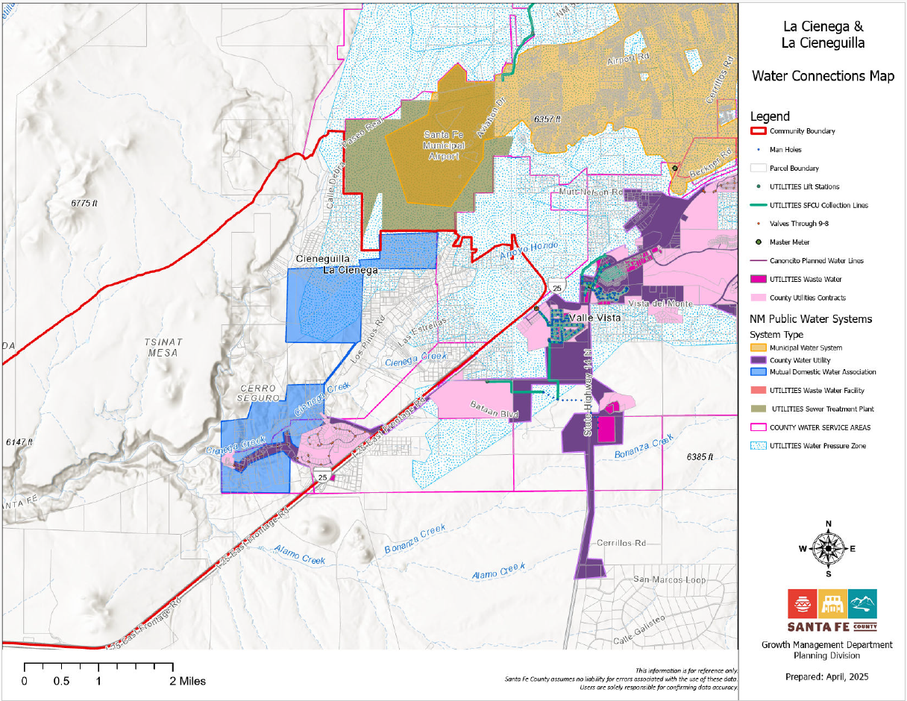
Figure 11: Water Connections Map

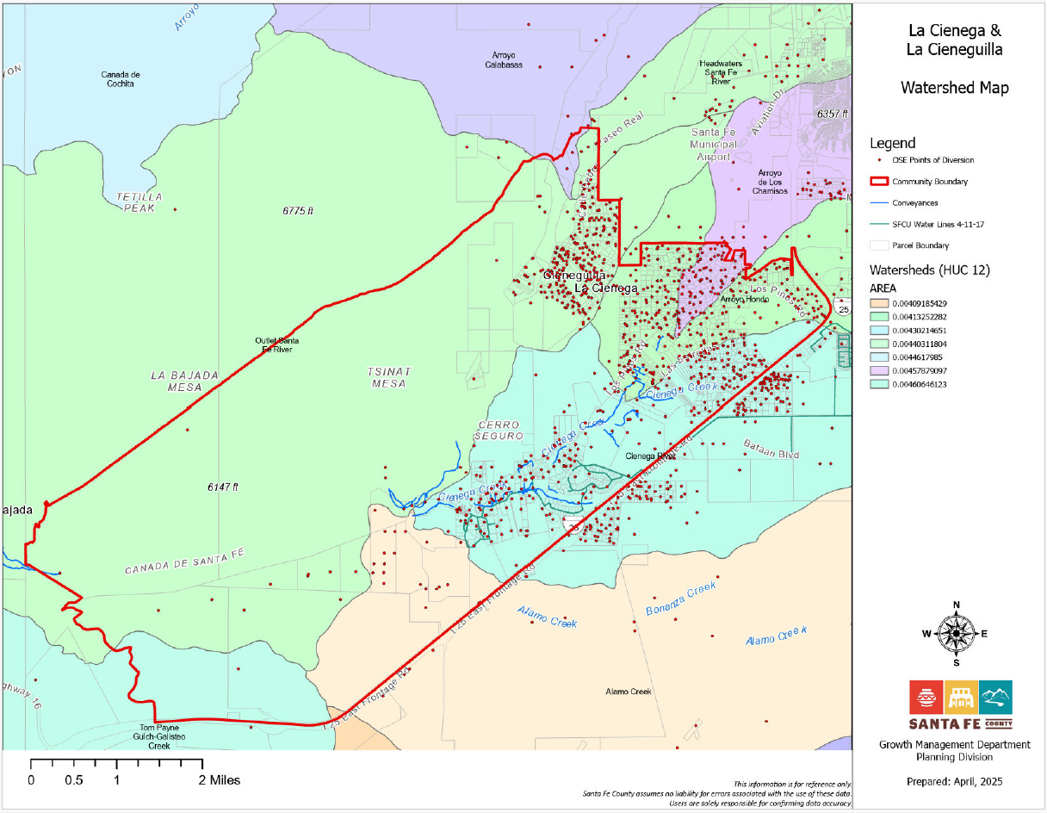
Add label

CHAPTER 2.8. COMMUNITY SERVICES

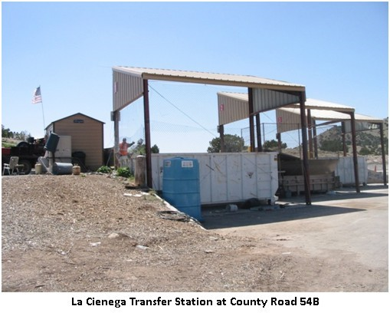
3.5.1 Electric and Gas Utilities

As the communities of La Cienega and La Cieneguilla have grown in the past few decades, the number of overhead utility cables has dramatically increased. The lines provide power and communications to Planning Area residents. However, the proliferation of overhead lines also creates aesthetically unappealing alterations to the rural landscape and scenic vistas in the area. Overhead lines are also at high risk of being damages and overhead power lines can fall during storms which can result in fires in the planning area.

3.5.2 Solid Waste

Traditionally, residents disposed of household waste by burning it at home. Since the 1980s, the County has managed garbage removal. Solid waste is collected at a County operated transfer station, also known as the La Cienega "Convenience Center" located on County Road 54 B. The transfer station is open five days per week and residents purchase “unit” permits that allow a specified number of visits. Commercial businesses generating less than 850 pounds of refuse per month may also use the transfer station. Use of the facility’s recycling bins is free of charge. The County's Solid Waste Ordinance No. 2014-10 outlines maximum size and weight of loads, requirements for bagging and covering loads, prohibited materials, fines for disposal of waste after hours, permit abuses, and requires recycling of pulp based materials such as paper and cardboard.

The existing facility is perceived to lack the necessary capacity for the area it serves and the location is considered inconvenient for many. The large service area, including communities outside of the planning area, brings additional traffic to the area and litter throughout the traditional planning area as dump loads are often not properly covered.

Illegally dumping garbage along roadways and in arroyos is still an issue. Many residents are unaware of the procedures for disposing of waste or the community impacts of illegal dumping. Many people from outside the community also dump their waste in the local arroyos and along roadways to avoid dump fees.

3.5.4 Community Services Key issues

- Overhead cables alter the rural aesthetics of the roads and vistas of the Planning Area.
- Utility easement access is often missing for existing homes, and no reasonable method exists to obtain easements over private property.
- The location of the solid waste transfer station on County Road 54 B generates additional traffic on narrow roads in the Planning Area. This creates safety and traffic problems. It would be beneficial to move this facility outside the planning area to a location more central to I-25 and the frontage road.
- The solid waste transfer station serves too broad of an area and results in a large amount of solid waste from outside of the Planning Area's communities being brought into the community.
- There is illegal trash dumping on public and private property.
- The impacts of illegal dumping create problems such as public health, water contamination and aesthetic detriment to the rural community character.

3.5.5 Community Services Keys to Sustainability

The Community supports a number of the keys to sustainability expressed in the County’s Sustainable Growth Management Plan (SGMP), including:
- SGMP Goal 27: Reduce solid waste production and support recycling to limit landfill use and move toward zero waste

CHAPTER 2.9. GOVERNANCE

7.1 Community Notification

As the recognized Community Organization for the La Cienega/La Cieneguilla community planning area, the LCVA will notify the community of development proposals in the planning area to the extent possible, however, the County will require public meetings to be held in the planning area concerning large scale development in the community. Additionally, the La Cieneguilla Land Grant is a recognized Registered Organization.

7.2 Amendments to the Plan

Any amendments to the Plan will be made in accordance with the SGMP and the SLDC Section 2.1.

SECTION III. IMPLEMENTATION

# | Program/Project | Element, page numbers | Potential Partners | Project Time Frame | 2025 Status + Comments
1. | Extension of Santa Fe County Water Lines in Upper La Cienega and La Cieneguilla | Water Service Priority Area | LC/LC Community Organization LCVA, County, NMED, Federal Government | 5-10 years | To do
2 | PFAS and other emerging contaminants remediation planning and engineering | Water | LCVA, County, City, NMED, Federal Government | 2-10 years | In progress continued study and monitoring will be needed going into the future
3 | Fuel Mitigation & Fire/Flood Response Program | Public Safety | County Fire, LCVA, Acequia Associations, BLM, USFS | 2-5 years | New
4 | New Joint City/County Wastewater Treatment Plant | Water | LCVA, County, City, NMED, Federal Government | 5-10 years | New + community advocacy for a joint City/County Water Strategy
5 | Develop Incentive Zoning, Land Use and Development Standards in support of the preservation or expansion of contiguous agricultural lands and acequia systems. | Traditional Irrigated Agricultural Land Preservation | Acequia Associations, Property Owners, LC/LC Community Organization LCVA, County | 1-3 years | Some incentives were enacted (i.e. TDR program), but more support for preservation and expansion can be done.
6 | Analyze supplemental water to use for irrigation | Existing Conditions, Goals and Strategies Water Resources | Acequia Associations, State Penitentiary, National Guard, SF Wastewater, Treatment Plan, Property Owners, LC/LC Community Organization LCVA, County | 1-2 years | To do
7 | Drainage Master planning and Engineering Plus Wastewater Feasibility Study and Engineering Plan | Existing Conditions, Goals and Strategies Water Resources | County Public Works, NMED, EPA, USDA | 1-2 years | This should be considered in conjunction with the springs restoration planning that is currently in progress but may require additional study and engineering.
8 | Implement the Transportation Safety Study Community Pedestrian and Equestrian Circulation Study | Transportation Community Parks, Open Space & Trails | LC/LC Community Organization LCVA, County Public Works | 2-5 years | New + the upcoming Transportation Safety Study will examine pedestrain and equestrain to a certain extent.
9 | La Bajada Ranch Conceptual Plan and Outreach | Open Space | County, LCVA | 1-2 years | New
10 | Agricultural Lands Directory | Agriculture | Acequia Associations, LC/LC Community Organization LCVA, County, USDA Farm & Ranch | 2-5 years | To do
11 | Multipurpose, Multigenerational Community Center , Conduct a needs assessment | New Community Facilities | LC/LC Community Organization LCVA, County, State Land Office | 2-5 years | To do
12 | La Cienega Community Library Expansion | Acquire funds for expansion from the existing space into a larger space or into the remainder of the community center if a new community center is constructed. | LCVA, Santa Fe County Public Works, Santa Fe Public Library System, Las Golondrinas, UNM and any entity created by LCVA to manage the library | 5-7 years | To do
13 | Develop accurate population estimates for the La Cienega and La Cieneguilla Community Planning Area. These population figures will be used in conjunction with a water budget for the planning area to determine potential population impacts on local water resources and the development of realistic water availability estimates to guide future land use decisions. This study should be completed no more than 3 years from the date that the Plan is adopted | Existing Conditions | Acequia Associations, LC/LC Community Organization LCVA, County Planning, NM OSE | 1-3 years | County Planning Staff may be able to complete this as an internal study and may be able to remove this as a Implementation Matrix item.
14 | Creation of Public Park and pedestrian/bike trail system in Santa Fe County Open Space to be extended throughout community | New | LCVA, Santa Fe County Open Space, HIPICO | 5 years | Will require community partnerships to create a full scale trail system. Could tie in with the Santa Fe River trail system and lower Santa Fe River management planning.
15 | Springs Restoration Study and Engineering Plan | Existing Conditions, Goals and Strategies Water Resources | Acequia Associations, Mutual Domestic Association, Santa Fe County Planning, Santa Fe County Public Utilities, Owners of Private Irrigation Ditches, Las Golondrinas, Ojo Santa Fe | 1-2 years for completion | In progress

ALPHABETICAL INDEX OF GOALS BY ELEMENT
note: new language is denoted by red lines
Goal Land Use

Goal 1: Agriculture and Ranching
Goal 2: Community Services
Goal 3: Economic Development
Goal 4: Governance
Goal 5: Land Use
Goal 6: Open Space
Goal 7: Public Safety
Goal 8: Transportation
Goal 9: Water

GOALS, STRATEGIES, & ACTIONS BY ELEMENT
any new language will be denoted by red lines
Land Use
Goal 5: Create a land use plan that recognizes the hydrologic area and aims to protect the natural and historical resources and rural character of the La Cienega and La Cieneguilla planning area while at the same time position the communities to leverage their location adjacent to regional and interstate highway systems, regional transit systems and the airport to increase economic viability. (originally on page 74)

Strategy 5.1: Modify the existing zoning and land use regulations as needed for the La Cienega and La Cieneguilla planning area based on the communities’ needs, culture, and resources by amending the Community District Overlay.

Action 5.1.1: The La Cienega/La Cieneguilla Planning Committee will work with County Planning staff to develop appropriate amendments for SLDC Section 9.8: La Cienega and La Cieneguilla Community District Overlay, including creating height restrictions for development in the planning area and limitations on the number of units

Economic Development

Goal 3: Enhance economic development that is respectful of historic traditions and natural resources.
Strategy 3.1: The County should collaborate with local, state, and federal government agencies to improve internet access for local residents and to promote the use and installation of underground fiberoptic throughout the planning area.
Action 3.1.1: LCVA and community members should work with County Planning to coordinate internet expansion through County Economic Development and the New Mexico Office of Broadband Access and Expansion.

Agriculture and Ranching
Goal 1: Support, mMaintain, and expand agriculture in the the plan areaLa Cienega and La Cieneguilla plan area.

Strategy 1.1: Maintain existing agricultural uses of land and protect agricultural water rights by minimizing conversion of agricultural land to non-agricultural uses.

Action 1.1.1: County Planning staff will work with farmers and the Office of the State Engineer to Creatingcreate an inventory of agricultural lands in the planning area.

Action 1.1.2: The County will work with LCVA to adopt an ordinance limiting the ability of individual property owners to separate land from agricultural water rights in areas that serve historic agriculture through use of acequias and private ditches. In New Mexico, if an acequia (or community ditch) has adopted a bylaw giving itself authority over water transfers, any proposed transfer into or out of the acequia must first go through the acequia commission for approval or denial, as required by state law. There are three community ditches or acequias – Acequia de la Cienega, El Guicu Ditch and Acequia de la Capilla.The Acequias bylaws give their commissions the right to refuse the request to transfer water rights off of the acequia where such a transfer will be detrimental to the members of the acequia.

Action 1.1.3: The LCVA and the County will work together to Formingform a representative committee of stakeholders to develop a community managed agricultural land protection program using methods such as, but not limited to, land trusts, conservation easements, and transfer of development rights.

Action 1.1.4: The County will assist residents through nvestigatinginvestigate various funding mechanisms to support agricultural land protection and management programs through mechanisms including, but not limited to, improvement districts, development impact fees, grants, and legislative appropriations.

Action 1.1.5: The County will support the use of federally managed and state managed land for grazing, as it is a community tradition and directly tied to sustaining economically viable agricultural enterprises in the planning area.

Action 1.1.6: Supporting incentive based zoning thatCounty Planning staff and LCVA will encourages property owners to create permanent agricultural conservation easements and support the preservation of agricultural lands in the planning areas via the County’s Transfer of Development Rights program and/or land trusts.

Strategy 1.2: Support farmers and ranchers.

Action 1.2.1:The County with assistance from LCVA will help to educate residents in the planning areas about County Assessor programs which Investigate the feasibility of alleviate property tax burdens for small-scale ranching and farming operations.

Action 1.2.2: LCVA, with assistance of the County and relevant State agencies and in coordination with the three acequias, should iInvestigate the feasibility of recharging area springs in order to support traditional agricultural uses of water resources in the planning area.

Action 1.2.3 LCVA, with assistance of the County and relevant State agencies or non-profits, should dDevelop an agricultural support program to help revitalize traditionally irrigated lands and agricultural activities such as small-scale farming and ranching in the Planning Area. This may include educational outreach, skills training, and marketing assistance to support economically and environmentally viable farming practices for community members in the Planning Area. The program may also include educational outreach for appropriate scale gardening and landscaping in newer subdivision areas.

Open Space
Goal 6: Ensure that parks, open spaces and trails in the community reflect and support community values.

Strategy 6.1: Ensure that planned uses on public lands do not inappropriately impact the plan area.

Action 6.1.1: The County Planning Division, working in coordination with the LCVA and relevant public agencies, will maintain an accurate inventory of all public land uses and leases in and surrounding the planning area. This will include development of a reporting procedure whereby all parties can be informed as to current and planned uses of these public lands.

Action 6.1.2 The County Open Space, Trail and Parks program and the Planning Division will work with local residents to develop a public education program to help clearly identify boundaries between public and private properties in order to respect and protect private property from non-permitted public use.

Action 6.1.3 The County working in coordination with LCVA will fForm a representative committee of stakeholders to develop a community open space protection program.

Strategy 6.2: Maintain open space and limit new growth to development that is cognizant of edisting land use and oreserves historic viewsheds and community traditions.

Action 6.2.1: The Planning Division will coordinate with local residents and non-profits dDevelop voluntary open space protection programs including but not limited to: land conservation programs, Transfer of Development Rights programs, conservation easements, creating purchase of development rights programs to send development rights to other areas and community-based land trusts.

Strategy 6.3: Plan for appropriate pedestrian and equestrian access aligned with exiting road networks that provide connections to community facilities and regional trails.

Action 6.3.1 LCVA and the Planning Division will work together to identify pedestrian connections in conjunction with planning and creation of new community facilities.

Action 6.3.2 LCVA and the Planning Division will identify roads in the plan area with appropriate right-of-waye R.O.W. that can accommodate a future trail network to avoid trail linkages across private property or in arroyos.

Action 6.3.4 The Planning Division will work with private land owners, the BLM and the State Land Office to develop voluntary use agreements, easements, or other arrangements for public use of these trails. This will include working with all parties to help identify trailhead locations for existing trails. This will also include closure of all unauthorized trails and measures to educate the public to eliminate trespass on private properties.

Action 6.3.5 Prior to sale or transfer of community open space the County will first approach the community and inform LCVA of any intent to sell or transfer. The County recognizes that the sale or transfer of lands in the planning areas designated as open space is inherently bad for the well-being of the community. The County shall not sell or transfer open spaces without providing public notice through publication in a newspaper of general circulation for three weeks prior to holding a public hearing, which shall include an opportunity for public comment before the County Commission. When possible, the community will negotiate a voluntary first right of refusal on sales or transfers in order that the lands may be purchased for protection and inclusion in community open spaces. The community may also create a programs or entities to pursue funding to purchase the lands and maintain the lands, for common community use..

Action 6.3.6 The Planning Division will develop an accurate inventory of wildlife habitat areas in the Planning Area and in coordination with LCVA, will develop a management and protection program with direct participation from local residents, property owners and business owners.

Action 6.3.7 : tThe Planning Division in coordination with resdients, LCVA, Las Golondrinas and other entities in the planning area will identify and create a management program consistent with existing county and state regulations to preserve historical and archaeological areas within the Planning Area including but not limited to petroglyphs, Pueblo ruins, and other historical cultural sites.

Action 6.3.8 The Planning Division will develop a community-based stewardship and management program for public lands in and adjacent to the Planning Area, which shall include local residents. The management program will create environmentally and culturally sensitive programs to maintain traditional activities such as common open space areas, horseback trails, agriculture, and grazing.

Strategy 6.4: Plan for small parks to serve the communities of La Cienega and La Cieneguilla.

Action 6.4.1 Work with local non-profits, residents and businesses to create management programs to support the creation of parks throughout the communities.

Public Safety
Goal 7: Create a fire protection network for the entire community
Strategy 7.1. Increase capacity to respond to fire events.

Action 7.1.1: The community will coordinate with County Utilities, County Fire, and the mutual domestic water association to investigate means to increase water pressure in existing fire hydrants. This may include but is not limited to connecting existing hydrants to the County water system and/or other available water systems at the earliest possible date.

Action 7.1.2: County Utilities and County Fire in coordination with LCVA and LCMDWA will identify additional public and/or private water sources and to develop use agreements in order to meet emergency service needs in the planning area.

Action 7.1.3: County Fire, and County Utilities in coordination with LCVA and LCMDWA will wevelop an implementation and funding plan in order to expand the number and location of accessible fire hydrants throughout the planning area. This may include, but is not limited to, construction of water storage facilities for emergency use in the planning area. Improvements must be designed to maintain the rural character of the community.

Action 7.1.4: County Fire, and County Utilities in coordination with LCVA and LCMDWA will assess the capacity and working order of existing fire hydrants and develop a repair and or replacement program for hydrants which are not in proper working order.

Action 7.1.5: County Fire, and County Utilities in coordination with LCVA and LCMDWA will assess fire access conditions in the planning area and develop a community education program to ensure proper access conditions on roads, driveways and gated drives and roads within the planning area.

Action 7.1.6: County Fire in coordination with Acequia de la Cienega, El Guicu Ditch and Acequia de la Capilla and LCVA will plan for coordinated permitting and burning of agricultural fields, including working with the local Acequia Associations to coordinate burns and provide support to fire personnel.

Action 7.1.7: County Fire in coordination with the Pueblo of Pojoaque and LCVA will assist to help ensure that fire protection is available for addressing the spontaneous burning of manure piles and ensure that similar stockpiling of manure does not occur in the future.

Strategy 7.2. Require an access management plan for all new roadways, per SGMP Strategy 29.4.2.

Action 7.2.1: Santa Fe County Land Use and County Fire will ensure that developments and subdivisions in the Planning Area meet all commitments to create adequate fire protection services by coordinating fire protection efforts and planning with LCVA. These commitments should be fully developed and in proper working order to service new residences and subdivisions.

Strategy 7.3. Increase volunteer fire fighter recruitment from within the Planning Area.

Action 7.3.1: County Fire will develop an educational campaign to increase awareness in the Planning Area of the need for volunteers and options for volunteering. (Coordinate with County efforts per SGMP Policy 29.3 and Strategy 29.3.1). LCVA will assist with providing information about these programs to residents.

Action 7.3.2: County Fire will work with LCVA and other community groups and non-profits to increase fire protection awareness in the Planning Area. This will include an educational campaign to inform residents of current County Code requirements as well as practical measures that residents can implement to improve fire protection. LCVA will assist with providing information about these programs to residents.

Transportation
Goal 8: Develop a transportation system that provides for community mobility and safety.
Strategy 8.1: Ensure existing transportation infrastructure is properly maintained.

Action 8.1.1: County Planning, in coordination with the community, will develop educational materials to inform Planning Area residents of the County's notification procedures for road maintenance needs and requests.

Action 8.1.2: The County's Transportation Advisory Committee and the County Planning Division will coordinate with community representatives including the LCVA to develop a community priority list of road improvements and funding priorities.

Strategy 8.2: Ensure that future transportation improvements maintain and preserve the plan area’s rural character.

Action 8.2.1: County Planning, in coordination with the community and County Public Works, will design road safety features, in consultation with the community and LCVA, including but not limited to, lighting and signage that are designed to maintain the rural character of the community.

Action 8.2.2: County Planning, in coordination with the community and County Public Works, will work to ensure that all construction, widening and/or upgrading of public roads into the Planning Area shall be planned and designed through consultation with a representative community body including the LCVA. Design standardsshall meet all legal requirements while also maintaining the rural character of the Planning Area.

Strategy 8.3: Enhance the transportation network’s safety.

Action 8.3.1: The County Planning, in consultation with the community and LCVA will identify areas with speeding problems and develop a periodic monitoring schedule with the County Sheriff’s Department to enforce speed limits within the planning area.

Action 8.3.2: County Planning, in coordination with the community, will study the feasibility of implementing traffic calming measures, such as speed bumps and median and road-edge rumble strips, on roads with consistent speeding problems and develop strategies to reduce speeding and other unsafe road conditions

Action 8.3.3: The County Traffic Study will inform County Planning of high traffic areas in the planning area. The County may ask LCVA to assist in coordinating with establishments in the planning area that generate high traffic volumes in order to develop either alternative traffic routes and/or event planning to minimize impacts from high traffic.

Action 8.3.4: County Planning, in coordination with the community, will study the feasibility of implementing guardrails on dangerous and sharp curves in the planning area and install roadway improvements that will minimize hazards.

Action 8.3.5: County Planning, in coordination with County Public Works, and the community, will work with the NMDOT to create screening which will clearly separate headlights on the interstate from headlights on the Frontage Road. This will specifically address the intersection of Las Estrellas Road and the Interstate 25 Frontage Road; the intersection of Los Pinos Road and Interstate 25 Frontage Road; and other intersections on along west Frontage Road..

Action 8.3.6: The Planning Division will work with County Public Works to install signage in designated areas to alert drivers about cattle, equestrian use, wildlife crossings, pedestrians, and cyclists.

Action 8.3.7: The Planning Division will coordinate with County Public Works and NMDOT to study the feasibility of wildlife corridors under or over Interstate 25.

Strategy 8.4: Support the use of alternative transportation modes.

Action 8.4.1: County Planning, in coordination with the community, will study the feasibility of providing transportation services to low mobility residents through existing public, non-profit and private transportation services and educate the community about services that are available.

Action 8.4.2: County Planning, in coordination with the community, will study the feasibility of developing alternative transportation services including options such as ride-sharing and park and ride.

Action 8.4.3 County Planning and County Open Space in coordination with LCVA, will identify grants and other funding sources to develop better walking trails and pedestrian access along roadways.

Goal 8.5: Encourage the Santa Fe airport and national guard to create policies to reduce community impacts by working to create a community engagement plan and regular community input process.
Strategy 8.5.1: Minimize the airport’ s external impacts on the community.

Action 8.5.1: Take steps to minimize the impacts of airport operations on surrounding communities where possible by working with the City of Santa Fe, the Federal Aviation Administration (FAA) and any other relevant agency or group on issues including but are not limited to development of flight patterns that minimize the need to cross populated areas, timing of flights, placement of navigational beacons and noise abatement.
Action 8.5.2: LCVA, in collaboration with the County, will advocate for a permanent seat on the City of Santa Fe’s Airport Advisory Board in order to communicate the goals and aspirations of the community which are:
evelop
- Noise Mitigation and Abatement Program at the airport.

- Limit expansion of new carriers, daily flights by commercial aircraft and nonemergency operations.
- Explore options and constraints of locating an airport facility away from heavily populated areas in the County. This program action is intended as an investigative measure and does not imply any type of commitments by any party for siting of future facilities.
- Investigate options and means for developing a scheduling process to limit regular flights to daytime hours and decrease or eliminate regularly scheduled flights after 8:00 p.m.
- Work with the National Guard to reduce the impact of flights over populated areas, riparian areas and undeveloped private property in the planning area through higher flight patterns, noise abatement efforts, and other means.
- Encourage the airport management to educate pilots and other airport personnel about the importance of noise abatement procedures, respect for wildlife, common courtesy toward local residents, and the locations of private property in the airport vicinity.

Water
Goal 9A.1: Ensure a sustainable, fresh water supply for the community.
Strategy 9A.1: Develop La Cienega and La Cienguilla should develop alternative water sources to serve portions of the planning area, should work to preserve existing water supplies through conservation efforts and engage in strategic negotiation of methods to mitigate the impacts to area springs and aquifers from water users outside the planning area.

Action 9A.1.1: County Public Utilities should work with LCVA to Eensure that commercial and institutional entities with on-site wells in or adjacent to the planning area connect to the County water system at the earliest possible date. When possible, existing on-site wells should be retired or dedicated for emergency uses only, such as fire protection or in the event that the County water system should fail.

Action 9A.1.2 County Growth Management, in coordination with County Utilities, will ensure that all new residential development shall limit water consumption to .25 acre feet or less of water per year for domestic consumption per household for all indoor and outdoor water use.

Action 9A.1.3: The County will create a staffed department of water conservation to investigate and educate county residents of alternative sources of water to use for outdoor irrigation of non-agricultural lands without pre-1907 water rights. Sources might include water harvesting and/or other reuse initiatives such as treated effluent from the City of Santa Fe's wastewater treatment plant, the State penitentiary and/or National Guard facility to serve commercial, institutional and residential developments in or near the Community Planning Area.

Action 9A.1.4: County Planning should work with local residents and LCVA to dDevelop water conservation and protection initiatives at all commercial facilities within and adjacent to the Community Planning Area.

Action 9A.1.5: County Planning should work with LCVA to adopt an ordinance to ensure that water users and all new utility, institutional, residential, and commercial developments in the La Cienega and Santa Fe River watersheds will incorporate a reasoned approach in the development of water sources. These policies will be based upon the best available data and should be considered as necessary aspects of all development approvals in the planning area and in the La Cienega and Santa Fe River watersheds.

Strategy 9A.2: The La Cienega and La Cieneguilla planning area shall rRetain water rights which currently exist in the community within the community.

Action 9A.2.1..1 County Planning and County Utilities, will inventory water rights in the planning area, and if possible, develop a voluntary notification process for water right transfers in the planning area and a create a program to provide a preferential right of purchase for these water rights to members of the communities in order that they may continue to serve as a community resource.

Action 9A.2.2: The County will develop materials and LCVA will coordinate with the acequia associations, the La Cienega Mutual Domestic Water Association, residents, business owners and property owners to distribute such materials which promote the expansion of water conservation initiatives within the community by providing educational materials and practical examples of water conservation techniques that can be employed in the planning area.

Strategy 9A.3 Expedite the implementation of the La Cienega watershed conditions.

Action 9A.3.1: The County Utility Department will implement watershed conditions fully by seeking the prioritization of the extension of Santa Fe County water lines to serve existing and future residential and commercial uses in La Cieneguilla and portions of Upper La Cienega. The County will prioritize existing water users over new development (see Water Service Priority Area & La Cienega Watershed Conditions below).

Strategy 9A.4 Require documentation of conservation measures.
Note: staff will review these in context with all the pertinent SLDC and County regulations

Action 9A.4.1 Limit the maximum possible existing residential water use to 0.25 acre feet of water per dwelling unit per year. Any use above .025 acre feet per year must be applied for with a water budget and proof of 100 year water supply as per the existing County Sustainable Land Development Code or other regulation that may apply. The application must also demonstrate conservation of water through recycling, reduced use, rainwater (and other) collection and other means equal to stringent sustainable land use principles. This water consumption requirement applies only to use of water for domestic purposes from domestic wells as defined by the state and does not apply to any other water rights (irrigation or private.)

Action 9A.4.2 Verify that all new wells and buildings using ground water drawn from wells located within the Planning Area as a partial or total water supply have installed a water meter on their wells. All new development using shared wells or community water systems shall install a water meter on every dwelling unit or primary structure/intake that uses the well water.

Action 9A.4.3 Enforce current regulations requiring the monitoring and reporting of water usage. All users shall record water meter readings on a monthly basis and submit an annual report of monthly readings to the County Hydrologist and, if established, to the community’s water management authority. The community will coordinate with the County Hydrologist to develop a water meter auditing program to ensure compliance with water restriction covenants. If a user is over consuming, the County will work with the individual to 1) develop a water budget and conservation plan including efforts to replace any amount over consumed and, 2) develop a fine for repeated instances of over consumption.

Strategy 9A.5 Promote and enforce water conservation and best management practices.

Action 9A.5.1 The LCLCPC and County Planning will develop Overlay amendments so that all new development shall incorporate water conservation and best management practices which are compliant with state and county regulations as well as current sustainability practices. This may include reuse of gray water, storm water recharge and rainwater collection systems such as, cisterns, gravel beds or other storage systems for which regulations have been enacted. These practices may include:

- Water collection to the extent practical and affordable (and not required to exceed 1% of total construction costs) shall be used for landscape irrigation and/or other domestic uses in order to replace use of potable water supplies.
- Xeriscaping and/or native plants will be encouraged for landscaping on all new landscaping. The area of landscaping to be irrigated will be based on County Hydrologist approved water budget estimates of rainwater collection and storage capacity per the individual development. This will not apply to agricultural uses of water.
- The building of swimming pools is discouraged in the Community Planning Area. Any new pool must meet County SLDC, County water conservation guidelines, satisfy water availability requirements, and include a covering when not in use to minimize evaporation.

Strategy 9A.6 Regulate all new development of riparian areas and/or wetlands

Action 9A.6.1 Prior to development of new riparian areas and wetlands in the Planning Area, applicants shall demonstrate adequate water rights and/or source(s) of water to meet consumptive needs of the riparian area or wetlands, and demonstrate that the project will not negatively impact prior beneficial uses or traditional uses of water resources, in accordance with State Engineer's Office regulations.

Action 9A.6.2: LCVA will advocate for policies including OSE guidelines for determining the consumptive needs of the riparian area or wetlands, whichshall use the U.S. Soil Conservation Service Modified Blaney-Criddle Method, long-term weather data for the period from 1867 onward and consumptive-use coefficients developed by the U.S Bureau of Reclamation for riparian vegetation in the Middle Rio Grande Valley. The Consumptive Irrigation Requirement (CIR), an annual measure of water uptake by vegetation, exclusive of precipitation, shall be calculated for all proposed types of vegetation to be incorporated into the riparian area or wetlands.

Action 9A.6.3: County Growth Management will ensure that all development of new projects in riparian areas and wetlands shall also comply with all County Code requirements including, without limitation, terrain management. Projects may also be subject to monitoring, which will be designed on a case-by-case basis, to ensure that the water rights associated with the project are not exceeded. The County shall inform LCVA of all riparian development projects in the planning area and such projects shall also be brought to the attention of the community by holding regular public meetings (at least four meetings) within the community to obtain feedback on the project and address any possible negative impacts associated with the project.

Goal 9B: Protect the quality of surface and ground water.
Strategy 9B.1: Monitor existing on-site treatment wastewater systems to prevent contamination.

Action 9B.1.1: County Utilities will undertake and fund a feasibility study for different scales and approaches to wastewater management in the plan area including sanitation districts, satellite systems and regional wastewater treatment facilities. County utilities shall explore the possibility of establishing local financing mechanisms, such as an assessment district, to create a water and/or sanitation district or multiple different systems to serve the planning area. Any county managed wastewater treatment system created in the planning area shall be required to reuse effluent to serve the needs of the residents in the planning area and to supplement the planning areas water supply and shall not be exported outside of the planning area.

Action 9B.1.2: County Utilities will develop a program that will assist homeowners with septic system compliance. Such a program should include education, outreach and funding mechanisms to help homeowners ensure existing and new septic systems meet applicable standards. Non-conforming septic systems are required to conform to existing requirements for septic systems if any component of the septic system is replaced according to the New Mexico Environmental Department Regulations.

Action 9B.1.3: The LCLCPC and County Planning will develop Overlay amendmentguidelines to assist in ensuring all new developments install wastewater treatments systems which are designed to treat effluent or wastewater to EPA and NMED standards. (The state requires systems to meet EPA and NMED standards and in order to get a County development permit an applicant must have a state approved permit). This will include working with the Drinking Water Bureau of the Environment Department to disseminate information regarding how individuals can test their own water, all relevant County and State regulations regarding well drilling and maintenance, as well as scheduling periodic water fairs in the planning area.

Action 9B.1.4: County land Use will work with the NMED to develop voluntary noticing procedures whereby when new wells or septic systems are installed within the planning area, the land owner will provide a map of all wells, septic systems, open water courses, springs, arroyos and acequias on or adjacent to the property. New septic systems shall not be permitted within or directly adjacent to water courses, springs, arroyos or acequias. The intent of this is to prevent accidental placement of wells or septic systems which might have potential impacts to water resources and drainage on adjoining properties.

Action 9B.1.5: LCVA will advocate that the County develop a septic tank monitoring program. Such a program will require that individual septic tank sludge levels be measured every 2 years and pumped if called for by NMED standards. A biennial report examining septic tank conditions and problems in the planning area will be compiled and distributed to interested community organizations. This policy is intended to help homeowners ensure that septic systems will not fail, to avoid large costs of repairing failed systems, and protect surrounding water resources from potential contamination.

Strategy 9B.2: Minimize ground water impacts associated with polluting land uses.

Action 9B.2.1: The LCLCPC and County Land Use will develop Overlay amendments to require existing commercial and institutional entities which produce animal or chemical wastes that have the potential to contaminate ground water which are located adjacent to or in the planning area to properly contain and dispose of all wastes either brought onto the property or generated through the entity’s operations.

Strategy 9B.3: Reduce erosion and pollution from storm water runoff.

Action 9B.3.1: County Land Use will coordinate with LCVA to control runoff through use of retention ponds, water harvesting, and/or other techniques while also allowing for aquifer recharge.

Action 9B.3.2: County Sustainability and County Planning will coordinate with LCVA to review all roadways and future roadway projects that affect run-off in the La Cienega and Santa Fe River watersheds and Planning Area such as the Arroyo de Los Chamisos, Arroyo Calabasas, Arroyo Hondo and the Santa Fe River to minimize instances of flooding in the planning area and reduce the instances and hazards associated with flash flooding.

Action 9B.3.3 LCVA will work with the County to apply for funds to conduct a drainage study in the Planning Area to develop engineered solutions and recommendations on ways to address flooding off of roadways and during storms.

Strategy 9B.4: Enhance water quality and quantity in the Santa Fe River.

Action 9B.4.1: LCVA will seek to develop cooperative agreements to allow for joint information sharing and dissemination program that allows for periodic review of the City's Wastewater treatment facility operations and reports. This will be designed to allow for greater communication and cooperation between the City, the County, NMED and County residents regarding facility operations' impacts on the community at large and the communities of the planning area. Issues of concern to the community include but are not limited to facility design and potential for spills, reliable supplies for power generation and emergency back-ups, sludge treatment and storage capacity, and sludge field injection practices and potentials for water contamination. The goal of this action is to get the above parties to investigate means to formalize such a cooperative program through development of cooperative agreements between the various parties and agencies.

Action 9B.4.2: The City of Santa Fe will Monitor to ensure that quantity and quality of effluent flows from the City's wastewater treatment plant are sufficient, based on the best available data, to meet the needs of downstream water users and in recognizing priority water rights of downstream users, once established.

Action 9B.4.3: LCVA will coordinate with entities such as the Santa Fe Watershed Association to develop a study of best management practices to ensure quality of water, wildlife habitat and beneficial use of water resources along the Santa Fe River in the planning area.

Community Services
Goal 5: Ensure adequate utility services that do not undermine the plan area’s rural character.
Strategy 5.1: Ensure that the planning and installation of future utility services reflect community preferences.

Action 5.1.1: County Planning, in coordination with the community, will develop design and installation standards for all new or replacement utility services in the planning area. All improvements must be designed to maintain the rural character of the community. This will include a public process for input from residents, business owners and property owners.

Action 5.1.2: The County should require all new and replacement utility services within the Planning Area to be installed underground or, if this is not possible, installed in such a manner so as to mitigate the aesthetic impact on the rural character of the community and surrounding natural environment.

Action 5.1.3: The County will coordinate with PNM to develop solutions to address the frequent electricity outages in Lower La Cienega.

Goal 6: Ensure solid waste is appropriately disposed.
Strategy 6.1: Prevent illegal dumping.

Action 6.1.1: County Public Works in coordination with LCVA, will study how well existing solid waste management practices are serving the planning area. This may include investigating the possibilities for additional sites for solid waste transfer, particularly for areas on the eastern side of I-25 and communities north of the planning area, as well as means to finance a new station.

Action 6.1.2: County Public Works, in coordination with LCVA, will study the possibility of opening the solid waste facility seven days per week in order to better meet the demand for waste disposal from the entire area served by the transfer station and to eliminate illegal dumping at times when the facility is not open.

Action 6.1.3: County Code Enforcement in coordination with LCVA, will develop more effective enforcement of illegal dumping fines and develop regular community wide sweeps to discourage illegal dumping.

Action 6.1.4: County Code Enforcement, County Public Works, and County Planning in coordination with LCVA, will Develop new signage to educate people regarding illegal dumping and to deter the practice in the planning area. Signage should also educate people about disposal of hazardous household items that can enter water resources.

Strategy 6.2: Reduce trash in the plan area.

Action 6.2.1: LCVA will initiate an annual community program "Clean-up." This will include developing a representative community committee to coordinate local waste management activities and projects. This may also include working with the County to expand an Adopt a Road program and to create affordable incentives for community participation in annual clean-ups.

Goal 10: Ensure the availability of community facilities to serve the planning area’s diverse and growing population.
Strategy 10.1: Establish new community facilities in appropriate locations in the plan area.

Action 10.1.1: LCVA and the County will continue to investigate means, including funding for development, operations and maintenance costs, to establish community facilities in the pPlanning aArea and to improve upon existing facilities. For example the La Cienega Community Center needs updates to its electrical systems to make the space more useful. Other facilities may include but are not limited to a park, development of trails for walking and biking, a local history center, recreational facilities for sports, expansion for the community library, a senior center, youth center, a cooperative grocery, a historic entry feature at each of the four entrances to the community and a multipurpose community meeting center. LCVA and the County will coordinate efforts to apply County resources to local facilities as described in SGMP Chapter 12.

Action 10.1.2: The County and LCVA will investigate options including but not limited to linking public facilities with acquisition and management of County Open Space properties and /or other lands held by public agencies within the planning area. Coordinate efforts to apply County resources to local facilities as described in SGMP Chapter 6.

Action 10.1.3: The County and LCVA will investigate mechanisms available to include public recreational facilities in new development and/or local funding mechanisms to support maintenance of community facilities and to coordinate efforts to apply County resources to local facilities as described in SGMP Chapters 6 and 12.

Action 10.1.4: County Planning Staff and the LCVA will ensure that all proposed community facilities shall be designed through consultation with a representative community body and shall include low water use design, energy efficient construction, passive solar features, and low-maintenance design.

Strategy 10.2: Expand the scope of community services available in the plan area.

Action 10.2.1: LCVA with the assistance of County Planning and through application for funding from the county will develop a one or more message board(s)s, including digital marquees at each of the four entrances to the planning area and at the community center, for the Community Organization to use for announcements of development projects to facilitate greater public notification and review of proposed development in the Pplanning aArea. Such board(s) should be placed in centrally located spot(s) within the pPlanning aArea and be used by the Community Organization for public notification procedures as outlined in this Plan. A separate public message board or kiosk shall be included at the community center. LCVA shall coordinate efforts to apply County resources as described in SGMP Chapter 14.

Action 10.2.2: LCVA and the County have developed a commercial kitchen for community use at the La Cienega Community Center. If a new community center is created in the future the commercial kitchen should be moved to the new facility and the existing community center may be used for an expansion of the La Cienega Library.

Action 10.2.3: LCVA will seek additional resources from the County to develop a permanent funding source for community outreach, including announcement board signs, community website expansion and maintenance, community newsletters, and other informational programs.

Governance
Goal 24: Ensure implementation of the community plan by maintaining regular planning committee meetings and updating the plan every five years.
Strategy 24.1: The La Cienega and La Cieneguilla Planning Committee (LCLCPC) should establish regular meetings to monitor and implement the plan.
Action 24.1.1: The LCLCPC should hold meetings with sufficient frequency and meet as needed with County staff to implement the plan.

